Cells and Systems: From the Basic Unit of Life to the Human Body
A Grade 8 Science lesson connecting cells, tissues, organs and human body systems
Audience: Grade 8 Science students
Grades: Grade 8
Subjects: Science
Time: about 60 minutes
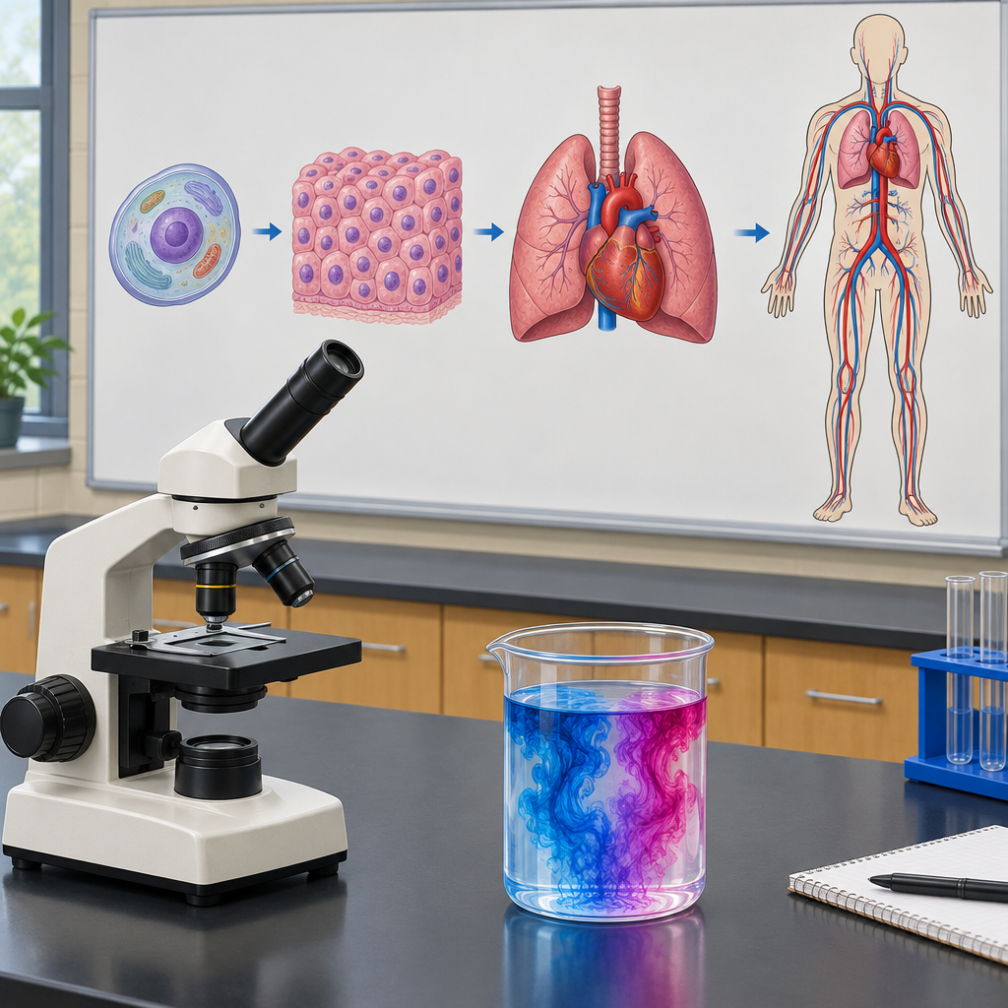

Overview
This lesson introduces the cell as the basic unit of life and builds toward how cells, tissues and organs work together in human body systems (Outcome, Outcome). Students start by applying the concept of a system to familiar organisms and analyzing their general structure and function(Outcome, Outcome). The lesson closes with small group research into one human body system, connecting cell-level function to whole-body responses like a racing heart during exercise (Outcome), and a brief look at how ongoing research improves human health (Outcome).
By the end of the lesson, students should be able to explain why cells are called the basic unit of life, name a structural difference between plant and animal cells, describe diffusion and osmosis in general terms, and describe how a human body system responds to a stimulus.

Outcomes covered
- Investigate living things, and identify and apply scientific ideas used to interpret their general structure, function and organization, by applying the concept of system in describing familiar organisms and illustrating how different organisms meet similar functions in a variety of ways. (Outcome, Outcome)
Understanding organisms as systems gives students a framework for making sense of the huge diversity of living things, from a single amoeba to a grizzly bear, and connects directly to how the human body is organized later in the unit.
- Investigate and describe the characteristics of living things and apply the concept of system in describing familiar organisms and analyzing their general structure and function. (Outcome, Outcome)
Students apply the concept of system in describing familiar organisms and analyzing their general structure and function.
- Apply the concept of system in describing familiar organisms and analyzing their general structure and function, and illustrate how different organisms have similar functions that are met in a variety of ways. (Outcome)
Students apply the concept of system in describing familiar organisms and analyzing their general structure and function, such as understanding how different body systems work together during physical activity like a sprint.

Materials
- Whiteboard and markers
- Small group worksheet with three prompts per body system (respiratory, circulatory, digestive, excretory, sensory)
- Student notebooks for exit tickets
- Textbook or printed notes on human body systems for group research
- Optional: glass of water and food colouring for a live diffusion demonstration

Sequence of activities

1. Warm-Up: What Makes Something 'Alive and Organized'? (8 min, whole class)
- Project or write this question: "A car has parts that all work together. Is a car alive?" Take three quick answers.
- Ask: "What is missing from a car that living things have?" Guide discussion toward cells, growth, and response to the environment.
- Introduce the idea of a system: a set of parts working together to do a job. Ask students to name one system in a school (example: the cafeteria system, moving food from kitchen to tray to student).
- Tell students that today's lesson connects this idea of systems to the smallest living unit, the cell, and to the human body (Outcome, Topic).
- Write the learning intentions on the board:
- I can apply the concept of system in describing familiar organisms and analyzing their general structure and function.
- I can compare single-celled and multicelled organisms.
- I can identify differences between plant and animal cells.
- I can illustrate how different organisms have similar functions that are met in a variety of ways.
Keep this brief and conversational. The goal is to activate prior knowledge of "systems" from everyday life before applying it biologically. If students struggle to name a school system, suggest the plumbing, the bell/timetable system, or the bus loop.
Sources: Outcome, Topic

2. Direct Instruction: Cells as the Basic Unit of Life (12 min, whole class)
- Explain that every living thing, from a single amoeba to a grizzly bear, is built from cells, and that the cell is the basic unit of life (Outcome, Outcome).
- Draw a simple T-chart on the board: Single-celled Organisms | Multicelled Organisms. Ask students to suggest examples (amoeba, bacteria on one side; poplar tree, grizzly bear, human on the other).
- Explain the comparison from the curriculum: an amoeba is a complete organism in one cell, doing everything itself, while a grizzly bear's trillions of cells are organized into tissues and organs that share the work (Outcome).
- Introduce plant versus animal cells. Draw two simple diagrams side by side on the board (do not use images, use a whiteboard sketch): both show a cell membrane, nucleus and cytoplasm; the plant cell also shows a cell wall and chloroplasts.
- Ask: "Why might a plant cell need a rigid wall but an animal cell does not?" Take answers (support and shape versus flexibility for movement). Confirm the key distinction: cell walls exist in plant cells and cell membranes surround both plant and animal cells (Outcome).
- Briefly connect to organization: cells group into tissues, tissues into organs, and organs into systems, in both plants and animals (Outcome, Outcome).
- Checkpoint question: "Give me one similarity and one difference between a plant cell and an animal cell." Cold-call two students.
Sample answers for checkpoint: Similarity, both have a membrane and a nucleus. Difference, plant cells have a cell wall and chloroplasts, animal cells do not. Watch for the common misconception that animal cells have no boundary at all; clarify that the membrane is present in both, only the wall is exclusive to plant cells.
Sources: Outcome, Outcome

3. Diffusion and Osmosis Demonstration Discussion (10 min, whole class)
- Ask students: "Why does a drop of food colouring spread through a glass of water on its own, without stirring?" Take guesses.
- Explain diffusion: particles move from an area of higher concentration to an area of lower concentration, until they are evenly spread (Outcome).
- Connect this to cells: oxygen moves into a cell where oxygen concentration is low inside compared to outside, and carbon dioxide moves out the same way (Outcome).
- Explain osmosis as the same idea applied specifically to water moving across a cell membrane, from an area with more water to an area with less water (Outcome). Remind students this is a general understanding, not a detailed mechanism (Outcome).
- Give a real-life example: a wilted piece of lettuce placed in water becomes crisp again because water moves into its cells by osmosis.
- Ask a check-for-understanding question: "If a cell is surrounded by a lot of sugar and very little water outside, which way will water move, into the cell or out of the cell?" Expected answer: out of the cell, toward the area with less water outside (higher solute concentration draws water out).
This is intentionally a conceptual, non-mechanistic treatment per the curriculum note (Outcome). Avoid introducing hypertonic and hypotonic vocabulary unless your class is ready; the outcome only requires a general understanding based on concentration differences.
Sources: Outcome

4. Small Group Task: Cells, Tissues, Organs and Body Systems (20 min, small group)
- Divide the class into groups of three or four. Assign each group one human body system: respiratory, circulatory, digestive, excretory, or sensory (Outcome).
- Give each group a sheet with three prompts:
- Name one organ in your assigned system and describe its role in general terms.
- Describe how cells contribute to the healthy functioning of this system (for example, blood cells, muscle cells, nerve cells).
- Describe one way this system's function changes in response to a stimulus (for example, heart rate rising during exercise, breathing rate increasing after running, pupils narrowing in bright light).
- Groups have 12 minutes to research using their textbook or provided notes and complete their sheet.
- Each group reports back to the class in under 1 minute: system name, one organ and its role, one cell example, one stimulus response.
- As groups report, the teacher records answers in a class chart on the board organized by system, to show how cells, tissues, organs and systems connect (Outcome, Outcome).
- Wrap the activity by pointing out that scientists continue to study how these systems work and how illness, aging or air quality affect them, which is part of ongoing medical research (Outcome).
Sample answers by system: Respiratory: lungs exchange oxygen and carbon dioxide, bronchia are air passageways; response to stimulus is faster breathing during exercise. Circulatory: heart pumps blood carrying oxygen and nutrients; response is faster heart rate during exercise. Digestive: stomach breaks down food; cells in stomach lining produce digestive juices. Excretory: kidneys remove waste from blood. Sensory: skin cells detect touch and temperature, eyes detect light; response is pupils narrowing in bright light. Circulate during group work to prompt groups that are stuck, and correct the common mix-up between an organ (the lung) and a system (respiratory system).
Sources: Outcome, Outcome, Outcome

5. Closing: Exit Ticket and Consolidation (10 min, individual)
- Distribute or display three exit ticket questions:
- In your own words, explain why the cell is called the basic unit of life.
- Name one structure found in a plant cell but not in an animal cell.
- Choose one human body system studied today and describe one way it changes in response to a stimulus.
- Give students 6 minutes to write their answers individually in their notebooks.
- Collect exit tickets or have students trade with a neighbour for a quick peer check against the sample answers you display on the board.
- Close by connecting back to the focusing question from the unit: how do living things, from single cells to complex human systems, stay organized and healthy (Topic)?
Sample answers: 1. The cell is the smallest unit that can carry out all the basic functions of life; every living thing is made of one or more cells. 2. Cell wall (or chloroplasts). 3. Example: the circulatory system responds to exercise by increasing heart rate to deliver more oxygen to muscles. Use exit tickets as your formative checkpoint for reteaching decisions tomorrow.
Sources: Outcome, Outcome, Topic

Differentiation
Extension
- Ask early finishers in the small group task to research one real example of scientific research into a dysfunction of their assigned system (for example, asthma and the respiratory system) and connect it to Outcome.
- Challenge students to draw a labelled diagram showing how a single stimulus (such as cold temperature) could trigger a response chain involving two different body systems.
Support
- Provide a partially completed T-chart of single-celled versus multicelled organisms with one example already filled in on each side.
- Give struggling groups a simplified sentence frame for the body system report: 'The ___ system includes the organ ___, which does ___. One type of organism studied involves single-celled or multicelled structures. This system responds to ___ by ___.'
- Pair students who need extra support with a stronger reader during the group research phase.
Inclusive supports
- Read exit ticket questions aloud for students who benefit from auditory input alongside text.
- Allow students to answer the exit ticket verbally to the teacher or through a scribe if writing is a barrier.
- Use consistent, simple diagrams on the board rather than fast freehand sketches so all students can copy accurately.

Assessment
Formative. Checkpoint questions during direct instruction asking students to state one similarity and one difference between plant and animal cells.
Look for: Students correctly identify the cell wall as unique to plant cells while naming the membrane and nucleus as shared structures. (Outcome)
Formative. Verbal check during the diffusion and osmosis discussion asking students to predict the direction water moves given a concentration difference.
Look for: Students correctly reason that water moves toward the area with less water (higher solute concentration) without needing to name the mechanism in detail. (Outcome)
Formative. Small group report-backs on an assigned human body system, covering an organ's role, a cell's contribution and a stimulus response.
Look for: Each group names an organ and its general role, gives a plausible cell example, and describes a real change in function tied to a stimulus, such as heart rate increasing with exercise. (Outcome)
Summative. Exit ticket with three short-answer questions covering cells as the basic unit of life, plant versus animal cell structures, and a body system's response to stimuli.
Look for: Written answers show understanding that cells are the basic unit of life, correctly identify at least one plant-only structure, and describe a specific, plausible stimulus response for a named body system. (Outcome, Outcome)

Vocabulary
- Cell: The basic unit of life. Every living thing is made of one or more cells (Outcome).
- System: A set of parts that work together to carry out a function, such as a body system or the structure and function of a whole organism (Outcome).
- Cell wall: A rigid outer layer found in plant cells but not animal cells, giving the cell extra support and shape (Outcome).
- Cell membrane: The boundary layer surrounding both plant and animal cells, controlling what enters and leaves the cell (Outcome).
- Diffusion: The movement of gases or particles from an area of higher concentration to an area of lower concentration until they are evenly spread (Outcome).
- Osmosis: The movement of water across a cell membrane from an area of more water to an area of less water, based on concentration differences (Outcome).
- Tissue: A group of similar cells working together to perform a shared job within an organ (Outcome).
- Organ: A structure made of different tissues working together to carry out a specific function in the body, such as the lungs or heart (Outcome).
- Stimulus: A change in internal or external conditions that causes a body system to respond, such as exercise raising heart rate (Outcome).

For families
- Ask your child to explain, using kitchen items, the difference between a plant cell and an animal cell (for example, comparing a plant cell's cell wall to a cardboard box around a balloon).
- Point out real-life diffusion at home, such as a tea bag spreading colour through hot water, and ask your child to explain why it happens without stirring.
- After exercise together, ask your child why their heart rate went up and which body system is responsible.

Sources
- Outcome: "apply the concept of system in describing familiar organisms and analyzing their general structure and function"
- Outcome: "describe the movement of gases and liquids into and out of cells during diffusion and osmosis, based on concentration differences"
- Outcome: "illustrate and explain how different organisms have similar functions that are met in a variety of ways"
- Outcome: "describe changes in body functions in response to changing conditions (e.g., changes in heart rate in response to exercise"
- Outcome: "distinguish between plant and animal cells (e.g., distinguish between cell walls and cell membranes)"
- Topic: "Living things take a variety of forms as reflected in their structures, internal processes and ways of responding to their environments."
- Outcome: "investigate and describe factors that affect the healthy function of the human respiratory, circulatory and digestive systems"

All content describes standard, age-appropriate Grade 8 biology concepts (cells, body systems, diffusion) using classroom-safe materials and activities, with no content that is culturally sensitive or physically risky.

AILI detailed pack · en · claude-sonnet-5 · 2026-09-17

