Heat in the Lab
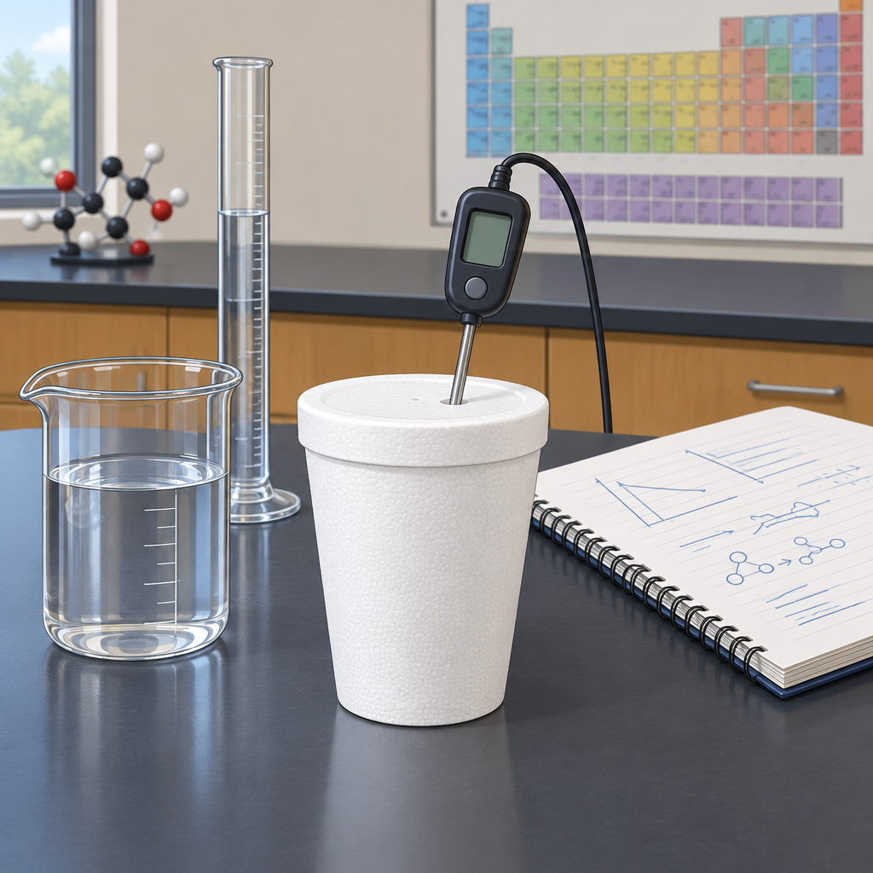
Maya and her lab partner Kai put on their safety goggles and gloves before measuring hydrochloric acid into a polystyrene cup. They were about to combine it with sodium hydroxide and measure the resulting temperature change. Kai read the thermometer: twenty degrees Celsius. He carefully added the base. The liquid grew warm. Thirty-two degrees. Kai looked at Maya. The reaction had released energy to its surroundings—it was exothermic. They recorded the data: a mass of twenty-five grams of solution and a specific heat capacity of four point zero joules per gram per degree Celsius. Q equals mass times specific heat capacity times temperature change. Kai calculated the heat released: twenty-five grams times four point zero joules per gram per degree Celsius times a twelve-degree rise, giving one thousand two hundred joules. Maya wrote it down. The enthalpy change was negative. Energy had flowed out of the system and into the solution. They understood now. Breaking bonds requires energy. Forming new bonds releases it. The difference between those two amounts is exactly what they had measured. Chemistry, they realized, is simply energy moving between molecules. And a polystyrene cup, a thermometer, and a pair of careful, safety-conscious students were all it took to see that energy in action.

Words to know
- exothermic: a chemical reaction that releases heat energy to the surroundings
- enthalpy change: the heat energy absorbed or released during a chemical reaction, shown as ΔH
- calorimetry: the experimental measurement of heat produced or absorbed in a chemical reaction
- specific heat capacity: the amount of energy needed to raise the temperature of one gram of a substance by one degree Celsius
Curriculum link: Outcome, Outcome, Outcome, Outcome, Outcome
Listen to the narration

AILI audio story · en · claude-haiku-4-5-20251001 · 2026-09-17

