Cells and Systems: Building Blocks of Life
From single cells to human body systems
Audience: Grade 8 science students in an Alberta classroom, ages 12 to 14, working in a lab or classroom setting with access to microscopes or projected diagrams.
Grades: Grade 8
Subjects: Science
Time: about 60 minutes
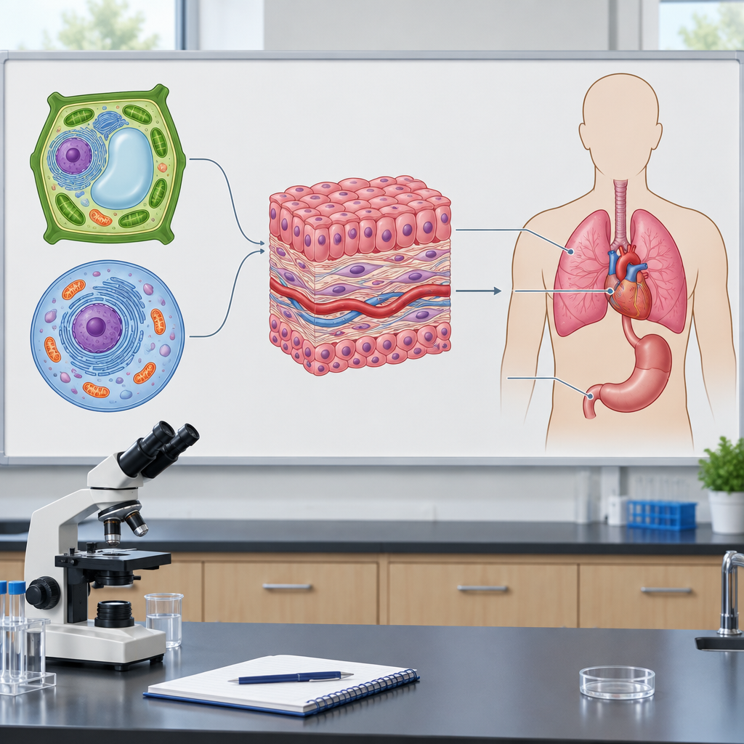

Overview
This lesson opens Unit B: Cells and Systems by building from the smallest unit of life, the cell, up to the major systems of the human body (Topic). Students compare plant and animal cells directly, observe diffusion using a simple food colouring demonstration, and rotate through stations exploring the respiration, circulation, digestion, excretion and sensory systems (Outcome, Outcome).
Throughout the lesson, students apply the concept of system to describe how living things, from a single-celled amoeba to a grizzly bear, are organized to carry out shared life functions in different ways (Outcome, Outcome). The lesson closes with an exit ticket that checks whether students can describe one human body system and compare single-celled and multicelled organisms (Outcome, Outcome, Outcome).

Outcomes covered
- Investigate living things; and identify and apply scientific ideas used to interpret their general structure, function and organization. (Outcome, Outcome)
Understanding organisms as systems helps students make sense of the huge diversity of living things, from a single-celled amoeba to a large mammal, using one common framework.
- Investigate and describe the general structure and function of living things, including how different organisms have similar functions that are met in a variety of ways. (Outcome, Outcome)
Investigating living things helps identify and apply scientific ideas used to interpret their general structure, function and organization. Understanding the general structure and function of organisms, and applying the concept of system in describing them, builds the foundation for analyzing how different organisms meet similar functions in a variety of ways.
- Apply the concept of system in describing familiar organisms and analyzing their general structure and function, including illustrating how different organisms have similar functions that are met in a variety of ways. (Outcome)
Apply the concept of system in describing familiar organisms to help explain everyday experiences.

Materials
- Clear glasses or beakers of room-temperature water
- Food colouring
- Prepared or projected slides of onion skin (plant) and cheek cells (animal), or printed cell diagrams
- Microscopes (optional, if available)
- Station info cards for respiration, circulation, digestion, excretion and sensory awareness
- Diagrams or simple models of human body systems
- Exit ticket handouts
- Student notebooks or paper for sketching and recording
- Stopwatch or clock for pulse check

Sequence of activities

1. Hook: What Makes You a System? (8 min, whole class)
- Ask students to check their own pulse for 15 seconds (count beats, multiply by 4). Record the number on the board for a few volunteers.
- Ask: "What just happened inside your body to make your heart speed up or slow down after you sat still?" Take two or three answers without correcting them yet.
- Introduce the big question for the lesson: living things, from a single amoeba to a grizzly bear, are organized as systems built from cells, tissues and organs (Outcome, Outcome, Topic).
- Tell students that by the end of the lesson they will be able to explain how cells contribute to the healthy functioning of the human body (Outcome).
If a student has a heart condition or discomfort with checking their pulse, let them read a partner's data instead or use a rest heart rate example you provide (e.g., 72 beats per minute).
Sources: Outcome, Outcome, Outcome, Topic

2. Cells as the Basic Unit of Life (12 min, pairs)
- In pairs, students look at prepared slides or diagrams of a plant cell (onion skin or leaf) and an animal cell (cheek cell diagram) under a microscope or on a projected image.
- Students sketch both cells and label at least three structures each, then circle what is different between the two (Outcome, Outcome).
- Ask pairs to answer: "What structure does the plant cell have that the animal cell does not?" Expected answer: a cell wall and a large central vacuole (note that onion skin cells, which grow underground, lack chloroplasts). The animal cell has a cell membrane but no wall (Outcome).
- Discuss as a class: why might a plant need a rigid wall while an animal cell does not? (Plants do not move around and need structural support to resist water pressure and maintain shape; animals move and need flexible cells.)
- Introduce the idea that cells are the basic unit of life, and that both single-celled organisms (like an amoeba) and multicelled organisms (like a grizzly bear or a poplar tree) are built from cells, just in very different numbers and arrangements (Outcome, Outcome).
If microscopes are unavailable, use printed or projected cell diagrams. Have students annotate directly on a photocopy rather than freehand sketching to save time.
Sources: Outcome, Outcome

3. Diffusion and Osmosis Demonstration (10 min, whole class)
- Drop one drop of food colouring into a clear glass of room-temperature water without stirring. Have students observe and predict what will happen over the next few minutes.
- While watching, explain diffusion: particles move from an area of high concentration (the drop) to an area of low concentration (the rest of the water) until they are evenly spread (Outcome).
- Connect this to cells: gases like oxygen and carbon dioxide, and liquids like water, move into and out of cells the same way, based on concentration differences (Outcome). Note this is a general understanding, not a detailed mechanism (Outcome).
- Give the osmosis example of a wilted lettuce leaf placed in water becoming crisp again, or a raisin plumping up in water. Ask students to explain using the word "concentration."
- Quick check: ask students to write one sentence in their notebooks explaining why cells in your lungs can pick up oxygen from the air you breathe in.
Expect answers like: oxygen is more concentrated in the air in the lungs than inside the blood cells, so it diffuses into the cells. Accept any answer that correctly uses the idea of moving from high to low concentration.
Sources: Outcome

4. From Cells to Systems: Human Body Stations (20 min, small group)
- Set up five stations, one for each body system: respiration, circulation, digestion, excretion and sensory awareness (Outcome). Each station has a diagram or model and a short info card.
- In groups of three or four, students rotate through stations (about 3 to 4 minutes each). At each station they record: the main organs involved, one job that system does for the body, and one type of cell that helps it work (Outcome). Example: circulation station - heart and blood vessels, job is carrying oxygen and nutrients to tissues, red blood cells carry oxygen.
- At the respiration station, prompt students to name the role of lungs (gas exchange) and bronchia (air passageway) as specific examples of organs and tissues supporting healthy body function (Outcome).
- At a sixth optional stimulus station, present two scenarios: "a student starts running" and "a student steps into cold air." Groups predict what changes their body would make (heart rate increasing during exercise, metabolism changing in response to cold, or an involuntary response like shivering) (Outcome).
- Regroup as a class. Ask one group per station to share their one job and one cell type. Correct or add detail as needed.
Keep station cards short (3 to 4 bullet points) so students spend more time discussing than reading. If time is tight, run only 4 stations and skip one system, but respiration and circulation should always be included since they connect directly to the diffusion demonstration.
Sources: Outcome

5. Exit Ticket: One Organism, Many Systems (10 min, individual)
- Hand out an exit ticket with two questions.
- Question 1: Choose one human body system from today (respiration, circulation, digestion, excretion or sensory awareness) and describe, in one or two sentences, how it supports healthy functioning of the body, naming at least one organ or tissue involved (Outcome).
- Question 2: Compare a single-celled organism (like an amoeba) and a multicelled organism (like a poplar tree or a grizzly bear) in one sentence, describing one similarity and one difference in how they carry out a basic life function such as getting food or moving materials in and out of cells (Outcome, Outcome).
- Collect exit tickets as a formative check before the next class on tissues and organs.
Strong answers name a specific organ (lungs, heart, stomach, kidney, skin, eye or ear) and connect it to a function. For question 2, accept any correct comparison that references cell number, structure or a shared function like diffusion, gas exchange or moving nutrients.
Sources: Outcome, Outcome, Outcome

Differentiation
Extension
- Ask students to research one real scientific study of a locally-found organism and describe how scientists studied its cell structure or system organization, connecting back to Outcome.
- Challenge students to explain, in writing, why a single-celled amoeba does not need separate organs or systems the way a grizzly bear does, using the concept of system from Outcome and Outcome.
- Have advanced students design a simple experiment to test osmosis using different concentrations of salt water and a plant sample, predicting results before testing.
Support
- Provide pre-labeled cell diagrams for students who need support with fine motor sketching, so they focus on comparing structures rather than drawing accurately.
- Give sentence starters for the exit ticket, such as "The ___ system helps the body by ___" and "A single-celled organism and a multicelled organism are similar because ___ but different because ___."
- Pair students with a stronger reader or writer at the body system stations so recording the information is shared.
Inclusive supports
- Provide information in formats that support student access to content about cells and living systems.
- Allow students to check a partner's pulse instead of their own if they are uncomfortable touching their own neck or wrist.
- Provide alternate seating or standing options for the station rotation activity for students who need movement breaks or physical accommodation.

Assessment
Formative. During the cell diagram pairs activity, circulate and check that students can correctly identify at least one structural difference between plant and animal cells (such as cell wall versus cell membrane).
Look for: Student sketches show correct labels and a circled difference; students can verbally state why plant cells have a wall and animal cells do not. (Outcome, Outcome)
Formative. During the diffusion demonstration, listen for students correctly using the term "concentration" when explaining how the food colouring spreads and how gases move into cells.
Look for: Written sentence in notebooks correctly links high-to-low concentration movement to oxygen entering cells in the lungs. (Outcome)
Formative. At the body system stations, check group recording sheets for accurate matching of organs, one function, and one relevant cell type per system.
Look for: Recording sheets name correct organs (e.g., heart, lungs, stomach, kidney, eye or ear) and at least one cell type such as red blood cell, nerve cell or muscle cell. (Outcome)
Formative. Exit ticket collected at the end of class, assessing description of one human body system and comparison of single-celled versus multicelled organisms.
Look for: Responses correctly describe a body system's role using at least one named organ or tissue, and correctly compare single-celled and multicelled organisms with reference to a shared basic function. (Outcome, Outcome, Outcome)

Vocabulary
- cell: The basic unit of life. All living things are made of one or more cells (Outcome).
- diffusion: The movement of gases or liquids from an area of high concentration to an area of low concentration, such as oxygen moving into a cell (Outcome).
- osmosis: The movement of water into or out of a cell based on concentration differences (Outcome).
- tissue: A group of similar cells working together to perform a shared function, such as muscle tissue or nerve tissue (Outcome, Outcome).
- organ: A structure made of different tissues working together to carry out a specific job in the body, such as the heart or lungs (Outcome).
- system: A set of organs and structures that work together to carry out a major function of the body, such as the circulatory system or respiratory system (Outcome, Outcome, Outcome).
- single-celled organism: A living thing made of only one cell, such as an amoeba, which must carry out all life functions within that one cell (Outcome, Outcome).
- multicelled organism: A living thing made of many cells, such as a grizzly bear or a poplar tree, where different cells, tissues and organs share the work of life functions (Outcome, Outcome).

For families
- Ask your student to explain, using their own words, why their heart beats faster after exercise. This connects to how the body responds to changing conditions.
- At home, try the food colouring in water demonstration together and ask your student to explain what is happening using the word concentration.
- Encourage your student to name one body system (like digestion or circulation) and one organ involved, then explain its job in their own words.

Sources
- Outcome: "Investigate living things; and identify and apply scientific ideas used to interpret their general structure, function and organization"
- Outcome: "describe the movement of gases and liquids into and out of cells during diffusion and osmosis, based on concentration differences"
- Outcome: "analyze similarities and differences between single-celled and multicelled organisms"
- Outcome: "describe ways in which various types of cells contribute to the healthy functioning of the human body"
- Outcome: "apply the concept of system in describing familiar organisms and analyzing their general structure and function"
- Topic: "healthy organisms, including healthy humans, function as balanced systems within a life-supporting environment"

This lesson uses only common classroom materials such as water, food colouring and standard cell diagrams, and the pulse-check activity includes an alternative for students uncomfortable checking their own pulse, making the content safe and age-appropriate for grade 8 students.

AILI detailed pack · en · claude-sonnet-5 · 2026-09-17

