Enthalpy Changes and Calorimetry
Chemistry 30, Unit A: Energy, Change and Systems

Slide 1: Enthalpy Changes and Calorimetry
Chemistry 30, Unit A: Energy, Change and Systems
Sources: Topic
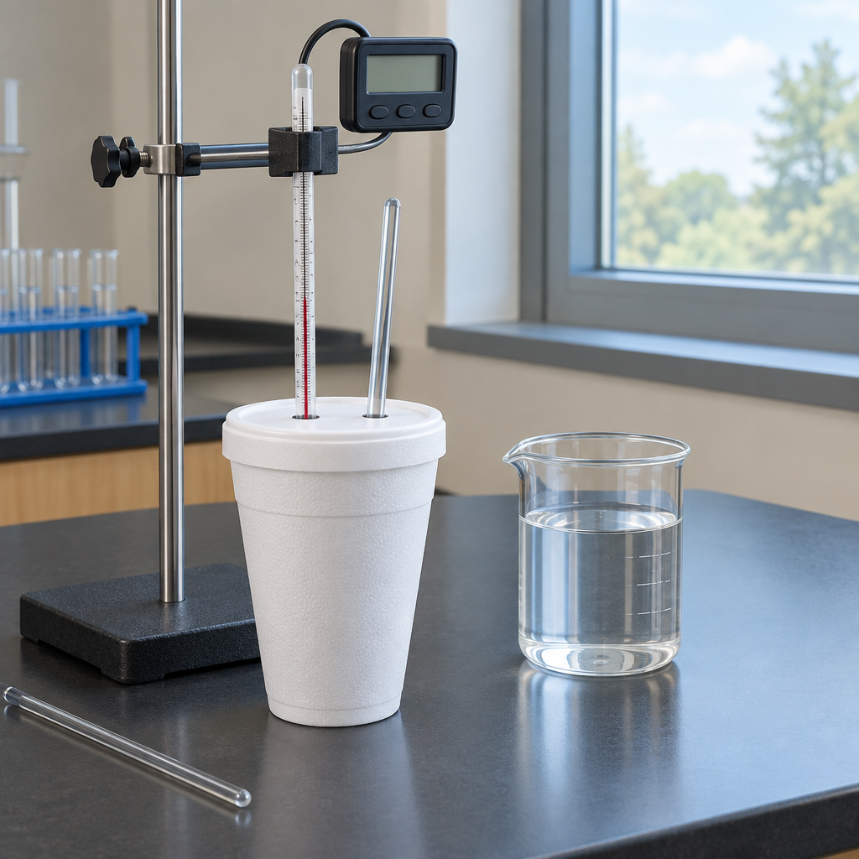
Notes: Introduce the unit theme of Energy, Change and Systems. Preview that students will quantify energy changes in chemical reactions using calorimetry and standard enthalpy data (Topic).

Slide 2: Why Study Energy in Chemical Reactions?
- Chemists quantify how much energy a reaction produces or absorbs (Topic).
- Society relies on chemical reactions for usable energy, so understanding energy changes has practical impact (Topic).
- Students will determine and interpret energy changes in chemical reactions (Topic).
- Students will also explain and communicate those energy changes (Topic).
- This unit builds on heat and temperature concepts from Science 10 and Grade 7 Science (Topic).
Sources: Topic, Topic, Topic
Notes: Use the focusing questions from Topic to open discussion: How does society use the energy of chemical changes? What determines whether energy is released or absorbed? Connect to prior learning on heat and temperature.

Slide 3: From Heat Transfer to Enthalpy
- Measure heat transfer: Apply Q = mcΔt to analyze heat absorbed or released by a substance (Outcome).
- Define enthalpy: Enthalpy and molar enthalpy describe the heat content change for a chemical reaction (Outcome).
- Use ΔH notation: ΔH notation communicates and calculates energy changes in reactions (Outcome).
- Classify the reaction: Reactions are classified as endothermic or exothermic, including photosynthesis, respiration and combustion (Outcome).
Sources: Outcome, Outcome, Outcome, Outcome
Notes: Walk through the logical sequence: students first calculate heat transfer numerically (Q = mcΔt), then connect that value to the concept of enthalpy, then represent it with ΔH notation, and finally classify the reaction type. Emphasize sign conventions: negative ΔH for exothermic, positive ΔH for endothermic.

Slide 4: Two Ways to Find ΔH for a Reaction
Standard Enthalpies of Formation
Students predict the enthalpy change for a chemical equation using standard enthalpies of formation of reactants and products (Outcome). This method uses tabulated reference values rather than direct measurement.
Hess' Law
Hess' law allows the enthalpy change for a net reaction to be calculated by combining a series of known reactions (Outcome). This works because enthalpy is a state function, independent of the pathway taken.
Sources: Outcome, Outcome
Notes: Give a worked example of each: (1) ΔH reaction = sum ΔHf products minus sum ΔHf reactants; (2) manipulating and adding two or three given reactions and their ΔH values to obtain a target equation. Check that students can flip a reaction (reverse sign of ΔH) and scale coefficients (scale ΔH proportionally).

Slide 5: Calorimetry in Practice
In a calorimetry experiment, students measure the temperature change of a known mass of water or solution surrounding a reaction to calculate heat transfer, then use that data to determine the enthalpy change of the chemical reaction itself (Outcome). This experimental approach links the mathematical relationship Q = mcΔt directly to real reaction data (Outcome), and the resulting energy diagram shows reactants, products, enthalpy change and activation energy (Outcome).
Determining ΔH experimentally
In a calorimetry experiment, students measure the temperature change of a known mass of water or solution surrounding a reaction to calculate heat transfer, then use that data to determine the enthalpy change of the chemical reaction itself (Outcome). This experimental approach links the mathematical relationship Q = mcΔt directly to real reaction data (Outcome), and the resulting energy diagram shows reactants, products, enthalpy change and activation energy (Outcome).
Sources: Outcome, Outcome, Outcome
Notes: Suggested lab: reaction of an acid and base in a coffee-cup calorimeter, or dissolving a salt in water. Have students calculate Q for the water, assume Q reaction equals negative Q water, then divide by moles of limiting reactant to find molar enthalpy. Discuss sources of error: heat loss to surroundings, calorimeter constant, incomplete reaction. Also review labeling energy diagrams with activation energy and ΔH (Outcome).

Slide 6: Bringing It Together
Summary: This unit connects heat transfer calculations, enthalpy definitions, ΔH notation, Hess' law, standard enthalpies of formation and calorimetry into one framework for quantifying energy changes in chemical reactions (Topic). Students also explain these changes at the particle level, referring to bonds breaking and forming and shifts between potential and kinetic energy (Outcome).
Question: If a calorimetry experiment measures a smaller temperature change than the true value due to heat loss to the surroundings, how would that affect the calculated molar enthalpy for an exothermic reaction?
Sources: Topic, Outcome
Notes: Use the closing question as an exit ticket or discussion starter. Expect students to understand calorimetry as a method to determine energy changes in chemical reactions. Extension: ask students to propose a calorimeter constant correction. Support: revisit the sign convention chart for exothermic versus endothermic ΔH before answering.

AILI presentation · en · claude-sonnet-5 · 2026-09-17

