Forces in Water and Air
Exploring buoyant force, thrust, drag, lift, and weight through hands-on investigation
Audience: Grade 5 science students in an Alberta classroom
Grades: Grade 5
Subjects: Science
Time: about 60 minutes
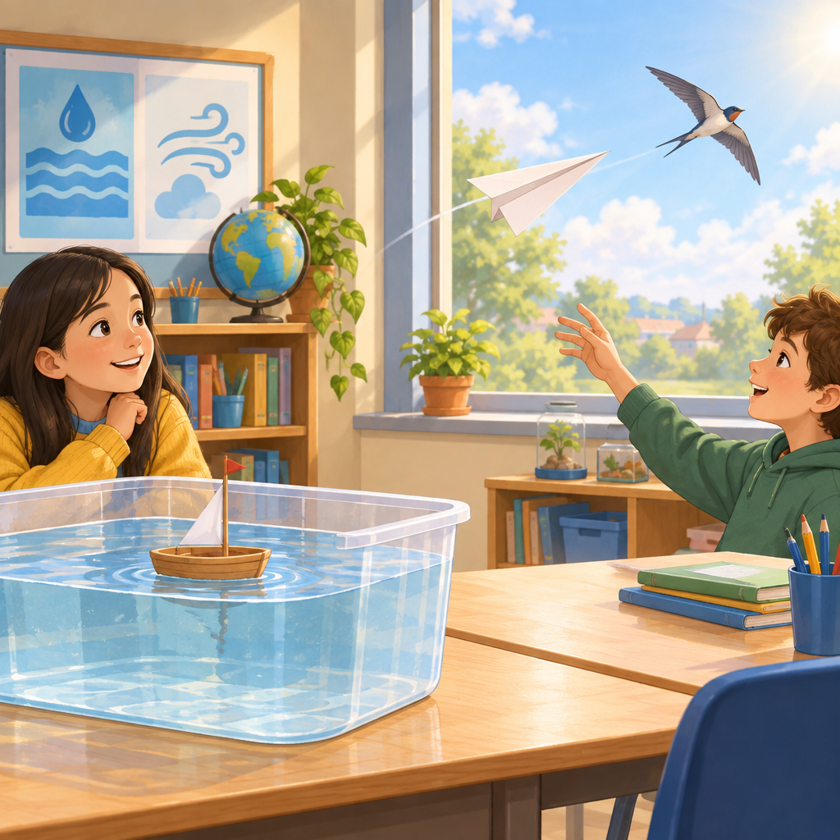

Overview
This lesson introduces Grade 5 students to the forces that act on living things and objects in water and in air (Outcome). Students explore buoyant force and weight through a hands-on sink or float investigation (Knowledge, Skills, Knowledge), then turn to the sky to learn about thrust, drag, lift, and weight as the four opposing forces of flight (Knowledge, PDF p.12).
Along the way, students connect these ideas to traditional technologies such as the bow and arrow, slingshot, and fishing spear, which reflect a long-standing human understanding of how forces affect motion through fluids (Knowledge, Skills). By the end of the lesson, students can diagram opposing forces, explain float and sink outcomes using scientific vocabulary, and compare how forces work similarly and differently in water and air (Skills, Understanding).

Outcomes covered
- Students investigate and compare how forces affect living things and objects in water and air. (Outcome, Outcome)
This is the central learning outcome for the unit and ties together the ideas of buoyant force in water and thrust, drag, lift, and weight in air, helping students see that both environments involve fluids that push back on objects.
- Flight of living things and objects is influenced by opposing forces. (Understanding, Understanding)
Understanding that thrust and drag, and lift and weight, work against each other helps students explain everyday flight, from a thrown ball to a soaring bird.
- The relationship between buoyant force and gravity can be used to explain the behaviour of an object in water. (Understanding, Understanding)
This gives students a clear, testable rule for predicting whether everyday objects like toys, coins, or boats will float or sink.

Materials
- Clear plastic tub filled with water (one per small group)
- Small objects to test: paperclip, cork, marble, small plastic toy, wooden block, coin, eraser, piece of foam
- Modelling clay or plasticine (one small ball per group or for teacher demonstration)
- Paper for folding paper airplanes
- Drawing paper or worksheets for the four forces diagram
- Pencils and crayons or markers
- Exit ticket slips (one per student)
- Take-home challenge cards (one per student)
- Picture or sample of a bow and arrow, slingshot, or fishing spear (optional, for discussion)

Sequence of activities

1. What makes things float or sink? (10 min, whole class)
- Hold up a small ball of modelling clay (or plasticine) and ask: will this float or sink if I put it in water? Take a quick class vote by show of hands.
- Drop it into a clear tub of water. It sinks. Ask students why they think that happened.
- Introduce the vocabulary: buoyant force is the upward push that water gives to anything placed in it, and weight is the downward pull of gravity (Knowledge, PDF p.1).
- Explain the rule: an object floats when the buoyant force is equal to or greater than its weight, and it sinks when the buoyant force is less than its weight (Knowledge, PDF p.1).
- Now reshape the same piece of clay into a wide, shallow bowl shape and try again. It floats. Ask: did the weight of the clay change? (No.) So what changed? (The shape changed how much water it pushes out of the way, which changes the buoyant force.)
- Tell students that fluids include both liquids and gases, so air can also push on objects the same way water does (Knowledge).
Key answer for step 5: the clay's weight stayed the same, but the bowl shape displaces more water, increasing the buoyant force until it matches or beats the weight. Keep this demonstration short and punchy so it hooks attention before independent work.
Sources: Knowledge, Knowledge, PDF p.1

2. Sink or Float investigation (15 min, small group)
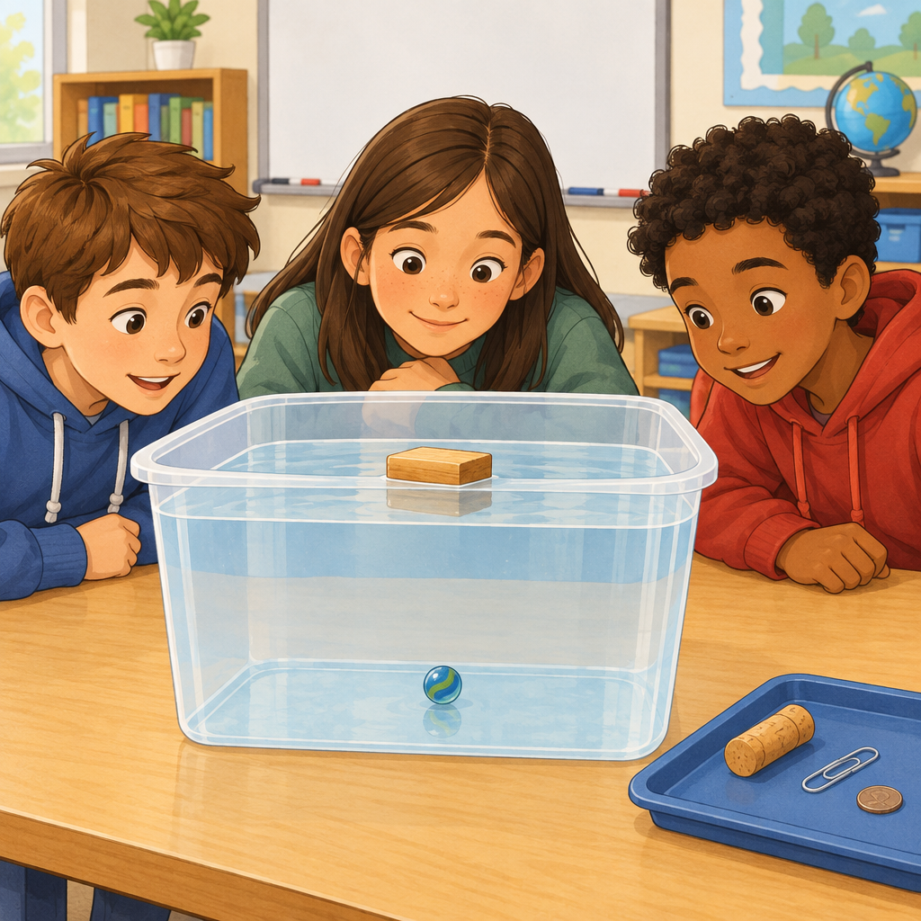
- In groups of three or four, give each group a tub of water and a tray of small objects: a paperclip, a cork, a marble, a small plastic toy, a wooden block, a coin, an eraser, and a piece of foam.
- Groups predict in writing whether each object will float or sink, and give one reason using the words buoyant force or weight.
- Groups test each object one at a time and record what actually happened next to their prediction.
- Groups pick two objects where their prediction was wrong and discuss why, using the sentence starter: 'I thought the ___ would ___ because ___, but it actually ___ because ___.'
- As a class, gather answers and confirm the rule: buoyant force greater than or equal to weight means float; buoyant force less than weight means sink (Skills, Understanding, Knowledge).
- Ask one group to share their most surprising result and explain it using the vocabulary.
This is a controlled experiment as named in Skills. Circulate to check students are using 'buoyant force' and 'weight' correctly rather than just saying 'heavy' or 'light'. Watch for the common misconception that heavy objects always sink; the wooden block or a large plastic toy usually floats despite being bigger, which is a good discussion point.
Sources: Skills, Understanding, Knowledge

3. Four forces of flight (15 min, pairs)
- Show a picture or a real paper airplane and ask: what forces act on this when it flies? Let pairs brainstorm for one minute.
- Introduce the four forces using PDF p.12 and Knowledge: thrust pushes an object in the direction it is moving; drag is the air pushing back against the movement; lift is the upward force that holds something in the air; weight is the downward pull of gravity.
- Explain that thrust and drag are a horizontal opposing pair, and lift and weight are a vertical opposing pair (Knowledge, PDF p.12).
- In pairs, students draw a simple bird or airplane shape and add four labelled arrows: thrust pointing forward, drag pointing backward, lift pointing up, weight pointing down (Skills).
- Ask pairs to compare their diagram with the pair beside them and check all four arrows point the correct way.
- Whole class discussion: ask why a streamlined shape (like a fish or an airplane nose) has less drag than a flat, wide shape. Connect this to why some birds have smooth, pointed wings.
Answer for step 6: a streamlined shape lets air flow smoothly around it, so less air pushes back against it, meaning less drag (PDF p.12). Check diagrams for correct arrow direction: thrust and lift should point toward motion or upward, drag and weight should point opposite the motion or downward. This is the diagramming skill named in Skills.
Sources: Knowledge, Skills, PDF p.12

4. Traditional tools and forces of flight (8 min, whole class)
- Ask students: has anyone ever used or seen a bow and arrow, a slingshot, or a fishing spear?
- Explain that these are traditional technologies developed by diverse cultures, and that each one works because someone understood how thrust, drag, lift, or weight affect a flying object (Knowledge, Skills).
- For the bow and arrow: pulling the string back and releasing it gives the arrow thrust. Ask: what force slows the arrow down as it flies? (Drag, from the air pushing against it, and weight pulling it toward the ground.)
- For the slingshot: the stretched band gives thrust to the stone, just like the bowstring. Ask how a flatter, smoother stone might fly differently than a bumpy rock (less drag, more predictable flight).
- For the fishing spear: ask why the spear is designed long and pointed rather than wide and flat (streamlined shape reduces drag as it moves toward the fish, in water or air).
- Summarize: people used their understanding of these forces long before scientists gave them these exact names.
This connects directly to Skills's requirement to describe traditional or modern technologies that reflect understanding of forces affecting flight. Keep this respectful and factual, presenting these as real tools developed and used by Indigenous and other cultures worldwide for hunting and daily life.
Sources: Knowledge, Skills

5. Exit ticket: compare water and air (7 min, individual)
- Give each student a small exit slip with two questions.
- Question 1: Draw and label an object floating in water, showing the buoyant force arrow and the weight arrow.
- Question 2: Name one way a force in water is similar to a force in air, and one way it is different.
- Students hand in their slips as they line up or move to the next activity.
- Collect answers to check understanding before the next lesson.
Sample strong answer for question 2: 'Both water and air can push up on an object with a force, and both are fluids, but water usually pushes up harder than air because water is thicker, so it is easier to float in water than to float in air' (Knowledge). Use this exit ticket as your main formative checkpoint for the lesson.
Sources: Knowledge, Understanding, Understanding

6. Take-home floating and flying challenge (5 min, family)
- At the end of class, hand out a simple take-home card describing two mini challenges for home.
- Challenge A: with an adult, find three objects at home and predict, then test, whether each floats or sinks in a sink or bathtub. Talk about buoyant force and weight for each one.
- Challenge B: fold a paper airplane with a family member and test how far it flies. Talk about which forces are acting on it (thrust, drag, lift, weight).
- Students bring back one sentence next class describing what they discovered.
This reinforces both major concepts (floating in water, flying in air) through a low-cost, no-materials-needed home activity. No submission is graded; it is meant to build vocabulary confidence through conversation.
Sources: Knowledge, Knowledge

Differentiation
Extension
- Ask students to research one more traditional or modern technology (beyond the bow and arrow, slingshot, and fishing spear) that uses an understanding of forces affecting flight, and present it to the class in one minute.
- Challenge students to design and test a second float-worthy shape from the same amount of modelling clay, then explain in writing why it held more or less weight before sinking, using buoyant force and weight vocabulary.
- Have students calculate how many paperclips a foil boat can hold before it sinks, then explain the point where buoyant force stops matching weight.
Support
- Provide sentence starters for the exit ticket, such as 'The buoyant force pushes ___ and the weight pushes ___' and 'One way water and air forces are the same is ___.'
- Pair students with a partner for the diagram activity instead of working alone, and provide a pre-drawn airplane or bird outline so students only need to add and label the four arrows.
- Use real objects (a sinking rock, a floating cork) rather than only diagrams when introducing buoyant force and weight, so the concept is grounded in something visible and touchable.
Inclusive supports
- Offer both a picture and a verbal explanation for each new vocabulary term (thrust, drag, lift, weight, buoyant force) to support different learning styles.
- Allow students to demonstrate understanding on the exit ticket by drawing and labelling only, without requiring full written sentences, for students who find writing challenging.
- Keep instructions short and posted visually at each station during the Sink or Float investigation so students can refer back to the steps without relying on memory.

Assessment
Formative. During the Sink or Float investigation, listen for pairs and small groups using the terms buoyant force and weight correctly when explaining their predictions and results.
Look for: Students explain float or sink outcomes by comparing buoyant force and weight rather than using vague words like heavy or light. (Skills, Knowledge)
Formative. Check the four forces diagrams pairs draw during the flight activity for correctly placed and labelled arrows for thrust, drag, lift, and weight.
Look for: Arrows point in the correct direction relative to the direction of motion: thrust forward, drag backward, lift up, weight down. (Knowledge, Skills)
Summative. Collect the individual exit ticket where students draw a floating object with labelled forces and compare a force in water to a force in air.
Look for: The diagram correctly shows buoyant force acting upward and weight acting downward, and the written comparison names at least one accurate similarity and one accurate difference between forces in water and air. (Knowledge, Understanding, Understanding)

Vocabulary
- Buoyant force: The upward push that a fluid (like water or air) gives to anything placed in it. It opposes the weight of the object.
- Weight: A downward force caused by gravity that pulls on any living thing or object.
- Thrust: A force that pushes an object in the direction it is moving, such as a bird flapping its wings or a hand throwing a paper airplane.
- Drag: A force that pushes back against an object as it moves through air (or water), opposing the direction of movement.
- Lift: An upward force that acts to overcome an object's weight and hold it in the air, often created by the curved shape of a wing.
- Fluid: Anything that can flow and take the shape of its container, including both liquids (like water) and gases (like air).

For families
- Ask your child to point out something at home that floats and something that sinks, and have them explain why using the words buoyant force and weight.
- Fold a paper airplane together and test different folds. Talk about which one flies straighter and ask your child which forces might be causing the difference.
- When you see a bird, a plane, or a boat this week, ask your child what forces might be acting on it.

Sources
- Outcome: "Students investigate and compare how forces affect living things and objects in water and air."
- Knowledge: "Thrust and drag are opposing forces."
- Skills: "Diagram opposing forces that act on living things or objects in flight."
- Understanding: "Flight of living things and objects is influenced by opposing forces."
- Knowledge: "Buoyant force is an upward force exerted by a fluid that opposes the weight of anything placed in the fluid."
- Skills: "Conduct controlled experiments to determine if various objects and materials float in different fluids."
- Understanding: "The relationship between buoyant force and gravity can be used to explain the behaviour of an object in water."
- Knowledge: "An object will float on the surface of a liquid when the buoyant force is equal to the weight of the object."
- Understanding: "The relationship between buoyant force and gravity can be used to explain the behaviour of an object in water."
- PDF p.12: "Thrust is a force that pushes an object in the intended direction of motion."
- PDF p.1: "An object floats when its buoyant force is greater than its weight."

All activities use everyday, non-hazardous classroom materials such as water tubs, small objects, and paper, and the content is factually grounded, culturally respectful when discussing traditional technologies, and appropriate for Grade 5 students.

AILI detailed pack · en · claude-sonnet-5 · 2026-09-17

