Cells and Systems (Grade 8 Science)
Central concept: Cells and Systems

Connections
- Cells and Systems (includes) -> Organisms
- Cells and Systems (applies) -> System Concept
- Cells and Systems (built from) -> Cell
- Cells and Systems (organizes into) -> Tissues and Organs
- Cells and Systems (seen in) -> Human Body Systems
- Organisms (analyzed by) -> System Concept
- Cell (compared as) -> Single vs Multicelled
- Cell (differs as) -> Plant vs Animal Cells
- Cell (exchanges via) -> Diffusion and Osmosis
- Cell (forms) -> Tissues and Organs
- Human Body Systems (relies on) -> Organ Roles
- Human Body Systems (made of) -> Cell Roles in Body
- Human Body Systems (adjusts via) -> Response to Stimuli
- Tissues and Organs (leads to) -> Organ Roles

Notes
- Cells and Systems: Living things function as balanced systems, from single cells to complex organisms. Topic
- Organisms: Diverse living things share common functions met by different structures, e.g. food gathering. Outcome, Outcome
- System Concept: Applying the idea of system to describe an organism's general structure and function. Outcome, Outcome
- Cell: The basic unit of life in all living things. Outcome, Outcome
- Single vs Multicelled: Comparing organisms like an amoeba versus a grizzly bear, or an alga versus a poplar tree. Outcome, Outcome
- Plant vs Animal Cells: Distinguished by features such as cell walls versus cell membranes. Outcome, Outcome
- Diffusion and Osmosis: Movement of gases and liquids into and out of cells based on concentration differences. Outcome, Outcome
- Tissues and Organs: Cells contribute to tissues and organs, which build plant and animal structures. Outcome, Outcome
- Human Body Systems: Respiration, circulation, digestion, excretion and sensory awareness systems. Outcome
- Organ Roles: Individual organs such as lungs and bronchia support healthy body function. Outcome
- Cell Roles in Body: Nerve, muscle, blood, skin and bone cells each contribute to healthy body function. Outcome
- Response to Stimuli: Body functions change with conditions, such as heart rate during exercise or reflexes. Outcome
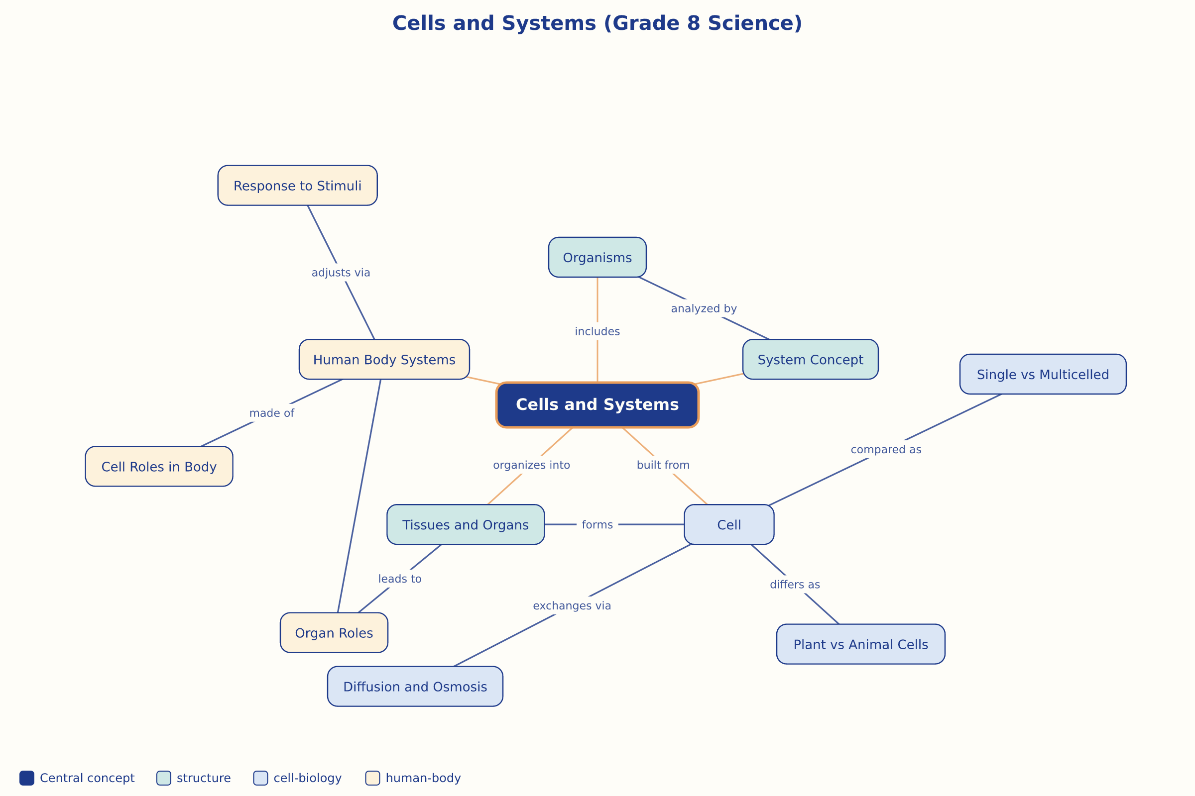

AILI word map · en · claude-sonnet-5 · 2026-09-17

