Enthalpy Changes and Calorimetry
Applying Q = mcΔt and ΔH notation to calorimetry data
Audience: Grade 12 Chemistry 30 students preparing for diploma examination content on thermochemical changes
Grades: Grade 12
Subjects: Chemistry 30
Time: about 60 minutes
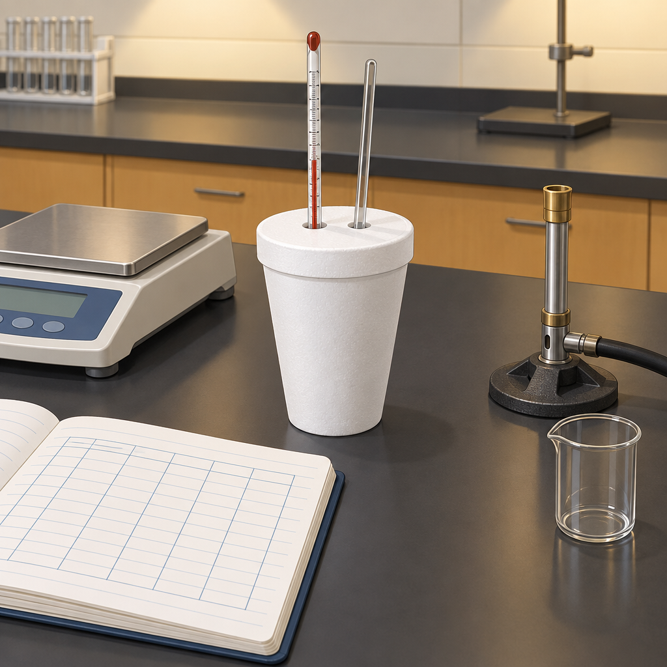

Overview
This lesson develops the quantitative link between measurable temperature change and enthalpy change in chemical reactions, a core relationship in Unit A: Thermochemical Changes (Topic). Students begin with a heat-transfer scenario, move through direct instruction on Q = mcΔt, enthalpy, molar enthalpy, and ΔH notation, and then apply calorimetry data to a worked combustion example modelled on a nut-calorimetry investigation (Resource).
The lesson closes with a small group task evaluating the precision of a simple polystyrene-cup calorimeter, drawing on the structure of a calorimeter-construction investigation (Resource), and an individual exit ticket that checks calculation fluency and correct sign conventions before the class moves on to Hess's law and molar enthalpies of formation (Resource).

Outcomes covered
- 30-A1.3k define enthalpy and molar enthalpy for chemical reactions (Outcome, Outcome)
Students need a precise definition of enthalpy and molar enthalpy to interpret thermochemical data correctly on diploma exam questions and in later work with Hess's law.
- 30-A1.1k recall the application of Q = mcΔt to the analysis of heat transfer (Outcome, Outcome)
Q = mcΔt is the quantitative tool that converts measured temperature and mass data into a usable heat value, forming the mathematical basis of every calorimetry calculation in the unit.
- 30-A1.8k use calorimetry data to determine the enthalpy changes in chemical reactions (Outcome)
Calorimetry is the primary experimental method chemists use to measure enthalpy changes, connecting laboratory measurement directly to the theoretical concept of enthalpy.
- 30-A1.5k use and interpret ΔH notation to communicate and calculate energy changes in chemical reactions (Outcome)
Correct use of ΔH notation, including sign convention for exothermic and endothermic processes, is required to communicate thermochemical results unambiguously and is directly assessed on the diploma exam.
- 30-A1.3s analyze data and apply mathematical and conceptual models to develop and assess possible solutions (Outcome)
Evaluating calorimeter precision and calculating percent error develops the skill of critically assessing experimental data against a mathematical model, a skill required across all science laboratory work.

Materials
- Thermometers or temperature probes
- Polystyrene cups for calorimeter construction or pre-built simple calorimeters
- Digital balance
- Sample calorimetry data handouts (nut combustion and NaOH dissolution scenarios)
- Calculators
- Whiteboard or projector for worked examples
- Exit ticket handout
- Chemistry data sheet (specific heat capacity of water and other reference values)

Sequence of activities

1. Activator: Hot Coffee, Cold Metal (8 min, whole class)
- Pose the scenario: a 250 g steel bolt at 95°C is dropped into 200 g of water at 20°C in an insulated cup. Ask students to predict, in words, what happens to the temperature of the water and the temperature of the bolt.
- Take three or four verbal predictions and record them on the board without judgment.
- Introduce the term calorimetry as the technique used to measure this kind of heat transfer experimentally (Outcome).
- Ask: what quantity would we need to measure with a thermometer, and what would we need to measure with a balance, to solve this problem? Elicit mass, initial temperature, final temperature.
- State the learning intentions and success criteria for the lesson.
This is a diagnostic check on prior knowledge of heat transfer direction (hot to cold) from Chemistry 20 or Science 10. Do not solve the problem yet; it is revisited in the worked example. Watch for the misconception that heat and temperature are the same quantity.
Sources: Outcome

2. Direct instruction: Q = mcΔt, enthalpy, and ΔH notation (15 min, whole class)
- Define heat transfer, Q, and derive the meaning of each term in Q = mcΔt: m is mass in grams, c is specific heat capacity in J/(g·°C), and Δt is the change in temperature (final minus initial), in °C (Outcome, Outcome).
- Give the specific heat capacity of water, c = 4.19 J/(g·°C), and note that this value is provided on the Alberta Chemistry data sheet in the diploma exam.
- Work through the bolt-and-water scenario from the activator: calculate Q absorbed by the water using m = 200 g, c = 4.19 J/(g·°C), and an assumed Δt = 8.9°C. Show that Q = 200 × 4.19 × 8.9 = 7458 J, so Q ≈ 7.5 kJ absorbed by the water.
- Define enthalpy (H) as the heat content of a system at constant pressure, and molar enthalpy (ΔHmolar) as the enthalpy change per mole of a specified substance in a reaction (Outcome, Outcome).
- Introduce ΔH notation: ΔH negative for exothermic reactions (heat released to surroundings) and ΔH positive for endothermic reactions (heat absorbed from surroundings). Show the two forms: ΔH = −7.5 kJ (exothermic) written beside the equation, or the equation written with energy as a term (Outcome).
- Recall the application of Q = mcΔt to the analysis of heat transfer. Explain the sign convention: Q for the surroundings (water) is positive when the surroundings warm up. ΔH for the system is negative because the reacting system lost energy. Apply Q = mcΔt to calculate heat transfer in a specific process.
- Check for understanding with a quick oral question: if a reaction's ΔH is +45 kJ/mol, is the reaction exothermic or endothermic? (endothermic)
Students often confuse the sign of Q for the water with the sign of ΔH for the reaction. Use the coffee-cup calorimeter diagram to physically separate 'system' (reaction) from 'surroundings' (water) and label signs on each side. Remind students that Δt = t_final − t_initial, and a negative Δt for a substance that cooled down is expected and correct.
Sources: Outcome, Outcome, Outcome, Outcome, Outcome

3. Worked example: calorimetry to find molar enthalpy of combustion (12 min, whole class)
- Present the data, modelled on a nut-combustion calorimetry investigation: burning 0.65 g of a peanut sample raises the temperature of 100.0 g of water from 21.0°C to 55.0°C in a simple calorimeter (Resource).
- Ask students to identify, with a partner for 90 seconds, which values go into Q = mcΔt.
- Calculate together: Δt = 55.0 − 21.0 = 34.0°C. Q = (100.0 g)(4.19 J/(g·°C))(34.0°C) = 14 246 J ≈ 14.2 kJ absorbed by the water.
- State that, by conservation of energy in an ideal calorimeter, the heat released by the combustion equals the heat absorbed by the water, so Q(reaction) = −14.2 kJ (Outcome).
- Convert to molar enthalpy: the peanut sample is mostly fat; approximate molar mass 880 g/mol for a triglyceride as a modelling assumption for this exercise. Moles burned = 0.65 g ÷ 880 g/mol = 7.4 × 10^−4 mol. Molar enthalpy = −14.2 kJ ÷ 7.4 × 10^−4 mol ≈ −1.9 × 10^4 kJ/mol.
- Discuss why this value is far from typical published values for fat combustion (heat loss to the surroundings, calorimeter absorbing heat, incomplete combustion), setting up the next activity on experimental error.
This worked example draws directly on the structure of the nut-calorimetry investigation described in Resource, which uses photographs, temperature and mass measurements, and guided calculations. If time allows, show any available images from that resource on the projector before doing the calculation. Emphasize units at every step; diploma exam markers deduct for missing or incorrect units.
Sources: Outcome, Outcome, Resource

4. Small group task: evaluating calorimeter precision and sources of error (15 min, small group)
- In groups of three, give each group a data table from a polystyrene-cup calorimeter trial (mass of water, initial and final temperature, mass and identity of substance reacted), modelled on the constructing-and-testing-a-calorimeter investigation (Resource).
- Each group calculates Q using Q = mcΔt, using the mass of the resulting solution (102.1 g) or the mass of water only (100.0 g); either choice is acceptable, though the mass of the resulting solution is the more rigorous convention.
- Groups then calculate molar enthalpy of the reaction using the given mass and molar mass of the reactant.
- Groups compare their calculated molar enthalpy to a reference literature value provided on a handout, then calculate percent error: percent error = |experimental − accepted| ÷ accepted × 100%.
- Groups list at least three sources of experimental error specific to a simple polystyrene-cup calorimeter (heat loss to surroundings, heat absorbed by the cup and thermometer, incomplete reaction, evaporation) and rank them by likely size of effect (Outcome, Outcome, Resource).
- Each group prepares one sentence stating a proposed improvement to the calorimeter design and how it would reduce a specific source of error.
- Use calorimetry data to determine the enthalpy changes in chemical reactions.
This task addresses Outcome by having students analyze data, apply the mathematical model (Q = mcΔt), and assess the quality of their solution against a reference value. Assign roles within groups (calculator, recorder, spokesperson) to keep all three students engaged in a 15-minute window. Circulate to check that Δt is calculated in the correct direction and that percent error is expressed as a positive value.
Sources: Outcome, Outcome, Resource

5. Consolidation and exit ticket (10 min, individual)
- Distribute a short exit ticket with two questions.
- Question 1: A 50.0 g sample of ethanol releases 6.46 kJ of heat as it cools from 78.0°C to 25.0°C. Calculate the specific heat capacity of ethanol. (Answer: c = 6460 J ÷ (50.0 g × 53.0°C) = 2.44 J/(g·°C).)
- Question 2: A student adds 2.10 g of NaOH(s) to 100.0 g of water in a calorimeter. The temperature rises from 22.5°C to 31.8°C. Calculate the molar enthalpy of dissolution of NaOH, including the correct sign, given molar mass of NaOH = 40.0 g/mol. (Answer: Q = 100.0 × 4.19 × 9.3 = 3897 J absorbed by water; moles NaOH = 2.10 ÷ 40.0 = 0.0525 mol; ΔH = −3897 J ÷ 0.0525 mol = −74 200 J/mol ≈ −74.2 kJ/mol, exothermic. Note: using the mass of the resulting solution (102.1 g) is also acceptable.)
- Students submit the exit ticket individually as a formative check before leaving.
- Briefly preview that the next lesson extends this reasoning to Hess's law and standard molar enthalpies of formation, mentioned as a related topic in the unit overview (Resource).
Use the exit ticket to identify students who need support before the next lesson on Hess's law. Common errors to watch for: forgetting to convert grams to moles, applying the wrong sign to ΔH, and mixing up which mass belongs in Q = mcΔt when a solid is added to water.
Sources: Outcome, Outcome, Outcome, Outcome, Outcome, Resource

Differentiation
Extension
- Ask students to derive an expression for the heat absorbed by the calorimeter itself (calorimeter constant) and to redo the molar enthalpy calculation in the worked example accounting for this correction.
- Have students research the accepted molar enthalpy of combustion for a fat or hydrocarbon fuel and calculate the percent error of the class worked example against that literature value, then propose a redesigned experimental procedure to reduce the error.
- Challenge students to explain, using particle-level reasoning, why specific heat capacity differs between water and metals, connecting this to bonding and heat capacity data on the Chemistry data sheet.
Support
- Provide a filled-in template of Q = mcΔt with labelled boxes for m, c, and Δt so students can substitute values without reformatting the equation each time.
- Pre-highlight which numbers in a word problem correspond to m, c, and Δt using colour coding on the handout.
- Allow use of a calculator and a written step-by-step checklist (identify knowns, write formula, substitute, solve, check units) during the small group task and exit ticket.
Inclusive supports
- Offer the exit ticket in both written and verbal formats for students who benefit from talking through their reasoning with the teacher.
- Provide sentence starters for the group discussion, such as 'One source of error in our calorimeter was... because...', to support students who need scaffolding for academic discussion.
- Ensure group composition mixes confidence levels in mathematics so no group is without a member comfortable with unit conversions.

Assessment
Formative. Oral questioning during direct instruction, checking whether students can identify the sign of ΔH given a description of a reaction as exothermic or endothermic.
Look for: Correct identification of exothermic versus endothermic from a stated ΔH value or verbal description, with a brief justification referencing energy flow into or out of the system. (Outcome)
Formative. Circulation and questioning during the small group calorimetry task, checking that groups correctly apply Q = mcΔt and calculate percent error.
Look for: Group data tables show correct substitution of mass, specific heat capacity, and Δt into the formula, correct unit conversions, and a percent error calculated with the correct formula and a positive result. (Outcome, Outcome, Outcome)
Formative. Exit ticket with two calculation questions: one solving for specific heat capacity from calorimetry data, and one solving for molar enthalpy of dissolution with correct sign convention.
Look for: Correct numerical answers with units shown at each step, correct sign on the molar enthalpy value, and moles calculated using molar mass before dividing into Q. (Outcome, Outcome, Outcome, Outcome, Outcome)

Vocabulary
- Enthalpy (H): The heat content of a system at constant pressure; enthalpy change (ΔH) describes the energy absorbed or released during a chemical reaction.
- Molar enthalpy: The enthalpy change associated with a reaction expressed per mole of a specified reactant or product, typically reported in kJ/mol.
- Calorimetry: An experimental technique used to measure the quantity of heat transferred during a physical or chemical process, typically by monitoring the temperature change of a known mass of surroundings such as water.
- Q = mcΔt: The equation relating heat transferred (Q, in joules) to mass (m, in grams), specific heat capacity (c, in J/(g·°C)), and temperature change (Δt, in °C).
- ΔH notation: A convention for writing enthalpy change beside a balanced chemical equation, using a negative sign for exothermic reactions and a positive sign for endothermic reactions.
- Percent error: A measure of the accuracy of an experimental result compared with an accepted value, calculated as the absolute difference between experimental and accepted values divided by the accepted value, multiplied by 100%.

Sources
- Outcome: "30-A1.3k define enthalpy and molar enthalpy for chemical reactions"
- Outcome: "30-A1.1k recall the application of Q = mcΔt to the analysis of heat transfer"
- Outcome: "30-A1.8k use calorimetry data to determine the enthalpy changes in chemical reactions"
- Outcome: "30-A1.1k recall the application of Q = mcΔt to the analysis of heat transfer"
- Outcome: "30-A1.3k define enthalpy and molar enthalpy for chemical reactions"
- Outcome: "30-A1.5k use and interpret ΔH notation to communicate and calculate energy changes in chemical reactions"
- Topic: "Students will determine and interpret energy changes in chemical reactions."
- Outcome: "30-A1.3s analyze data and apply mathematical and conceptual models to develop and assess possible solutions"
- Resource: "This unit covers calorimetry, enthalpy changes, Hess's law, molar enthalpies of formation, and energy diagrams, with applications in sustainable energy and fuel evaluation."
- Resource: "This lab presents a multimedia investigation of calorimetry by examining how burning a nut transfers thermal energy to water."
- Resource: "This lab presents a guided investigation of building a polystyrene-cup calorimeter and evaluating the calorimeter's performance by measuring temperature changes during mixing."

All laboratory scenarios described are standard low-hazard calorimetry procedures appropriate for a Grade 12 chemistry classroom, and no content raises age-appropriateness or cultural sensitivity concerns.

AILI detailed pack · en · claude-sonnet-5 · 2026-09-17

