Energy Flow in Technological Systems
Science 10, Unit B: Thermodynamics, Mechanical Energy, and Efficiency

Slide 1: Energy Flow in Technological Systems
Science 10, Unit B: thermodynamics, efficiency, and energy conversion devices
Sources: Topic
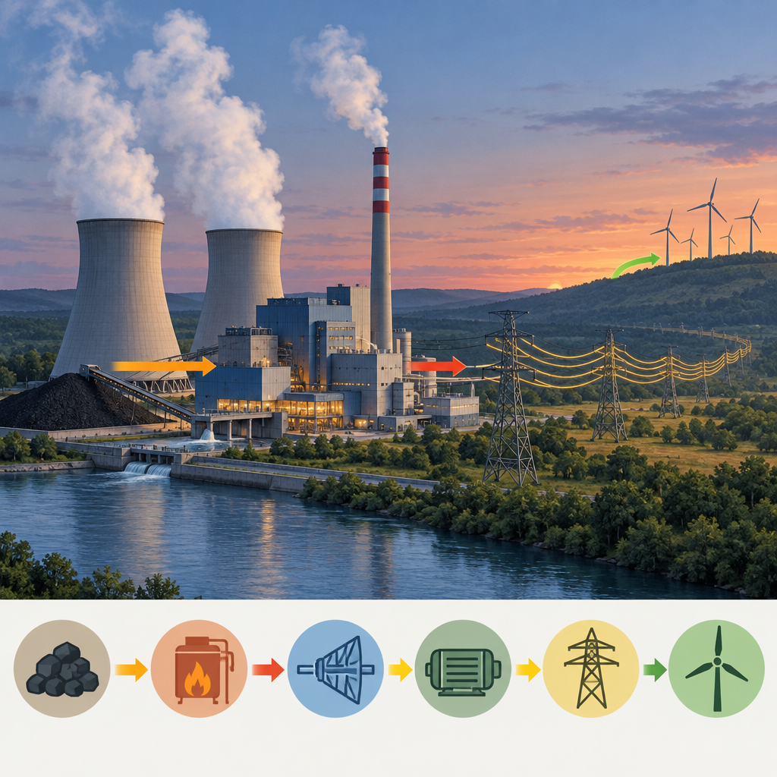
Notes: Introduce the unit by framing energy flow as the central idea linking mechanics, thermodynamics, and technology design. Preview that students will move from qualitative descriptions of energy forms to quantitative efficiency calculations.

Slide 2: Learning Intentions and Success Criteria
- I can illustrate how energy exists in multiple forms in natural and technological systems (Outcome).
- I can describe how energy transfer technologies produce measurable changes in motion, shape, or temperature (Outcome).
- I can explain, quantitatively, efficiency as useful work compared to total energy input (Outcome).
- I can apply the first and second laws of thermodynamics to explain why no conversion is 100% efficient (Outcome).
- I can relate Ep = mgh, W = Fd, and Ek = 1/2 mv^2 to energy transformations in a system (Outcome).
Sources: Outcome, Outcome, Outcome
Notes: Read success criteria aloud and connect each to an upcoming activity: form-of-energy sort, efficiency lab, and mechanical energy calculation problems. Post criteria on the wall for students to self-assess against by end of unit.

Slide 3: Tracing Energy Through a Hydroelectric System
- Gravitational potential energy: Water stored behind the dam has potential energy due to elevation (Outcome).
- Kinetic energy of falling water: Water falls and gains kinetic energy as it moves through the penstock (Outcome).
- Mechanical energy in turbine: Moving water turns the turbine blades, converting kinetic energy to mechanical rotation (Outcome).
- Electrical energy in generator: The generator converts mechanical energy into electrical energy for transmission (Outcome).
- Useful energy vs. losses: At each stage, some energy converts to non-useful heat, so overall efficiency is less than 100% (Outcome).
Sources: Outcome, Outcome, Outcome, Outcome
Notes: Use this flowchart as a model before students trace their own system, such as energy flow from the Sun to the school lighting system, per Outcome. Emphasize that this is a stage-by-stage useful-energy analysis, an operational skill outlined in Outcome.

Slide 4: First and Second Laws in Everyday Devices
First Law: Conservation
Energy is neither created nor destroyed during a conversion; total energy in equals total energy out for a system such as an automobile engine or a heat pump (Outcome). This principle is the basis for delta E = W, the relationship between work done on a system and its change in energy (Outcome).
Second Law: Degradation of Useful Energy
Some input energy always converts to non-useful heat, which is why heat engines can never reach 100% efficiency (Outcome). This limit explains why designers of high-efficiency furnaces and automobile engines focus on minimizing these losses rather than eliminating them (Outcome).
Sources: Outcome, Outcome, Outcome
Notes: Contrast the two laws directly: conservation tells us energy totals balance, while the second law tells us the form of that energy limits what we can use. Connect to James Watt's engine improvements and modern valve design as historical examples of chasing efficiency gains within these constraints (Outcome).

Slide 5: Case Study: Efficiency of a Thermal Power Plant
Alberta's thermal power plants convert chemical potential energy stored in fuel into thermal energy, then into mechanical energy, and finally into electrical energy. At each stage, some energy escapes as waste heat rather than becoming useful electrical output (Outcome). Comparing coal and natural gas requires weighing energy content, cost, efficiency, and sustainability side by side, then judging which fuel better protects the environment while making reasonable use of natural resources (Outcome).
Comparing coal and natural gas generation in Alberta
Alberta's thermal power plants convert chemical potential energy stored in fuel into thermal energy, then into mechanical energy, and finally into electrical energy. At each stage, some energy escapes as waste heat rather than becoming useful electrical output (Outcome). Comparing coal and natural gas requires weighing energy content, cost, efficiency, and sustainability side by side, then judging which fuel better protects the environment while making reasonable use of natural resources (Outcome).
Sources: Outcome, Outcome, Outcome
Notes: Have students research energy content data for Alberta fuels, as suggested in Outcome, then build a short comparison table of cost, efficiency, and sustainability. Extension: ask students to propose alternative solutions and weigh strengths and weaknesses, per the analyzing and interpreting skill outcome in Outcome. Support: provide a partially completed table with fuel names and one data column filled in.

Slide 6: Bringing It Together
Summary: Energy exists in many forms and moves through technological systems in traceable stages, with useful energy diminishing at every conversion because of the second law of thermodynamics (Topic). Quantitative tools such as Ep = mgh, Ek = 1/2 mv^2, and the efficiency ratio let us measure and compare how well real devices perform (Outcome, Outcome). Efficiency and sustainability matter because they determine how well a technology protects the environment and conserves natural resources (Outcome).
Question: If you designed a more efficient version of one device you traced today, which stage of energy loss would you target first, and what evidence would you collect to test your design?
Sources: Topic, Outcome, Outcome, Outcome
Notes: Use the closing question as an exit ticket or as the seed for the unit's culminating design project, referencing the construct-and-test-a-prototype skill outcome in Outcome. Collect responses to check for misconceptions about energy being used up rather than degraded in usefulness.

AILI presentation · en · claude-sonnet-5 · 2026-09-17

