Adding and Subtracting Within 100
We are learning to add and subtract two-digit numbers by breaking them into tens and ones.
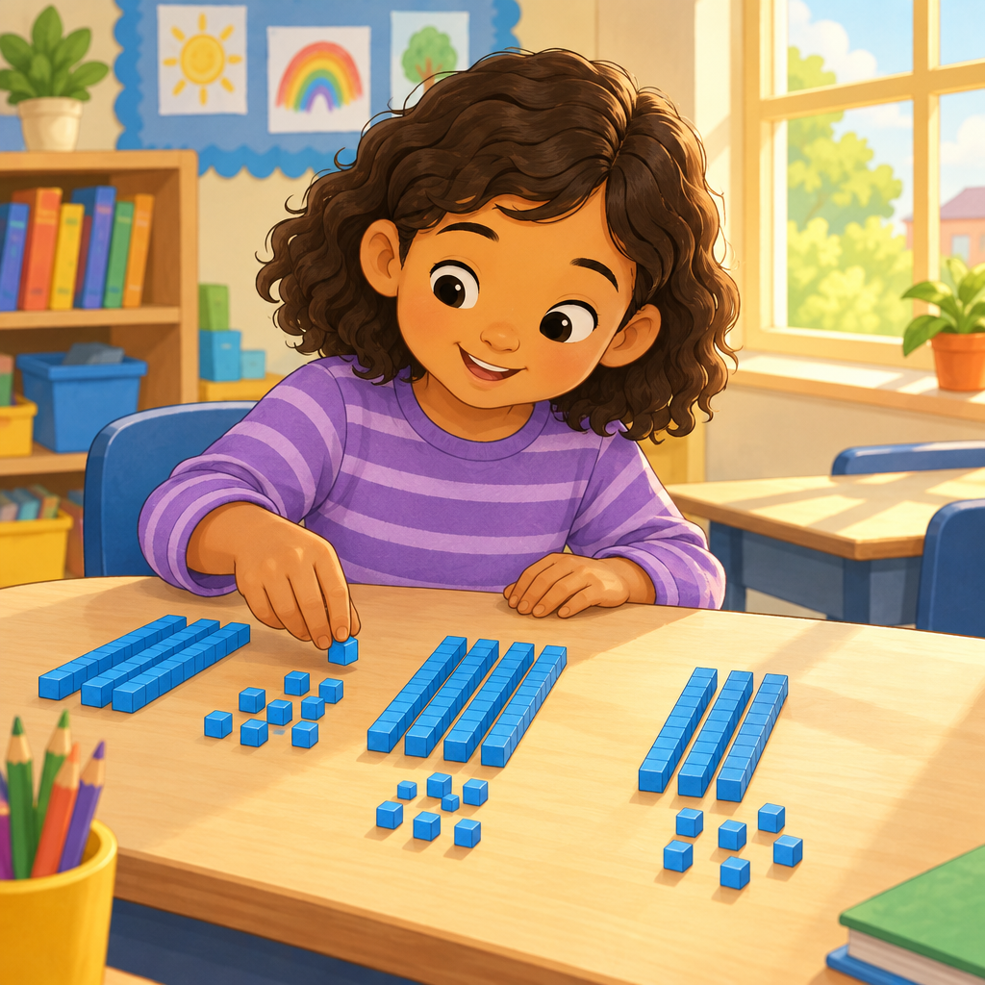

Learning intentions
We are learning to add and subtract numbers up to 100 (Outcome).
We are learning to use tens and ones to solve addition and subtraction problems (Knowledge).

Success criteria
I can add two-digit numbers by breaking them into tens and ones.
I can subtract two-digit numbers by breaking them into tens and ones.
I can show my work using pictures, numbers, or objects.

Curriculum alignment
Students investigate addition and subtraction within 100 (Outcome).
Familiar addition and subtraction number facts facilitate addition and subtraction strategies (Knowledge).
Addition and subtraction strategies for two-digit numbers include making multiples of ten and using doubles (Knowledge).
Investigate strategies for addition and subtraction of two-digit numbers (Skills).
Add numbers up to a sum of 100 and subtract numbers with a maximum minuend of 100 (Skills).

Materials
Base-ten blocks (tens rods and ones cubes) or bundled straws for each pair.
Number line (0 to 100) on chart paper or whiteboard.
Whiteboard and markers for demonstration.
Practice worksheet with 6 problems (two-digit addition and subtraction).
Small counters or beans (optional, for counting on).

Lesson sequence
1. Hook (5 minutes)
Show the class a pile of 23 counters or beans in a cup.
Ask: How many do you think are in here?
Pour them out and count together by tens and ones. Make two piles: one pile of 10s and one pile of 1s.
Say: I have 2 tens and 3 ones. That makes 23.
Ask: If I add 15 more, how many will I have altogether?
Tell the class: Today we are going to add and subtract big numbers by using tens and ones.
2. Direct instruction (10 minutes)
Write on the board: 24 + 13 =?
Say: Let me break this into tens and ones. 24 is 2 tens and 4 ones. 13 is 1 ten and 3 ones.
Use base-ten blocks or draw quick pictures on the board. Show 2 long rods (tens) and 4 small cubes (ones) for 24. Show 1 long rod (ten) and 3 small cubes (ones) for 13.
Say: Now I add the tens together. 2 tens and 1 ten makes 3 tens. That is 30.
Say: Now I add the ones together. 4 ones and 3 ones makes 7 ones.
Say: 30 and 7 makes 37. So 24 + 13 = 37.
Write the answer on the board.
Repeat with a subtraction example: 35 − 12 =?
Say: 35 is 3 tens and 5 ones. 12 is 1 ten and 2 ones.
Show with blocks or pictures.
Say: I subtract the tens. 3 tens take away 1 ten leaves 2 tens. That is 20.
Say: I subtract the ones. 5 ones take away 2 ones leaves 3 ones.
Say: 20 and 3 makes 23. So 35 − 12 = 23.
3. Guided practice (12 minutes)
Work through two problems together as a class. Give each student or pair base-ten blocks.
Problem 1: 32 + 14 =?
Say: Show me 32 with your blocks. How many tens? How many ones?
Wait for students to show 3 tens and 2 ones.
Say: Now show me 14. How many tens? How many ones?
Wait for students to show 1 ten and 4 ones.
Say: Push the tens together. How many tens do you have now?
Let them count: 4 tens.
Say: Push the ones together. How many ones do you have now?
Let them count: 6 ones.
Say: 4 tens and 6 ones makes 46. Write it down: 32 + 14 = 46.
Problem 2: 28 − 15 =?
Say: Show me 28 with your blocks. How many tens? How many ones?
Wait for students to show 2 tens and 8 ones.
Say: Now I want to take away 15. That is 1 ten and 5 ones. Take away 1 ten from your tens. What do you have left?
Let them show 1 ten.
Say: Now take away 5 ones from your ones. What do you have left?
Let them show 3 ones.
Say: 1 ten and 3 ones makes 13. Write it down: 28 − 15 = 13.
4. Independent practice (10 minutes)
Give each student or pair a worksheet with six problems. Problems should include:
Two addition problems: 21 + 16 =?, 33 + 24 =?
Two subtraction problems: 37 − 13 =?, 45 − 22 =?
Two mixed problems: 19 + 20 =?, 50 − 30 =?
Say: Use your blocks to help you. Break each number into tens and ones. Add or subtract the tens. Add or subtract the ones. Write your answer.
Circulate and ask students: How many tens do you have? How many ones? What do you get when you put them together?
5. Consolidation (3 minutes)
Gather the class together.
Ask three students to share one of their answers and how they solved it.
Ask: What did you do first? What did you do next?
Listen for: break into tens and ones, add or subtract the tens, add or subtract the ones, put them together.
Say: You all did a great job breaking numbers into tens and ones. That is a smart way to add and subtract big numbers.

Differentiation
Extension
Give students problems where the sum is exactly 100 or close to it: 47 + 53 =?, 60 + 40 =?.
Ask: Can you make 100 in more than one way? For example, 50 + 50 = 100. What else makes 100?
This connects to visualizing 100 as a composition of multiples of 10 in various ways (Skills).
Support
Provide pre-made base-ten blocks or bundles of straws so students do not have to count out the tens.
Use numbers with smaller ones digits first: 20 + 13 =?, 30 − 10 =?.
Pair the student with a peer who can model the strategy first.
Allow students to use a number line to count on or count back if blocks feel overwhelming.

Assessment
Formative check during independent practice:
Observe students as they work. Ask each student: Show me 23 + 14 with your blocks. How many tens do you have? How many ones? What is the answer?
Look for:
- Student correctly breaks the first number into tens and ones.
- Student correctly breaks the second number into tens and ones.
- Student combines the tens and combines the ones separately.
- Student arrives at the correct sum or difference.
If a student struggles, ask: How many tens is 23? (Pause.) How many ones? (Pause.) Now show me 14. How many tens? How many ones?
If a student is secure, ask: Can you show me another way to make 37? (This checks understanding that a sum can be composed in multiple ways, Understanding.)

AILI rapid lesson · en · claude-haiku-4-5-20251001 · 2026-09-17

