Food Chains: How Plants and Animals Depend on Each Other
Plants and animals need each other to survive, and we can show how with food chains.
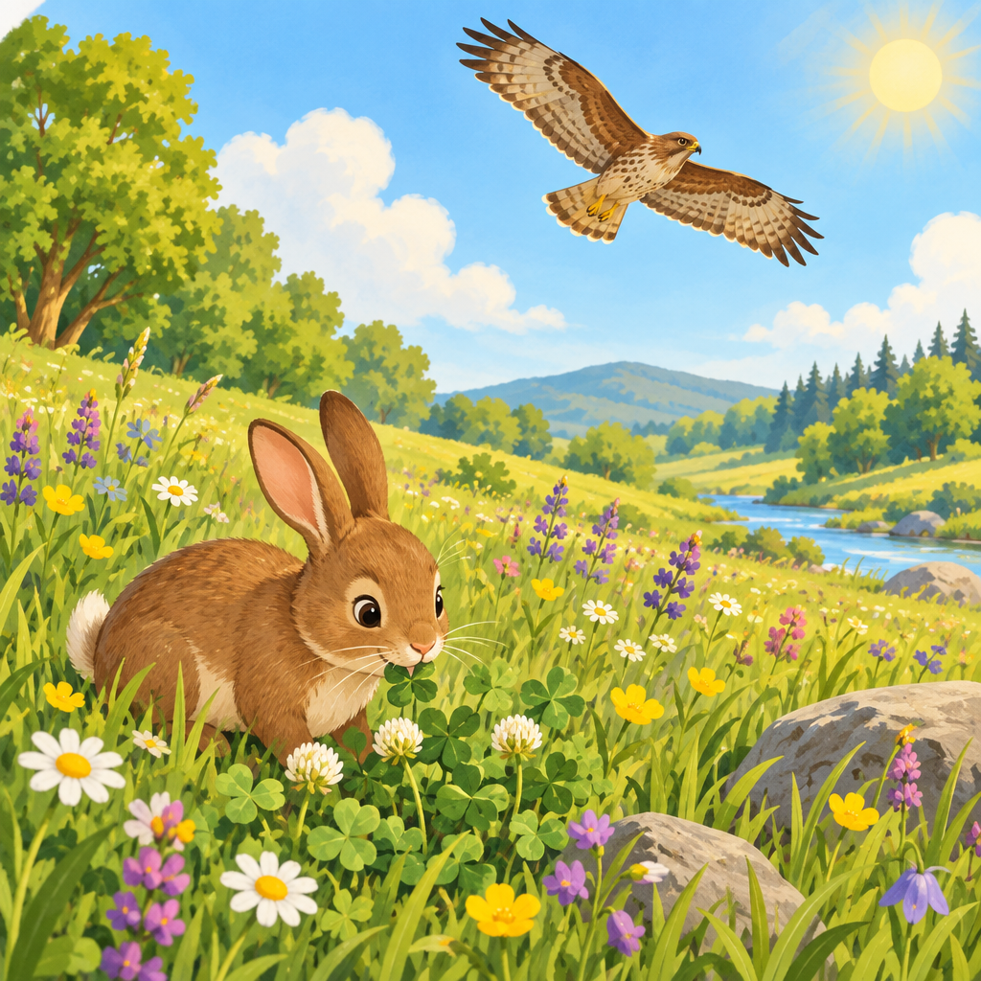

Learning intentions
We are learning to understand how plants and animals depend on each other for food.
We are learning to represent food chains in different ways.

Success criteria
I can name what each animal eats in a food chain.
I can sort animals into groups: herbivores, carnivores, and omnivores.
I can draw or write a food chain to show how plants and animals connect.

Curriculum alignment
Students analyze and describe how plants and animals interact with each other and within environments (Outcome).
A food chain shows the order in which plants and animals depend on each other for food (Knowledge).
Animals can be classified as carnivores, herbivores, or omnivores based on what they eat (Understanding).
Plants and animals interact with each other in various environments in ways that can be represented with food chains (Understanding).

Materials
- Chart paper and markers
- Picture cards of plants and animals (grass, clover, rabbit, fox, mouse, owl, seeds, deer, bear, fish, bird)
- Large index cards or paper strips for building food chains
- Crayons or coloured pencils
- Worksheet with three columns labelled "Herbivore," "Carnivore," and "Omnivore"
- Optional: string or yarn to connect food chain pictures on a display

Lesson sequence
1. Hook (5 minutes)
Show the picture of a rabbit and ask: "What does a rabbit eat?" (Grass, clover, plants.)
Then show a picture of a fox and ask: "What does a fox eat?" (Meat, including rabbits.)
Ask: "How do these two animals connect?" Guide students to see that the rabbit eats plants, and the fox eats the rabbit. Say: "That connection is called a food chain. Today we are going to build food chains and learn how plants and animals depend on each other."
2. Direct instruction: What is a food chain? (8 minutes)
Explain: "A food chain shows the order in which plants and animals depend on each other for food" (Knowledge).
Draw a simple food chain on chart paper:
Grass → Rabbit → Fox
Point to each picture and say: "The grass is food for the rabbit. The rabbit is food for the fox. This is a food chain."
Explain: "Every food chain starts with a plant. Plants and animals depend on each other for food in a food chain. Then an animal eats the plant. Then another animal eats that animal."
Ask: "What would happen if there were no grass? The rabbit would have no food. What would happen if there were no rabbits? The fox would have no food. Plants and animals need each other."
3. Direct instruction: Three types of eaters (8 minutes)
Introduce the three groups (Knowledge):
"Animals eat different things. We sort them into three groups."
Write on chart paper:
Herbivores eat only plants. Examples: rabbit, deer, mouse, grasshopper.
Carnivores eat mostly meat. Examples: fox, owl, hawk, lion.
Omnivores eat both plants and meat. Examples: bear, human, chicken, pig.
Show picture cards one at a time. Say the animal's name and ask the class: "What does it eat? Is it a herbivore, carnivore, or omnivore?"
Rabbit: herbivore (eats plants).
Fox: carnivore (eats meat).
Bear: omnivore (eats plants and fish).
4. Guided practice: Build a food chain together (10 minutes)
Place picture cards on a table where all students can see them: grass, mouse, owl.
Say: "Let's build a food chain together. Which comes first?" (Grass. Plants always start a food chain.)
Place the grass card at the left.
Ask: "What eats grass?" (Mouse.) Place the mouse card next.
Ask: "What eats the mouse?" (Owl.) Place the owl card at the end.
Draw arrows between them on the board:
Grass → Mouse → Owl
Say: "This food chain shows us that the mouse depends on grass for food, and the owl depends on the mouse for food."
Repeat with a second example using different animals (for example, clover → rabbit → fox).
5. Independent practice: Sort animals and build a chain (7 minutes)
Give each student a worksheet with three columns: "Herbivore," "Carnivore," and "Omnivore."
Call out animal names one at a time: rabbit, lion, bear, sheep, eagle, pig, cow, snake.
Students write or draw each animal in the correct column.
Then give students a set of picture cards (or ask them to draw) to build their own food chain. Provide a simple template:
___________ → ___________ → ___________
Students arrange the cards or draw the animals in order. Remind them: "Start with a plant. Then an animal that eats the plant. Then an animal that eats that animal."
6. Consolidation (2 minutes)
Gather the class. Ask three students to share their food chains. For each one, ask: "Which animal is the herbivore? Which is the carnivore?"
Remind students: "Every living thing in a food chain depends on the others. Plants feed animals. Animals feed other animals. That is how nature works."

Differentiation
Support
Provide a smaller set of picture cards (four to six animals) so students are not overwhelmed by choice.
Use real photos or very clear pictures so students can see what each animal looks like.
Pair the student with a partner to build the food chain together.
Read the animal names aloud and let the student point to the correct column on the worksheet instead of writing.
Extension
Ask students to build a food chain with four or five links instead of three (for example, grass → grasshopper → mouse → owl → eagle).
Ask: "Can you find two different food chains that share one animal?" (For example, grass → rabbit → fox and grass → rabbit → eagle both have rabbit.)
Challenge students to draw a food web, where multiple food chains overlap and animals eat more than one thing.
Ask: "What would happen if all the grass disappeared? Which animals would be affected first? Which would be affected next?"

Assessment
Formative checkpoint (during independent practice)
Observe as students sort animals into the three groups.
Look for: Can the student correctly identify what each animal eats? Do they understand that herbivores eat plants, carnivores eat meat, and omnivores eat both?
Ask each student: "Tell me one animal that is a herbivore. What does it eat?" Listen for a plant-eating animal and a reason based on food.
Ask: "Show me your food chain. Which animal eats the plant? Which animal eats that animal?" Listen for correct order and reasoning.
If a student struggles, point to the picture and ask: "Does a rabbit eat meat or plants?" to guide them back to the correct answer.

AILI rapid lesson · en · claude-haiku-4-5-20251001 · 2026-09-17

