Enthalpy Changes and Calorimetry
Using measured temperature changes to calculate the heat absorbed or released in a chemical reaction.
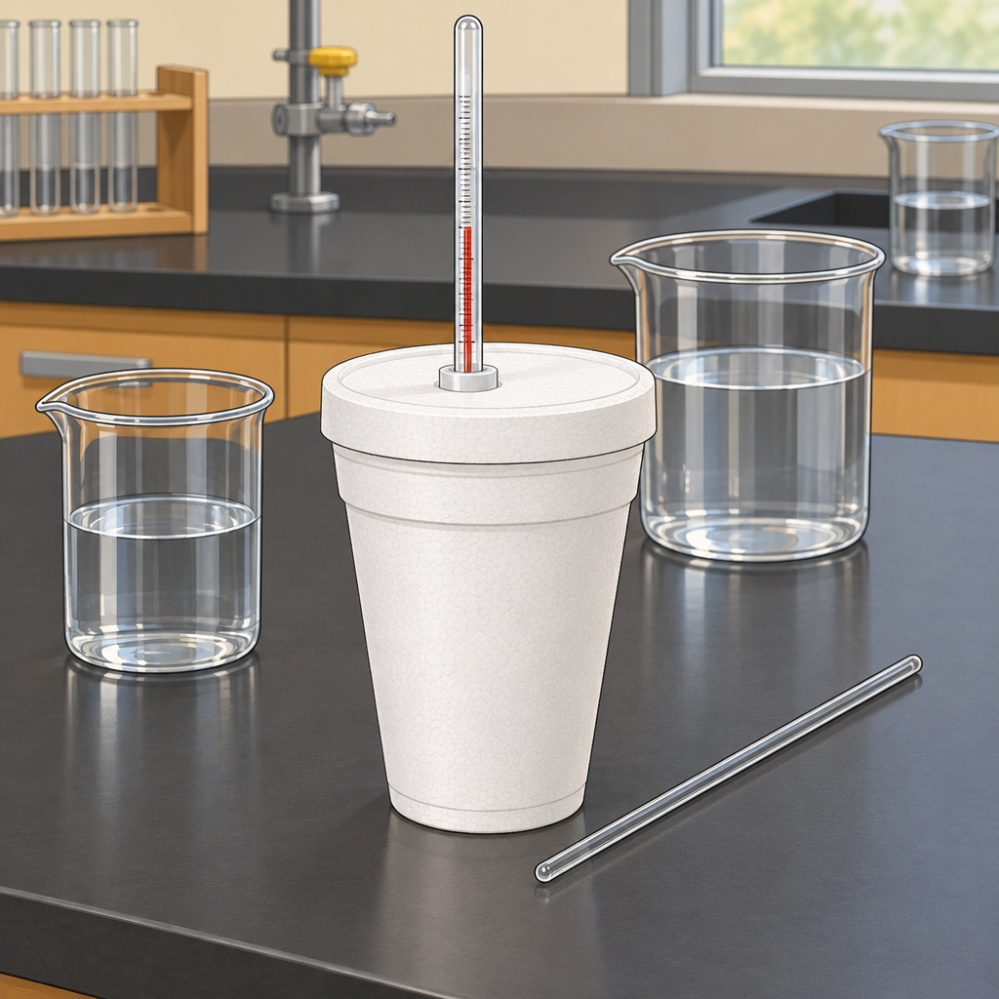

Learning intentions
We are learning to calculate enthalpy changes from calorimetry data and to express those changes using correct ΔH notation.

Success criteria
I can define enthalpy and molar enthalpy for a chemical reaction.
I can apply Q = mcΔt to calculate heat transfer in a calorimetry experiment.
I can use calorimetry data to determine the enthalpy change of a reaction and express the result with ΔH notation.

Curriculum alignment
- Determine and interpret energy changes in chemical reactions (Topic).
- Define enthalpy and molar enthalpy for chemical reactions (Outcome).
- Recall the application of Q = mcΔt to the analysis of heat transfer (Outcome).
- Use calorimetry data to determine the enthalpy changes in chemical reactions (Outcome).
- Use and interpret ΔH notation to communicate and calculate energy changes in chemical reactions (Outcome).

Materials
- Whiteboard or projector for worked examples
- Student notebooks or worksheet with blank calorimetry problems
- Scientific calculators
- One set of demonstration calorimetry data (mass of water, initial and final temperature, mass or moles of reactant) written on the board or a handout
- Optional: a polystyrene-cup calorimeter, thermometer, and hot water for a quick visual demonstration (not a full lab)

Lesson sequence
1. Hook (5 minutes)
Write this scenario on the board: "A student places 50.0 g of hot metal into 100.0 g of water in an insulated cup. The water temperature rises from 20.0°C to 24.5°C." Ask the class: "Where did that energy come from, and where did it go?" Take two or three verbal answers without correcting them yet. Then ask: "If I told you the specific heat capacity of water is 4.19 J/(g·°C), could you figure out how much energy the water absorbed?" Let students sit with the question before moving to instruction.
2. Direct instruction (10 minutes)
State the definitions clearly: "Enthalpy, H, is the heat content of a system at constant pressure. We cannot measure H directly, but we can measure ΔH, the change in enthalpy, which equals the heat absorbed or released during a reaction at constant pressure" (Outcome). Write ΔH on the board and explain the sign convention: negative ΔH means the reaction releases heat (exothermic), positive ΔH means the reaction absorbs heat (endothermic).
Introduce molar enthalpy: "Molar enthalpy is the enthalpy change per mole of a specified substance in the reaction, expressed in kJ/mol" (Outcome, Outcome).
Write the calorimetry equation on the board: Q = mcΔt, where Q is heat in joules, m is the mass of the substance absorbing or releasing heat (usually water), c is the specific heat capacity in J/(g·°C), and Δt is the change in temperature in °C (Outcome).
Explain the link between the two ideas: "In a calorimeter, the heat gained or lost by the water equals in magnitude the heat lost or gained by the reaction, but the sign is reversed. That heat, converted to a per-mole basis, gives us ΔH for the reaction" (Outcome).
Work through the hook scenario as a full example on the board:
Q(water) = mcΔt = (100.0 g)(4.19 J/(g·°C))(24.5°C − 20.0°C)
Q(water) = (100.0 g)(4.19 J/(g·°C))(4.5°C)
Q(water) = 1885.5 J, or about 1.9 kJ
State: "The water absorbed about 1.9 kJ, so the metal released about 1.9 kJ. For the metal, Q = −1.9 kJ."
3. Guided practice (10 minutes)
Present this problem and solve it together, calling on students for each step: "In a calorimetry experiment, 2.50 g of a solid fuel is burned under a container holding 200.0 g of water. The water temperature rises from 22.0°C to 38.0°C. Calculate the heat absorbed by the water, then calculate the molar enthalpy of combustion if the fuel has a molar mass of 46.07 g/mol."
Ask students to calculate Δt first: "What is Δt here?" (16.0°C)
Ask a student to calculate Q: "Q = mcΔt = (200.0 g)(4.19 J/(g·°C))(16.0°C). What do you get?" (13 408 J, or about 13.4 kJ)
Ask: "How many moles of fuel burned?" (2.50 g ÷ 46.07 g/mol = 0.0543 mol)
Ask: "How do we get molar enthalpy?" (Divide the heat released by moles burned: 13.4 kJ ÷ 0.0543 mol = about 247 kJ/mol)
Finish by writing the answer with correct notation and sign: "ΔH = −247 kJ/mol, because the reaction releases heat" (Outcome, Outcome). Check that students understand why the sign flips from the water's positive Q to the reaction's negative ΔH.
4. Independent practice (10 minutes)
Assign this problem for students to solve individually or in pairs, writing full solutions in their notebooks:
"A 1.20 g sample of ethanol is burned in a calorimeter containing 250.0 g of water. The water temperature increases from 21.5°C to 35.0°C. The molar mass of ethanol is 46.07 g/mol.
a) Calculate the heat absorbed by the water.
b) Calculate the moles of ethanol burned.
c) Calculate the molar enthalpy of combustion of ethanol, and express it as ΔH with correct sign and units."
Circulate while students work. Watch for students forgetting to convert grams to moles before dividing, and for students dropping or misapplying the negative sign on ΔH.
Diagram 2: A close-up diagram-style illustration of a thermometer showing a rising mercury or digital reading beside a small flame under a metal.
5. Consolidation (5 minutes)
Bring the class back together. Ask one pair to share their answer for part c) and write it on the board. Confirm the expected answer: Q(water) is about 14 137 J (14.1 kJ), moles of ethanol is about 0.0261 mol, and ΔH is about −543 kJ/mol.
Ask the class: "Why is the sign negative here?" and "What would change in our calculation if the reaction were endothermic instead?" Close by connecting to the next lesson: tomorrow's lab uses this exact method to measure the enthalpy of a real combustion reaction with a nut sample (Resource), and a later lab will test how precise a homemade calorimeter actually is (Resource).

Differentiation
Extension: Ask early finishers to research and compare their calculated molar enthalpy of combustion for ethanol against an accepted literature value, then calculate percent error and suggest one source of experimental error in a calorimetry setup (heat loss to surroundings, incomplete combustion, or heat absorbed by the calorimeter itself).
Support: Provide a printed step-by-step template with labelled blanks (Δt =, Q =, moles =, ΔH =) so students can fill in one calculation at a time rather than tracking the full sequence unaided. Pair struggling students with a peer for the independent practice question rather than requiring solo work.

Assessment
Formative check: collect or visually scan the independent practice solutions (ethanol problem) as students finish.
Look for:
- Correct calculation of Δt (final minus initial temperature)
- Correct substitution into Q = mcΔt with consistent units
- Correct conversion from grams to moles using molar mass
- Correct division of heat by moles to find molar enthalpy
- Correct sign on the final ΔH value, matching the exothermic nature of combustion
Students who make the sign error consistently, or who skip the mole conversion, need a short reteach at the start of the next class before moving into the hands-on calorimetry lab.

AILI rapid lesson · en · claude-sonnet-5 · 2026-09-17

