The Mystery Sticker Boxes
This game uses addition and subtraction within 100, the focus for Grade 2 learners (Outcome). It asks you to find two numbers that add up a certain way, just like the guiding question about interpreting addition and subtraction (Guiding question). You will compose a sum in more than one way to solve it (Details), using number facts you already know (Topic).
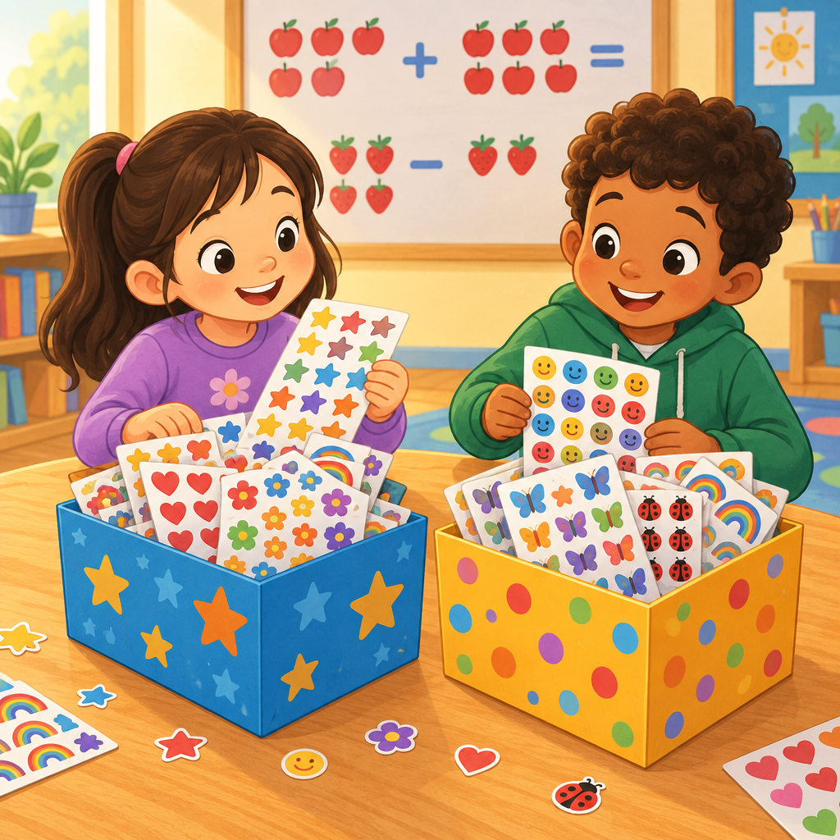

The puzzle
Mia and Sam share two boxes of stickers.
Together, the two boxes hold 100 stickers.
One box has 20 more stickers than the other box.
How many stickers are in each box?
Write both numbers. Show how you know they are correct.

Hints
Hint 1: Two numbers add up to 100. One number is bigger than the other.
Hint 2: The bigger number is exactly 20 more than the smaller number. Try picking a small number, then add 20 to get the bigger number. Do the two numbers add to 100?
Hint 3: If the smaller box has a stickers, the bigger box has a + 20 stickers. Add them together: a + (a + 20) = 100. Try a = 30. Try a = 40. Which one works?

Answer key
The boxes have 40 stickers and 60 stickers.
Check the sum: 40 + 60 = 100.
Check the difference: 60 − 40 = 20.
Both clues match, so this is the answer. This puzzle works because a sum within 100 can be built from two parts in many ways, but only one pair of parts also matches the difference clue (Details, Outcome).

AILI game · en · claude-sonnet-5 · 2026-09-17

