Enthalpy Changes and Calorimetry
Students measure heat transfer in a chemical reaction and use calorimetry data to calculate enthalpy change.
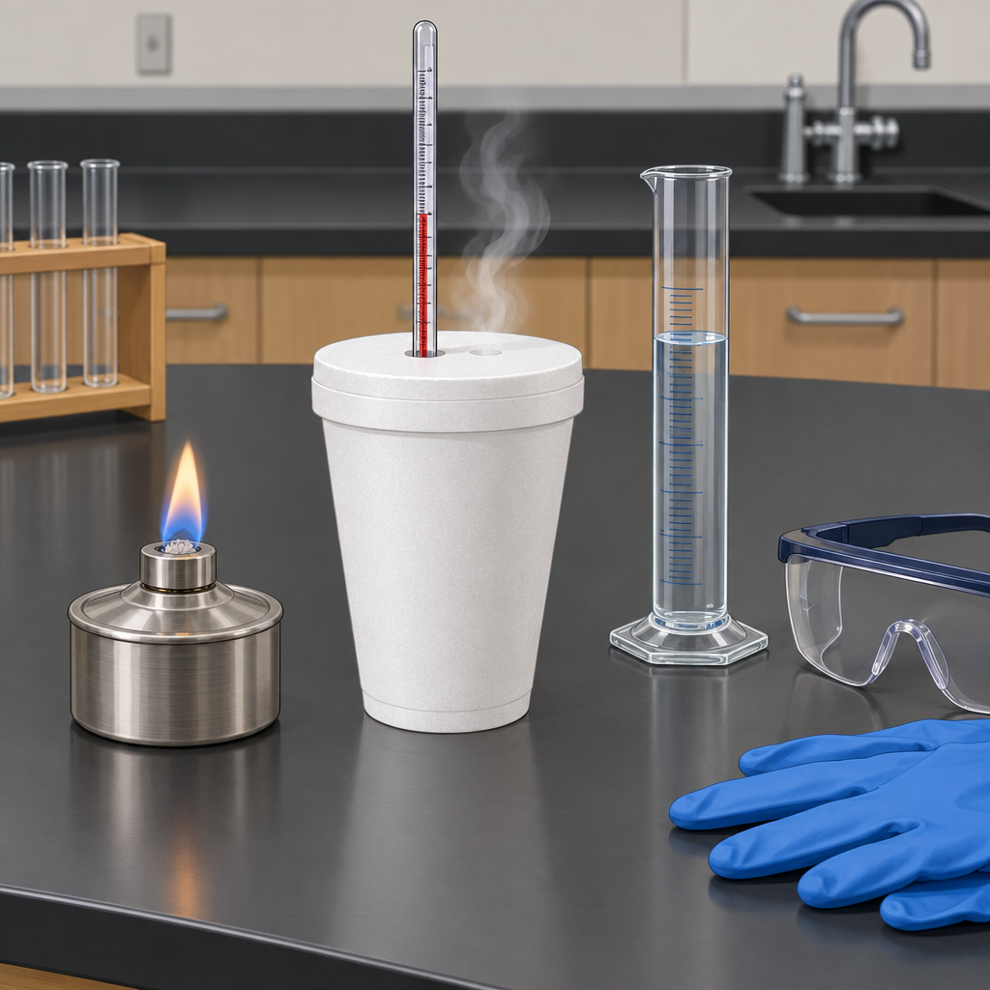

Learning intentions
We are learning to define enthalpy and molar enthalpy (Outcome, Outcome), apply the heat transfer equation Q = mcΔt (Outcome), use calorimetry data to determine enthalpy changes in chemical reactions (Outcome), and interpret ΔH notation to communicate energy changes (Outcome).

Success criteria
I can define enthalpy as the total heat content of a system and molar enthalpy as the heat change per mole of reactant. I can use Q = mcΔt to calculate heat absorbed or released. I can collect and analyze calorimetry data to find ΔH for a reaction. I can write and interpret ΔH values with correct sign and units.

Curriculum alignment
Specific Outcome 30-A1.3k: define enthalpy and molar enthalpy for chemical reactions (Outcome).
Specific Outcome 30-A1.1k: recall the application of Q = mcΔt to the analysis of heat transfer (Outcome).
Specific Outcome 30-A1.8k: use calorimetry data to determine the enthalpy changes in chemical reactions (Outcome).
Specific Outcome 30-A1.5k: use and interpret ΔH notation to communicate and calculate energy changes in chemical reactions (Outcome).
Specific Outcome 30-A1.3s: analyze data and apply mathematical and conceptual models to develop and assess possible solutions (Outcome).

Materials
Per student pair:
- polystyrene-cup calorimeter or insulated container
- thermometer (0 to 110°C, ±0.5°C precision)
- graduated cylinder (100 mL)
- balance (±0.01 g precision)
- water (distilled)
- calcium chloride (anhydrous, 10 g) or another soluble salt that releases heat on dissolution
- stirring rod
- paper towels
- safety goggles and lab coat
For demonstration:
- large calorimeter or beaker
- thermometer
- 100 mL water
- 10 g calcium chloride
- document camera or visualizer (optional, to show temperature readings)

Lesson sequence

1. Hook and prior knowledge (5 minutes)
Display a simple calorimeter or show a photograph of one. Ask students: "When you dissolve calcium chloride in water, does the container get hot or cold? How would you measure the temperature change? How would you know how much energy was released?"
Take 2 to 3 brief answers. Explain that today they will measure heat transfer in a chemical reaction and use that data to calculate enthalpy change, a quantity that tells chemists whether a reaction releases or absorbs energy.

2. Direct instruction: heat transfer and Q = mcΔt (8 minutes)
Write on the board:
Q = mcΔt
Define each term aloud:
- Q is heat energy, measured in joules (J)
- m is mass of the substance being heated, in grams (g)
- c is specific heat capacity, in joules per gram per degree Celsius (J/g·°C)
- Δt is the change in temperature, in degrees Celsius (°C)
State that the specific heat capacity of water is 4.18 J/g·°C. This means 1 gram of water requires 4.18 joules of energy to raise its temperature by 1°C.
Work through a sample calculation on the board:
"If 50 g of water increases in temperature from 20°C to 28°C, how much heat was absorbed?
Δt = 28 − 20 = 8°C
Q = mcΔt
Q = 50 g × 4.18 J/g·°C × 8°C
Q = 1,672 J or 1.67 kJ"
Emphasize that the sign of Q matters: if temperature increases, Q is positive (heat absorbed by the water). If temperature decreases, Δt is negative and Q is negative (heat released by the water).

3. Direct instruction: enthalpy and ΔH notation (6 minutes)
Define enthalpy (H) as the total heat content of a system. State that chemists do not measure absolute enthalpy; instead, they measure the change in enthalpy, written ΔH (Outcome).
Write on the board:
ΔH = H(products) − H(reactants)
Explain the sign convention:
- If ΔH is negative, the reaction releases heat to the surroundings (exothermic).
- If ΔH is positive, the reaction absorbs heat from the surroundings (endothermic).
Define molar enthalpy as the enthalpy change per mole of a specified reactant or product, with units of kJ/mol (Outcome, Outcome).
Show an example:
"If burning 1 mole of methane releases 890 kJ of heat, we write:
CH₄(g) + 2O₂(g) → CO₂(g) + 2H₂O(g) ΔH = −890 kJ/mol"
Point out that the negative sign tells us heat is released. The molar enthalpy is −890 kJ/mol.

4. Guided practice: calorimetry calculation (8 minutes)
Conduct a demonstration or show results from a calorimetry experiment. Present the data:
"A student dissolved 10.0 g of calcium chloride in 100 mL of water in a calorimeter. The initial temperature of the water was 22°C. After mixing and allowing the salt to dissolve, the final temperature was 38°C. The mass of the solution is approximately 110 g. Assume the specific heat capacity of the solution is 4.18 J/g·°C.
Calculate the heat released by the reaction."
Work through the calculation step by step:
Δt = 38 − 22 = 16°C
Q = mcΔt
Q = 110 g × 4.18 J/g·°C × 16°C
Q = 7,356.8 J ≈ 7.36 kJ
State: "The temperature increased, so the reaction released heat. The water absorbed 7.36 kJ, which means the reaction released 7.36 kJ. We write ΔH = −7.36 kJ for this amount of calcium chloride."
Ask: "If we dissolve 2 moles of calcium chloride, how much heat would be released?" Guide students to multiply by 2 and discuss molar enthalpy.

5. Independent practice: calorimetry lab (10 minutes)
Distribute calorimeter kits and guide students through the procedure:
- Measure 100 mL of distilled water using a graduated cylinder.
- Pour the water into the calorimeter and record the initial temperature (read to ±0.5°C).
- Measure 10.0 g of anhydrous calcium chloride on the balance.
- Add the salt to the water, stir gently, and record the maximum temperature reached.
- Calculate Δt and use Q = mcΔt to find the heat released.
- Record all data in a table with columns for initial temperature, final temperature, Δt, mass of solution, and Q.
Circulate to check that students are reading the thermometer correctly and recording data to appropriate precision. Prompt students who finish early to predict what would happen if they used 20 g of salt or if they repeated the experiment with a different initial temperature.

6. Consolidation and summary (3 minutes)
Gather the class. Ask one student to state the definition of enthalpy. Ask another to explain what a negative ΔH means. Ask a third to describe the steps in using calorimetry data to find ΔH.
Summarize: "Calorimetry lets us measure the heat released or absorbed during a chemical reaction. We use Q = mcΔt to convert temperature change into joules. The heat absorbed by the water equals the heat released by the reaction, with opposite sign. Enthalpy change, ΔH, tells us whether a reaction is exothermic or endothermic and by how much energy per mole."
Assign students to write a one-sentence definition of molar enthalpy in their own words as an exit ticket.

Differentiation
Support:
Provide a template for the calorimetry calculation with blanks for m, c, Δt, and Q. Pre-calculate Δt for students who struggle with subtraction or negative numbers. Pair students with a peer who reads the thermometer accurately. Offer a reference sheet with the specific heat capacity of water and the formula Q = mcΔt pre-written.
Extension:
Ask students to calculate the molar enthalpy if the mass of calcium chloride were doubled. Have them predict whether the ΔH value (in kJ/mol) would change and explain why. Challenge them to design an experiment to test the precision of their calorimeter by dissolving the same mass of salt in different volumes of water and comparing the calculated ΔH values. Discuss sources of error, such as heat loss to the surroundings and the assumption that the specific heat capacity of the salt solution equals that of pure water.

Assessment
Formative checkpoint during independent practice:
Observe students as they record data and perform calculations. Look for:
- Correct reading of the thermometer to ±0.5°C.
- Accurate subtraction to find Δt (sign and magnitude).
- Correct substitution of values into Q = mcΔt.
- Proper use of units (grams, J/g·°C, °C, joules or kilojoules).
- Correct interpretation of the sign of Q (positive if temperature rises, indicating heat released by the reaction).
Ask each student: "What does the negative sign in ΔH = −7.36 kJ tell you about this reaction?" Listen for the response that the reaction is exothermic and releases heat. If a student is uncertain, clarify that a negative ΔH means the system loses heat to the surroundings, making the surroundings (the water) warmer.

AILI rapid lesson · en · claude-haiku-4-5-20251001 · 2026-09-17

