Biological Diversity
Central concept: Biological Diversity

Connections
- Biological Diversity (includes) -> Diversity Among Species
- Biological Diversity (includes) -> Diversity Within Species
- Biological Diversity (maintained by) -> Reproduction
- Biological Diversity (enables) -> Niches and Adaptation
- Biological Diversity (includes) -> Reproductive Processes and Variation
- Reproduction (includes) -> Sexual Reproduction
- Reproduction (includes) -> Asexual Reproduction
- Reproduction (transmits) -> Inheritance
- Inheritance (depends on) -> Transmission of characteristics from parents to offspring
- Diversity Within Species (shaped by) -> Inheritance
- Niches and Adaptation (creates) -> Symbiotic Relationships
- Variation in Characteristics (transmitted) -> Offspring from Parents

Notes
- Biological Diversity: Range of species in environments and variations within species maintained through reproduction and affected by ecological factors Topic
- Diversity Among Species: Variation that distinguishes different species and enables them to occupy different niches in the same ecosystem Outcome, Outcome
- Diversity Within Species: Subtle variations in characteristics found within individual species, including discrete and continuous variation Outcome, Outcome
- Reproduction: Natural process that transmits species characteristics to offspring through sexual or asexual mechanisms Outcome, Outcome
- Sexual Reproduction: Reproduction involving two parents and formation of zygote through fertilization, allowing recombination of characteristics Outcome, Outcome, Outcome
- Asexual Reproduction: Reproduction by single organism through binary fission, budding or spore production, transmitting identical characteristics Outcome, Outcome, Outcome
- Inheritance: Transmission of heritable characteristics from parents to offspring; some traits influenced by both heredity and environment Outcome, Outcome
- Genetic Material: Chromosomes, genes and DNA that store genetic information and determine heritable characteristics Outcome
- Niches and Adaptation: Specific roles organisms occupy in ecosystems; variation enables closely related species to survive in same ecosystem Outcome, Outcome
- Symbiotic Relationships: Dependencies among species classified as mutualism, commensalism or parasitism that link survival of species Outcome, Outcome
- Human Impact: Human actions affecting species survival and variation, including extinction and extirpation of native species Outcome
- Conservation Strategies: Local and global approaches to minimize loss of species diversity including protected areas and breeding programs Outcome
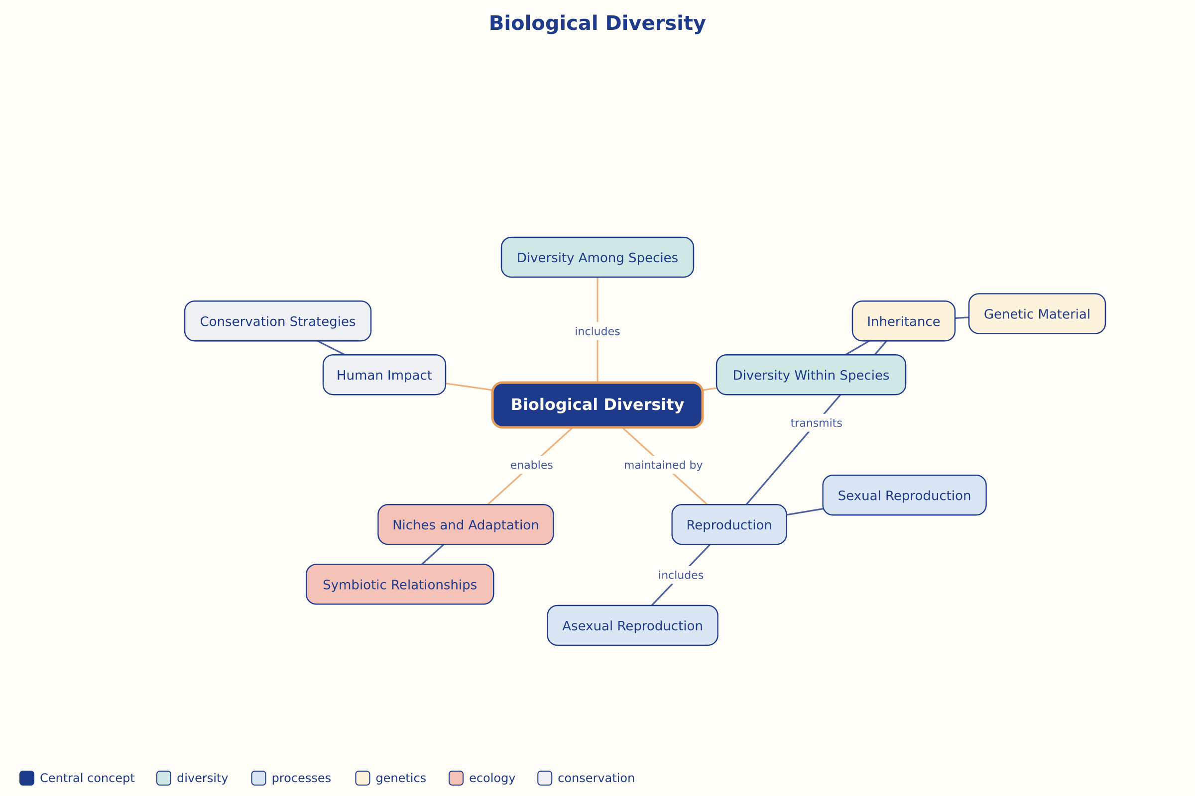

AILI word map · en · claude-haiku-4-5-20251001 · 2026-09-17

