The Comprehension Detectives Logic Puzzle
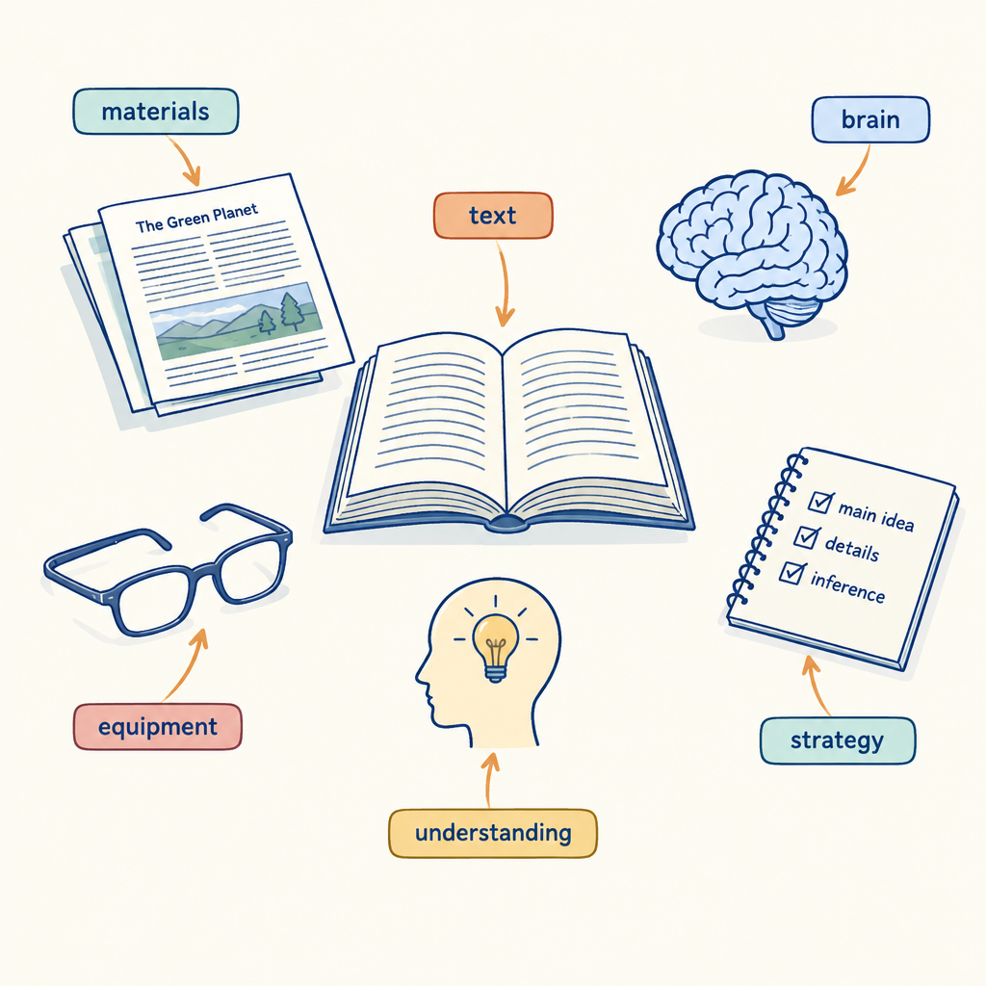
This brain teaser asks students to reason through clues about characters and their reading choices, drawing on the same skills that support text comprehension: making connections, asking and answering questions, and drawing conclusions from evidence rather than guesswork (Topic, Outcome). The organizing idea behind this activity holds that comprehension is supported by applying varied strategies, including questioning and connecting ideas, to arrive at a justified answer (Guiding question). Working through the grid mirrors the skill of answering questions that require interpretation and cause-and-effect reasoning, since no single clue reveals the full picture and students must combine information the way they would when summarizing key ideas and details from a text (Details).

How to play
- The puzzle is about 4 students and 3 categories. Each one has exactly one value in each category, and each value is used once.
- Read the 11 clues. Every clue is true. Use the grid to mark what is certain and cross out what is impossible.
- Exactly one arrangement fits every clue; the server has checked it. The hints go from gentle to direct, and the answer key shows the solution with the reasoning.

The puzzle
Four grade 6 students each practice a different comprehension strategy while working on their independent reading texts this week.
Maya, Jordan, Priya and Owen each have one item from every category below, and no two of them share an item.
- Comprehension strategy: summarizing the main idea, making a prediction, asking clarifying questions, identifying similarities between texts
- Type of text used: a text read aloud, a print text read independently, an informational text, a fictional story
- The order of sharing with the class (in order, from first to fourth): first, second, third, fourth
Use the clues to work out who has what. Mark in the grid what each clue rules out.
Name | Comprehension strategy | Type of text used | The order of sharing with the class
Maya
Jordan
Priya
Owen

- The student with an informational text is between the student with asking clarifying questions and the student with summarizing the main idea in the order of sharing with the class.
- The student with a text read aloud comes before the student with summarizing the main idea in the order of sharing with the class.
- The student with identifying similarities between texts is between the student with a print text read independently and the student with summarizing the main idea in the order of sharing with the class.
- The student with an informational text does not have third.
- The student with identifying similarities between texts does not have third.
- Maya does not have a fictional story.
- Maya does not have asking clarifying questions.
- Maya does not have an informational text.
- Priya does not have asking clarifying questions.
- Priya does not have fourth.
- Jordan does not have a fictional story.

Hints
- Start with clue 1. Mark in the grid what it rules out before you read on.
- Clues 1 to 8 together show that Maya has making a prediction.
- Maya has making a prediction, a text read aloud and third.

Answer key
Name | Comprehension strategy | Type of text used | The order of sharing with the class
Maya | making a prediction | a text read aloud | third
Jordan | asking clarifying questions | a print text read independently | first
Priya | identifying similarities between texts | an informational text | second
Owen | summarizing the main idea | a fictional story | fourth

Reasoning
- Clue 1: The student with an informational text is between the student with asking clarifying questions and the student with summarizing the main idea in the order of sharing with the class. Nothing is fixed yet; 2304 arrangements remain.
- Clue 2: The student with a text read aloud comes before the student with summarizing the main idea in the order of sharing with the class. Nothing is fixed yet; 768 arrangements remain.
- Clue 3: The student with identifying similarities between texts is between the student with a print text read independently and the student with summarizing the main idea in the order of sharing with the class. Nothing is fixed yet; 192 arrangements remain.
- Clue 4: The student with an informational text does not have third. Nothing is fixed yet; 48 arrangements remain.
- Clue 5: The student with identifying similarities between texts does not have third. Nothing is fixed yet; 24 arrangements remain.
- Clue 6: Maya does not have a fictional story. Nothing is fixed yet; 18 arrangements remain.
- Clue 7: Maya does not have asking clarifying questions. Nothing is fixed yet; 12 arrangements remain.
- Clue 8: Maya does not have an informational text. This fixes Maya has making a prediction, Maya has a text read aloud and Maya has third; 6 arrangements remain.
- Clue 9: Priya does not have asking clarifying questions. Nothing is fixed yet; 4 arrangements remain.
- Clue 10: Priya does not have fourth. This fixes Priya has identifying similarities between texts, Priya has an informational text and Priya has second; 2 arrangements remain.
- Clue 11: Jordan does not have a fictional story. This fixes Jordan has asking clarifying questions, Owen has summarizing the main idea, Jordan has a print text read independently, Owen has a fictional story, Jordan has first and Owen has fourth, and only one arrangement remains.

AILI game · en · claude-sonnet-5 · 2026-09-17

