The Particle Model of Matter
Central concept: Particle Model of Matter

Connections
- Particle Model of Matter (includes) -> Basic Ideas
- Particle Model of Matter (describes) -> Solids
- Particle Model of Matter (describes) -> Liquids
- Particle Model of Matter (describes) -> Gases
- Particle Model of Matter (explains) -> Physical Properties
- Particle Model of Matter (used in) -> Representing Particles
- Solids (has strongest) -> Attractive Forces
- Gases (has weakest) -> Attractive Forces
- Liquids (has moderate) -> Attractive Forces
- Physical Properties (includes) -> Mass
- Physical Properties (includes) -> Volume
- Physical Properties (includes) -> Density
- Physical Properties (includes) -> Compressibility
- Mass (compared to volume gives) -> Density
- Volume (compared to mass gives) -> Density

Notes
- Particle Model of Matter: Explains the behaviour of particles in matter. Understanding, PDF p.1
- Basic Ideas: All matter is made of small particles that are always moving and have spaces between them. Knowledge, PDF p.1
- Solids: Particles are close together and vibrate in place. Knowledge
- Liquids: Particles have spaces and can slide past each other. Knowledge
- Gases: Particles have large spaces and move in all directions. Knowledge
- Attractive Forces: Strongest in solids, weakest in gases, affecting particle arrangement. Knowledge, Skills
- Physical Properties: Include state, mass, volume, density, and compressibility. Knowledge
- Mass: Amount of matter, measured in grams and kilograms. Knowledge
- Volume: Amount of space matter takes up, measured in millilitres and litres. Knowledge
- Density: Compares mass to volume; denser objects sink, less dense objects float. Knowledge
- Compressibility: Ability of a liquid or gas to reduce in volume under pressure. Knowledge, Skills
- Representing Particles: Students draw and relate particle arrangement to state of matter. Skills, Resource
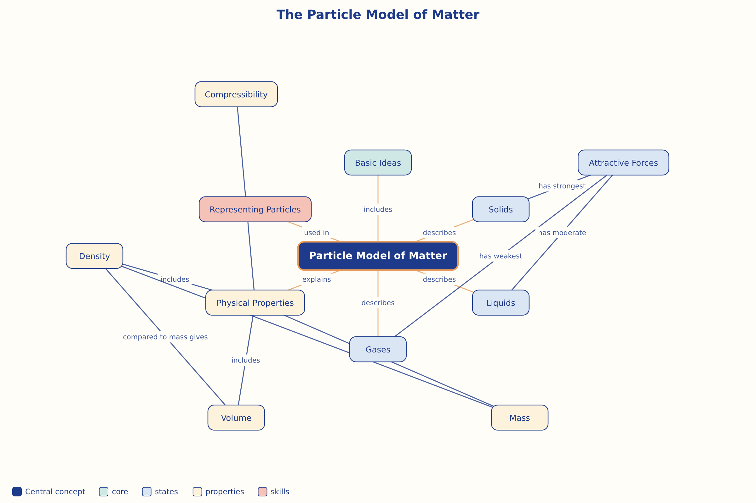

AILI word map · en · claude-sonnet-5 · 2026-09-17

