Making Tens: Adding and Subtracting Within 100
A hands-on lesson where second graders build two-digit sums and differences using tens and ones.
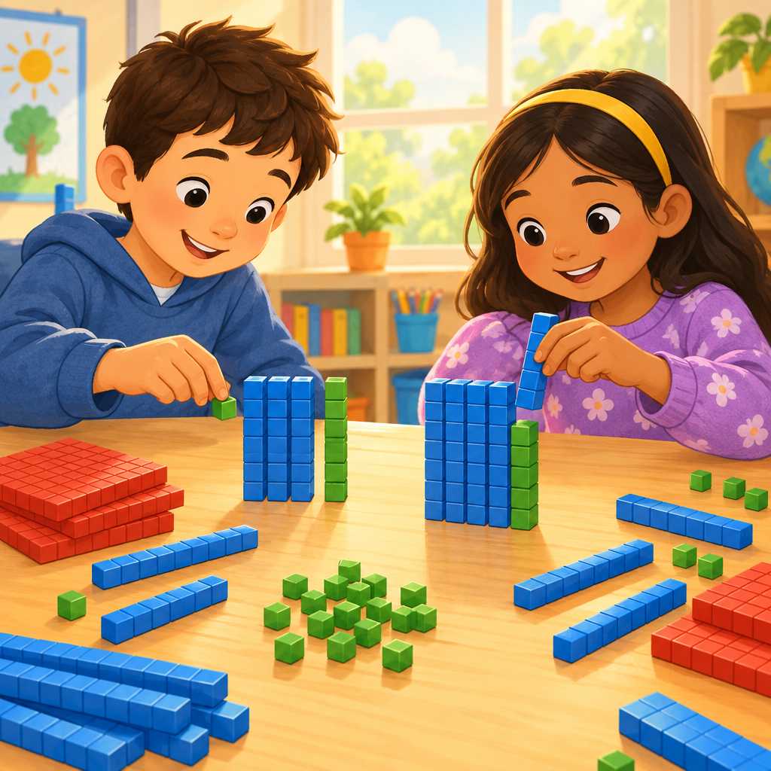

Learning intentions
We are learning to add and subtract two-digit numbers within 100.
We are learning to use a strategy, like making a ten, to solve addition and subtraction problems.

Success criteria
I can group ones into a ten to help me add two-digit numbers.
I can subtract two-digit numbers using a strategy I choose.
I can check my sum or difference using the opposite operation.

Curriculum alignment
- Students investigate addition and subtraction within 100 (Outcome).
- The order in which more than two numbers are added does not affect the sum(Details).
- Guiding question: How can addition and subtraction be interpreted? (Guiding question).
- Organizing idea: Number, quantity is measured with numbers that enable counting, labelling, comparing, and operating (Topic).

Materials
- Base ten blocks (tens rods and ones cubes), enough for pairs
- Small whiteboards and markers, one per student
- A large hundred chart posted at the front
- Number lines from 0 to 100, one per student
- Exit ticket slips (two problems per slip)

Lesson sequence

1. Hook (5 minutes)
Hold up two tens rods and four ones cubes. Ask: "How many blocks am I holding?" Let students call out. Write 24 on the board.
Add three more ones cubes. Ask: "Now how many do I have? How do you know?"
Say: "Today we are adding and subtracting numbers up to 100. We will use tens and ones to help us."

2. Direct instruction (10 minutes)
Write 34 + 28 on the board. Say: "Watch how I make a ten to solve this."
Model with blocks: "I have 3 tens and 4 ones. I have 2 tens and 8 ones. First, I add my tens: 3 tens plus 2 tens is 5 tens, that's 50."
"Now I add my ones: 4 plus 8. I know 4 plus 6 makes a ten, so I split the 8 into 6 and 2. 4 plus 6 is 10. I have 2 ones left over."
"50 plus 10 is 60. 60 plus 2 more ones is 62."
Write: 34 + 28 = 62.
Now model subtraction. Write 56 − 19 on the board. Say: "I can think of a number I know that's close to 19. 20 is close to 19."
"56 minus 20 is 36. But I subtracted one too many, so I add 1 back: 36 plus 1 is 37."
Write: 56 − 19 = 37.
Ask: "Why do addition and subtraction go together?" Guide students to notice that 37 + 19 = 56, so subtraction can be checked with addition (Outcome).

3. Guided practice (10 minutes)
Pair students with base ten blocks and whiteboards.
Write on the board: 47 + 26.
Say: "Talk with your partner. Build 47 with blocks. Build 26 with blocks. Combine your tens first."
Walk the room. Ask pairs: "How many tens do you have now? How many ones?"
Write the answer together: 47 + 26 = 73.
Next problem: 82 − 35.
Say: "This time, build 82. Take away 3 tens first. How many tens are left?"
Prompt: "Now you need to take away 5 more ones, but you only have 2 ones. What can you do?" Guide students to trade a tens rod for 10 ones.
Confirm together: 82 − 35 = 47.
Checkpoint: Ask each pair to show their blocks for 82 − 35. Look for correct trading of a tens rod for ones. Reteach the trade on the spot if a pair is stuck.

4. Independent practice (10 minutes)
Give each student a whiteboard and a number line. Write four problems on the board:
- 39 + 17
- 64 − 28
- 55 + 26
- 91 − 43
Say: "Choose your own strategy. You can use blocks, the number line, or make a ten in your head. Show your thinking."
Circulate and ask individuals: "How did you solve this one? Can you check it with the opposite operation?"

5. Consolidation (5 minutes)
Bring the class back together. Ask: "Who used making a ten? Who used a number line?"
Invite one student to share their strategy for 55 + 26 on the board.
Ask the class: "How can we check that 55 + 26 = 81 is correct?" Guide them to try 81 − 26 = 55 (Outcome).
Close with: "Tomorrow we will keep using these strategies with even trickier numbers."

Differentiation
Extension: Give students three addends to combine, such as 24 + 18 + 12, and ask which two numbers they add first and why. This connects to the understanding that a sum can be composed in multiple ways (Details). Students who finish early can also try estimating before solving, a strategy used with larger numbers in later grades (Details).
Support: For students still building fluency, reduce the numbers to within 20 first, using counting on and counting back strategies from Grade 1 (Outcome, Details). Provide a filled-in hundred chart and let students count tens by rows before tackling two-digit trades.

Assessment
Formative check: Collect the exit ticket with two problems: 46 + 37 and 73 − 25.
Look for:
- Correct use of tens and ones (are tens combined before ones, or traded correctly during subtraction).
- A written or verbal strategy, not just a final answer.
- Whether the student attempts to check their answer with the inverse operation (Outcome).
Students who make trading errors in subtraction need another guided session with blocks before moving to the standard algorithm.

AILI rapid lesson · en · claude-sonnet-5 · 2026-09-17

