Energy Flow in Technological Systems
Central concept: Energy Flow in Technological Systems

Connections
- Energy Flow in Technological Systems (includes) -> Forms of Energy
- Energy Flow in Technological Systems (involves) -> Energy Conversion
- Energy Flow in Technological Systems (depends on) -> Efficiency
- Forms of Energy (includes) -> Kinetic Energy
- Forms of Energy (includes) -> Potential Energy
- Energy Conversion (follows) -> Energy Conservation
- Energy Conversion (produces) -> Heat Loss
- Energy Conversion (powers) -> Energy Conversion Devices
- Kinetic Energy (relates to) -> Work and Force
- Potential Energy (relates to) -> Work and Force
- Efficiency (limited by) -> Heat Loss
- Engine Design (improves) -> Efficiency
- Energy Conversion Devices (includes) -> Engine Design
- Sustainability (requires) -> Efficiency

Notes
- Energy Flow in Technological Systems: Central organizing principle for understanding how energy transforms and transfers in devices and systems Topic
- Forms of Energy: Energy exists in multiple forms including mechanical, chemical, thermal, nuclear, and solar Outcome, Outcome
- Kinetic Energy: Energy due to motion, quantified using Ek = 1/2 mv² Outcome, Outcome
- Potential Energy: Energy due to relative position or condition, includes gravitational and chemical forms Outcome, Outcome
- Energy Conservation: First law of thermodynamics; energy cannot be created or destroyed, only transformed Outcome
- Energy Conversion: Process of transforming energy from one form to another in devices and systems Outcome, Outcome
- Efficiency: Measure of useful work compared to total energy input; no device is 100% efficient Outcome
- Work and Force: Work is energy expended when speed increases or object moves against opposing force; W = Fd Outcome, Outcome
- Heat Loss: Energy converted to heat during transformations; second law explains why useful energy diminishes Outcome
- Engine Design: Development of efficient engines through trial and error, including work of James Watt Outcome, Outcome
- Energy Conversion Devices: Hydroelectric generators, solar panels, windmills, fuel cells, heat pumps, furnaces Outcome, Outcome, Outcome
- Sustainability: Efficient energy conversions protect environment and make judicious use of natural resources Outcome
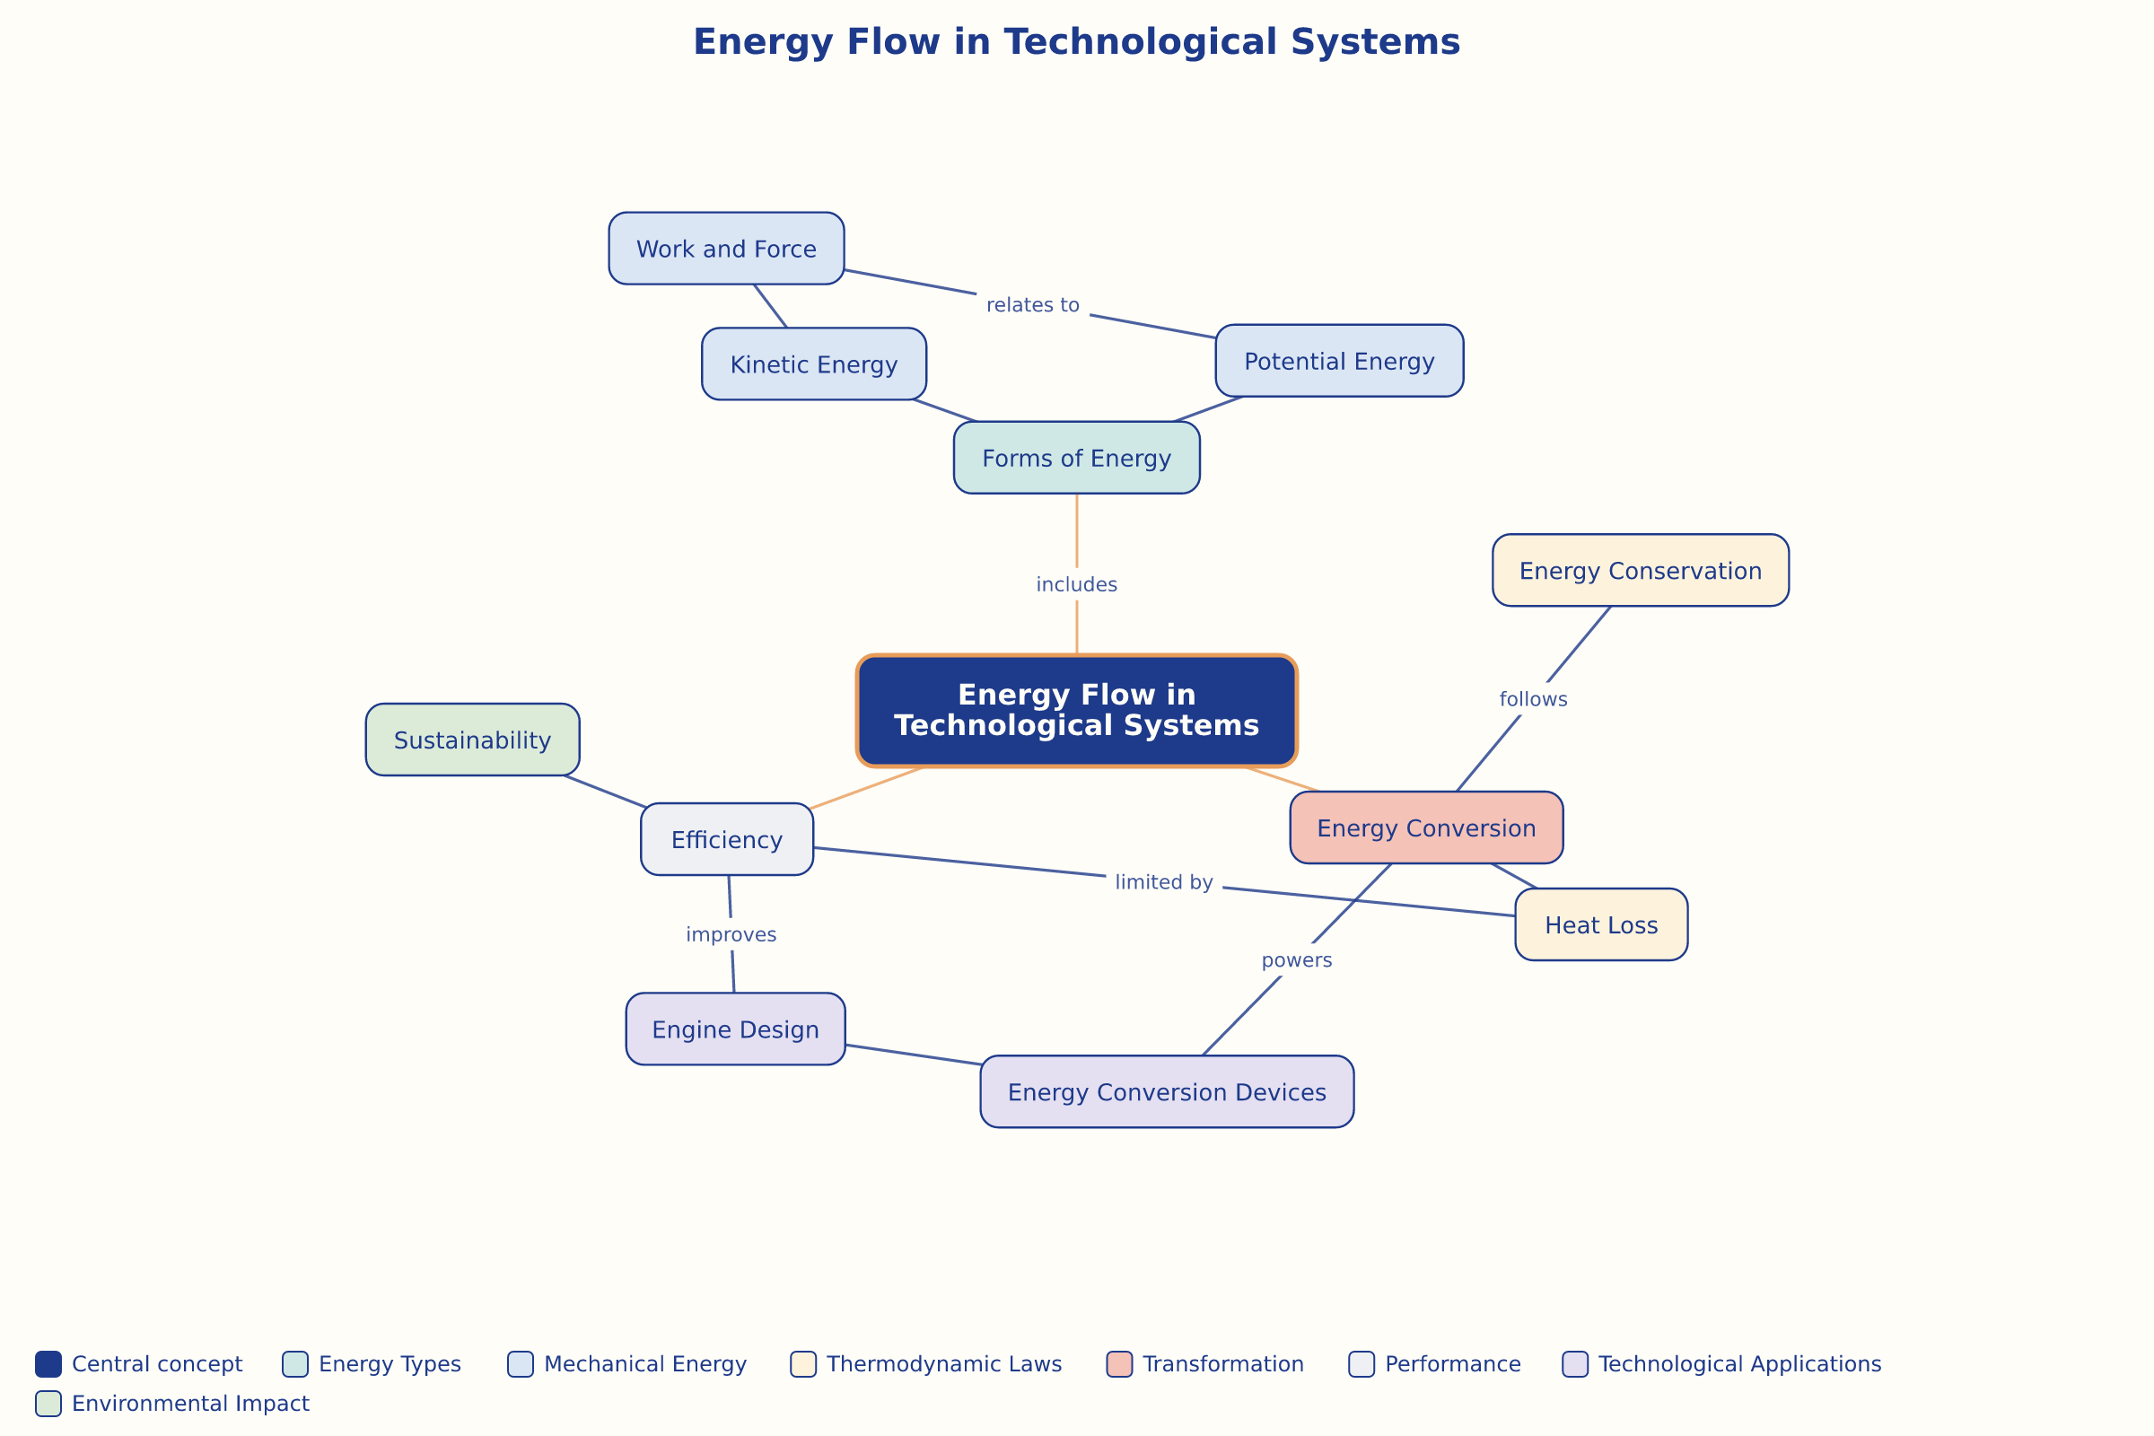

AILI word map · en · claude-haiku-4-5-20251001 · 2026-09-17

