Chemical Equilibrium
Chemistry 30, Unit D: Equilibrium and Acid-Base Systems

Slide 1: Chemical Equilibrium
Chemistry 30, Unit D: Equilibrium and Acid-Base Systems
Sources: Topic
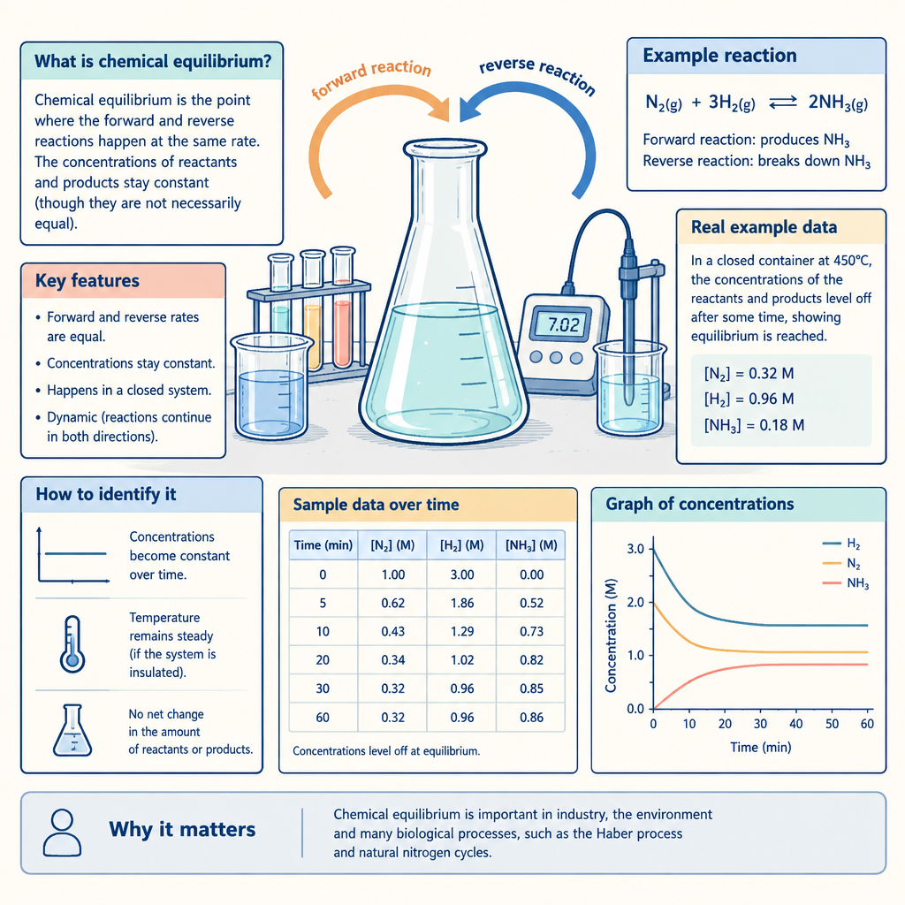
Notes: Introduce the unit by framing equilibrium as a dynamic balance, not a static endpoint. Preview that the unit connects general equilibrium theory to acid-base systems, buffers, and industrial applications.

Slide 2: What Is Chemical Equilibrium?
- A chemical system at equilibrium is closed to matter exchange with its surroundings
- Macroscopic properties such as colour and concentration remain constant over time
- The forward and reverse reaction rates are equal at equilibrium
- Equilibrium is dynamic: both reactions continue, but with no net change in concentrations
- Chemical equations for equilibrium systems are written and interpreted using a double arrow
Sources: Outcome, Outcome
Notes: Direct instruction on 30-D1.1k and 30-D1.2k. Use the analogy of two escalators moving in opposite directions at equal speed to reinforce that equilibrium is dynamic, not frozen. Have students distinguish equilibrium from a reaction that has simply stopped.

Slide 3: Le Chatelier's Principle: Predicting a Shift
- System at equilibrium: Forward and reverse rates are equal; properties are constant
- Stress applied: Change in concentration, temperature, pressure, volume, or a catalyst is introduced
- System shifts: The reaction favouring the forward or reverse direction proceeds to relieve the stress
- New equilibrium established: Rates become equal again; Kc may or may not change depending on the stress
Sources: Outcome, Outcome
Notes: Covers 30-D1.3k. Emphasize that only a temperature change alters the value of Kc; concentration, pressure, volume, and catalyst changes shift the position of equilibrium but leave Kc unchanged. Reinforce with graphing exercises interpreting concentration-versus-time data (30-D1.3s).

Slide 4: Brønsted-Lowry Acids and Bases
Definitions
A Brønsted-Lowry acid is a proton donor. A Brønsted-Lowry base is a proton acceptor. Conjugate acid-base pairs differ by a single proton, and amphiprotic substances such as HCO3- can act as either acid or base depending on the reaction partner.
Writing and Predicting
Brønsted-Lowry equations, including those involving indicators, are written to identify conjugate pairs. Comparing the relative strengths of the acids and bases involved predicts whether reactants or products are favoured, for both monoprotic and polyprotic systems.
Sources: Outcome, Outcome, Outcome
Notes: Covers 30-D1.5k, 30-D1.6k, and 30-D1.7k. Work through an example such as HF + H2O <-> H3O+ + F-, labelling both conjugate pairs. Extend to a polyprotic example such as H2CO3 to show stepwise proton transfer.

Slide 5: Equilibrium at Work: Buffers and Industry
A buffer contains relatively large amounts of a weak acid or base and its conjugate, allowing the system to resist pH change when small amounts of strong acid or base are added. Titration curves reveal buffering regions for combinations of strong and weak acids and bases. Equilibrium principles also guide large-scale industrial processes such as the Haber-Bosch process for ammonia and the Solvay process for sodium carbonate, where conditions are chosen to maximize product yield.
Buffers and industrial equilibrium applications
A buffer contains relatively large amounts of a weak acid or base and its conjugate, allowing the system to resist pH change when small amounts of strong acid or base are added. Titration curves reveal buffering regions for combinations of strong and weak acids and bases. Equilibrium principles also guide large-scale industrial processes such as the Haber-Bosch process for ammonia and the Solvay process for sodium carbonate, where conditions are chosen to maximize product yield.
Sources: Outcome, Outcome, Outcome, Outcome
Notes: Covers 30-D1.8k, titration curve interpretation (30-D1.3s), and industrial STS connections (30-D1.3sts). Consider a lab activity preparing a buffer and comparing its pH stability against a water control (30-D1.2s). Link to biological buffering, such as blood pH regulation, from 30-D1.1sts.

Slide 6: Bringing It Together
Summary: Chemical equilibrium describes a closed system with equal forward and reverse reaction rates and constant macroscopic properties. Le Chatelier's principle predicts how stresses shift that balance, while the equilibrium constant Kc quantifies the extent of a reaction. Brønsted-Lowry theory extends these ideas to acid-base systems, including buffers that stabilize pH and industrial processes that apply equilibrium principles at scale.
Question: If the Haber-Bosch process is run at high pressure and moderate temperature rather than at equilibrium-favoured low temperature, what trade-off between reaction rate and equilibrium yield is the industry accepting?
Sources: Topic, Outcome, Outcome, Outcome
Notes: Use the closing question to bridge equilibrium theory with kinetics from earlier units and prepare students for STS discussion of real industrial trade-offs (30-D1.3sts). Consider assigning the research task on the historical development of equilibrium theory (30-D1.2sts) as a follow-up.

AILI presentation · en · claude-sonnet-5 · 2026-09-17

