Concept Map: Thermochemical Changes (Chemistry 30)
Central concept: Thermochemical Changes

Connections
- Thermochemical Changes (includes) -> Definitions
- Thermochemical Changes (governed by) -> Laws
- Thermochemical Changes (quantified by) -> Calculations
- Thermochemical Changes (represented by) -> Diagrams
- Thermochemical Changes (investigated via) -> Lab Methods
- Thermochemical Changes (applied to) -> Applications
- Definitions (defines) -> Enthalpy
- Definitions (defines) -> Molar Enthalpy
- Definitions (uses) -> ΔH Notation
- Definitions (classifies as) -> Exo/Endothermic
- Definitions (explained by) -> Bond Energy Changes
- Laws (states) -> Hess' Law
- Laws (uses) -> Standard Enthalpies of Formation
- Laws (expressed in) -> Balanced Energy Equations
- Calculations (applies) -> Q = mcΔt
- Calculations (analyzes) -> Calorimetry Data
- Calculations (performs) -> Hess' Law Calculations
- Hess' Law Calculations (applies) -> Hess' Law
- Diagrams (drawn as) -> Energy Diagrams
- Energy Diagrams (labels) -> Activation Energy
- Activation Energy (lowered by) -> Catalysts
- Lab Methods (measures) -> Calorimetry Technique
- Lab Methods (tests) -> Hess' Law Lab
- Calorimetry Technique (produces) -> Calorimetry Data
- Hess' Law Lab (informs) -> Hess' Law Calculations
- Applications (evaluates) -> Fuels & Energy Efficiency
- Applications (includes) -> Biological Processes
- Biological Processes (illustrates) -> Exo/Endothermic

Notes
- Thermochemical Changes: Study of energy changes in chemical reactions and their impacts on society (Topic) Topic
- Definitions: Core vocabulary for describing energy changes in reactions (Outcome) Outcome
- Enthalpy: Heat content of a system defined for chemical reactions (Outcome) Outcome
- Molar Enthalpy: Enthalpy change per mole of substance reacting (Outcome, Topic) Outcome, Topic
- ΔH Notation: Symbol used to communicate and calculate energy changes (Outcome) Outcome
- Exo/Endothermic: Classification of reactions by direction of energy flow, e.g. photosynthesis, combustion (Outcome) Outcome
- Bond Energy Changes: Energy changes explained by bonds breaking/forming and potential/kinetic energy shifts (Outcome) Outcome
- Laws: Governing principles used to calculate reaction enthalpies (Outcome, Outcome) Outcome, Outcome
- Hess' Law: Net reaction enthalpy calculated from a series of reactions (Outcome) Outcome
- Standard Enthalpies of Formation: Used to predict enthalpy change for chemical equations (Outcome) Outcome
- Balanced Energy Equations: Equations written to include energy changes (Outcome) Outcome
- Calculations: Quantitative methods for determining energy changes (Outcome, Outcome) Outcome, Outcome
- Q = mcΔt: Formula recalled and applied to analyze heat transfer (Outcome) Outcome
- Calorimetry Data: Used to determine enthalpy changes in chemical reactions (Outcome) Outcome
- Hess' Law Calculations: Combining reaction steps to calculate molar enthalpy of combustion for magnesium (Resource, Outcome) Resource, Outcome
- Diagrams: Visual representations of energy changes during reactions (Outcome) Outcome
- Energy Diagrams: Diagram: potential energy vs reaction progress, showing reactant and product levels, activation energy peak, and enthalpy change arrow (Outcome) Outcome
- Activation Energy: Energy barrier labelled on energy diagrams (Topic, Outcome) Topic, Outcome
- Catalysts: Substances that lower activation energy, a key concept in the unit (Topic) Topic
- Lab Methods: Experimental approaches for measuring and applying enthalpy relationships (Resource, Resource) Resource, Resource
- Calorimetry Technique: Inquiry-based measurement of heat transfer in reactions (Resource) Resource
- Hess' Law Lab: Guided procedure combining reactions to find molar enthalpy of magnesium combustion (Resource) Resource
- Applications: Real-world relevance of thermochemical study to society and environment (Topic) Topic
- Fuels & Energy Efficiency: Evaluation of fuels and sustainable energy use (Topic, Resource) Topic, Resource
- Biological Processes: Photosynthesis and cellular respiration classified as endo/exothermic (Outcome) Outcome
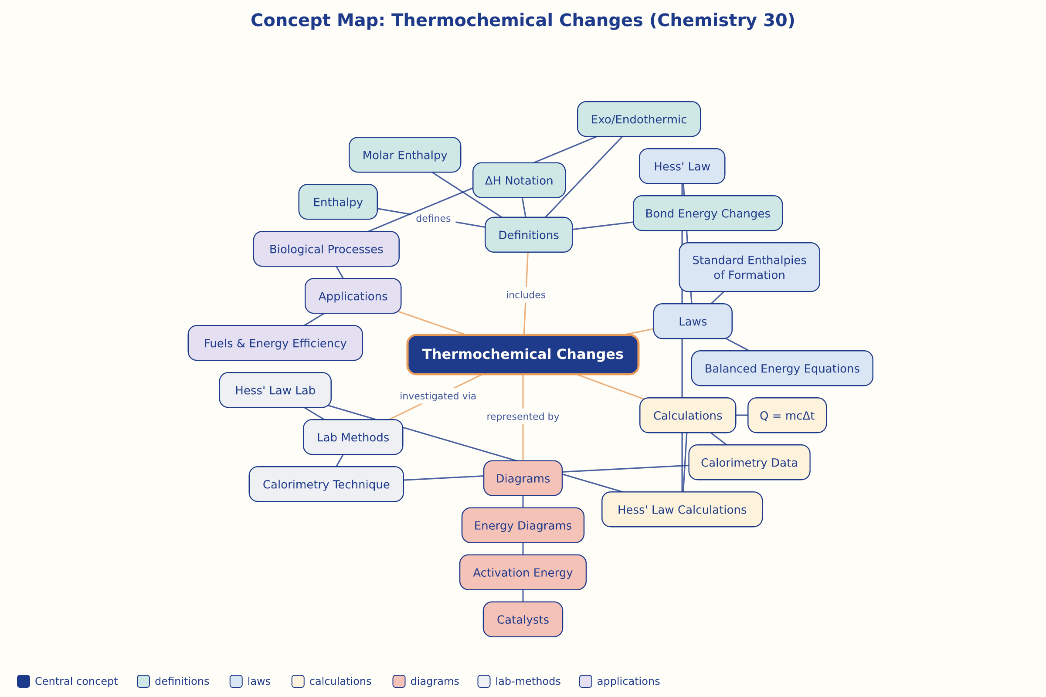

AILI word map · en · claude-sonnet-5 · 2026-09-17

