Personal Choices and Well-Being
Central concept: Well-Being

Connections
- Well-Being (comprises) -> Dimensions of Health
- Well-Being (shaped by) -> Determinants of Health
- Well-Being (requires) -> Balance in Life
- Well-Being (affected by) -> Personal Choices
- Dimensions of Health (includes) -> Emotional & Spiritual Well-Being
- Dimensions of Health (includes) -> Physical Wellness
- Personal Choices (can create) -> Barriers to Health
- Personal Choices (influenced by) -> Peer Pressure
- Balance in Life (maintained through) -> Stress & Change Management
- Emotional & Spiritual Well-Being (is part of) -> Holistic Well-Being
- Physical Wellness (depends on) -> Personal Resources
- Personal Well-Being (is affected by) -> Positive Attitudes About Self

Notes
- Well-Being: Holistic state encompassing emotional, intellectual, social, spiritual and physical dimensions Topic
- Dimensions of Health: Emotional/psychological, intellectual, social, spiritual and physical aspects that interact dynamically Outcome, Topic
- Determinants of Health: Factors that influence lifestyle choices and overall health outcomes Outcome
- Balance in Life: Dynamic equilibrium among dimensions that changes over time and circumstances Outcome, Outcome
- Personal Choices: Decisions made about health, relationships, resources and lifestyle that affect well-being Outcome, Outcome
- Barriers to Health: Combinations of poor choices, substance use, risk situations and external pressures that impede well-being Outcome, Outcome
- Peer Pressure: Social expectations and influence from others that shape personal choices Outcome, Outcome
- Emotional & Spiritual Well-Being: Constructive expression of feelings, moods and personal values; managing anger, depression and loss Outcome
- Physical Wellness: Nutrition, fitness, exercise, safety and risk-taking behaviours that support physical health Outcome
- Stress & Change Management: Strategies for anticipating, identifying and managing inevitable stress and life transitions Outcome
- Meaningful Relationships: Connections built on trust, integrity, respect and responsibility; skills for healthy interaction Outcome
- Personal Resources: Time, energy, knowledge, skills, talents, technology and finances available to meet lifestyle demands Outcome
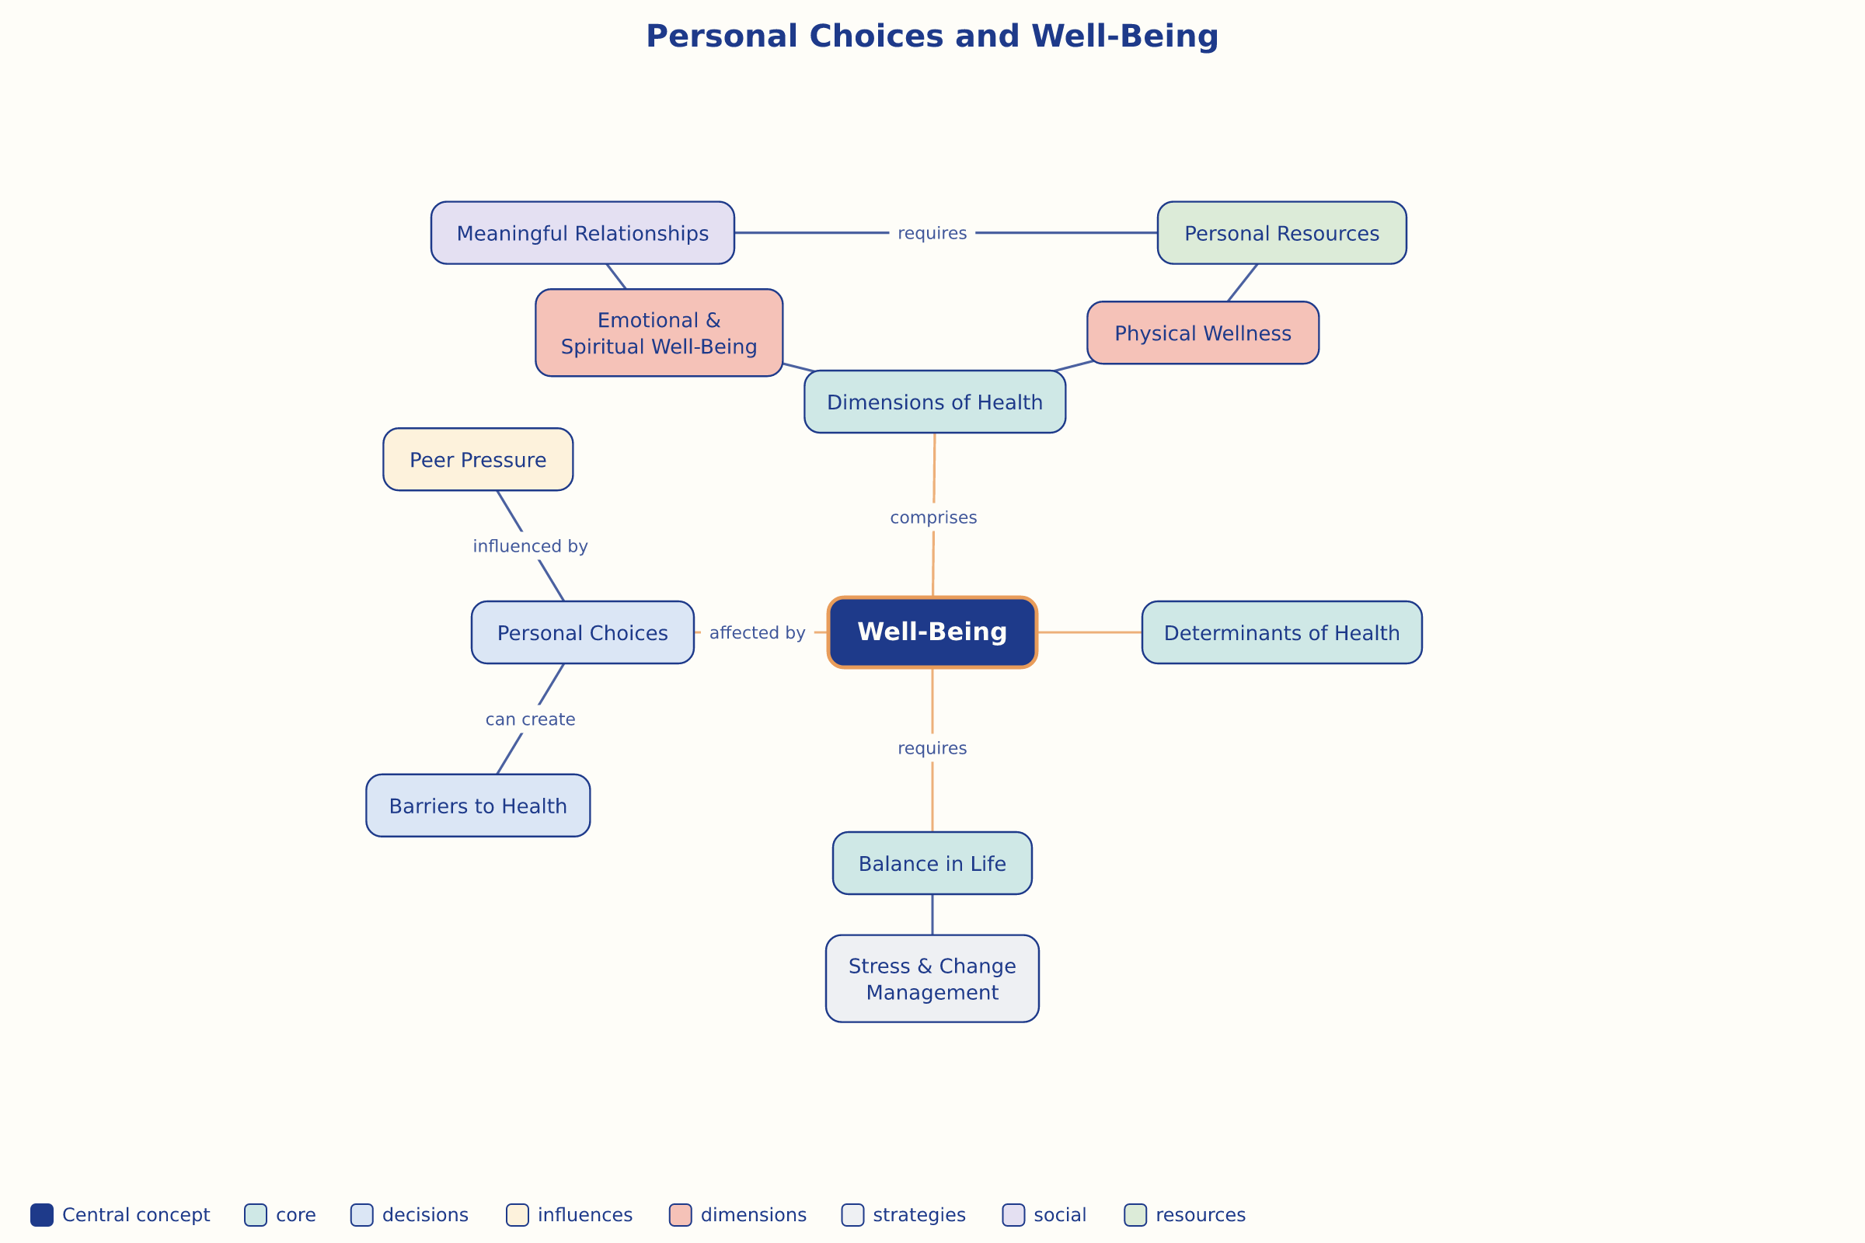

AILI word map · en · claude-haiku-4-5-20251001 · 2026-09-17

