Enthalpy Changes and Calorimetry
Central concept: Enthalpy Changes

Connections
- Enthalpy Changes (defines) -> Enthalpy
- Enthalpy Changes (includes) -> Molar Enthalpy
- Enthalpy Changes (measured by) -> Calorimetry
- Enthalpy Changes (expressed as) -> ΔH Notation
- Calorimetry (uses) -> Q = mcΔt
- Calorimetry (requires) -> Calorimeter Design
- Calorimetry (measures) -> Temperature Change
- Calorimetry (applies to) -> Combustion Analysis
- Q = mcΔt (includes) -> Temperature Change
- Calorimeter Design (evaluated by) -> Experimental Error
- Data Analysis (produces) -> Energy Diagrams
- Calorimetry (generates) -> Data Analysis

Notes
- Enthalpy Changes: Energy released or absorbed in chemical reactions at constant pressure Outcome, Outcome
- Enthalpy: A thermodynamic property of a system, equal to internal energy plus the product of pressure and volume, whose change equals the heat transferred at constant pressure Outcome, Outcome
- Molar Enthalpy: Enthalpy change per mole of reactant or product in a chemical reaction Outcome, Outcome
- Calorimetry: Experimental technique to measure heat transfer in chemical reactions Outcome, Resource, Resource
- Q = mcΔt: Equation relating heat absorbed to mass, specific heat capacity, and temperature change Outcome, Outcome
- ΔH Notation: Standard notation to express and calculate energy changes in chemical reactions Outcome
- Enthalpy and Molar Enthalpy: Definition of enthalpy and molar enthalpy for chemical reactionsResource
- Temperature Change: Change in system temperature used to calculate heat transfer Outcome, Outcome, Resource
- Enthalpy and Molar Enthalpy: Definition of enthalpy and molar enthalpy for chemical reactionsResource
- Data Analysis: Manipulation and presentation of calorimetry data using tools and spreadsheets Outcome
- Energy Diagrams: Visual representation comparing energy changes across different chemical reactions Outcome, Resource
- Enthalpy and Molar Enthalpy: Definition of enthalpy and molar enthalpy for chemical reactionsResource
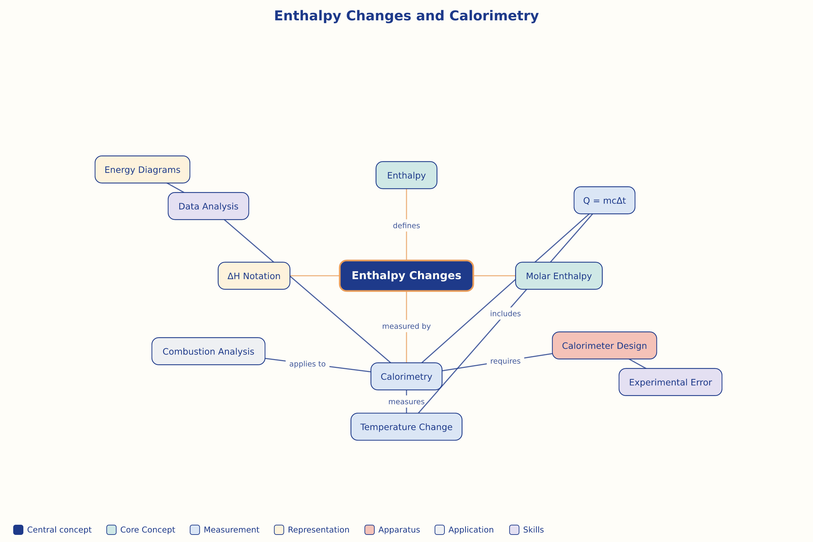

AILI word map · en · claude-haiku-4-5-20251001 · 2026-09-17

