What Makes Ice, Water and Steam Different
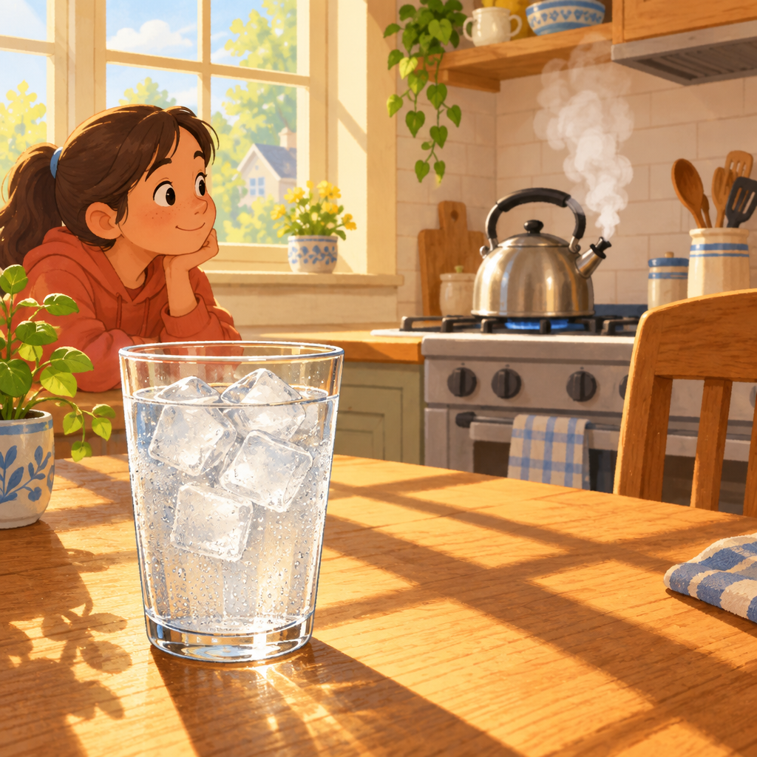
Maya watched her ice cube float in a glass. "Why doesn't it sink?" she asked her mum. "All matter is made of tiny particles," Mum said, pointing at the ice. "In ice, particles are packed tight together and vibrate in place. They stick hard to each other." Maya held the glass up to the light. The ice began to melt. "Now the particles have more space between them," Mum continued. "They can slide past each other. That's why water flows and pours." Steam rose from the kettle behind them. "And in steam, particles spread far apart and zoom around in every direction. They barely hold on to each other at all." Maya smiled. "So the particles tell the story of.

Words to know
- particles: tiny pieces of matter too small to see
- vibrate: to shake back and forth in one spot
- state of matter: the form something takes: solid, liquid, or gas
- attractive forces: invisible pulls that hold particles together
Curriculum link: Knowledge, Understanding
Listen to the narration

AILI audio story · en · claude-haiku-4-5-20251001 · 2026-09-17

