The Symbiosis Puzzle
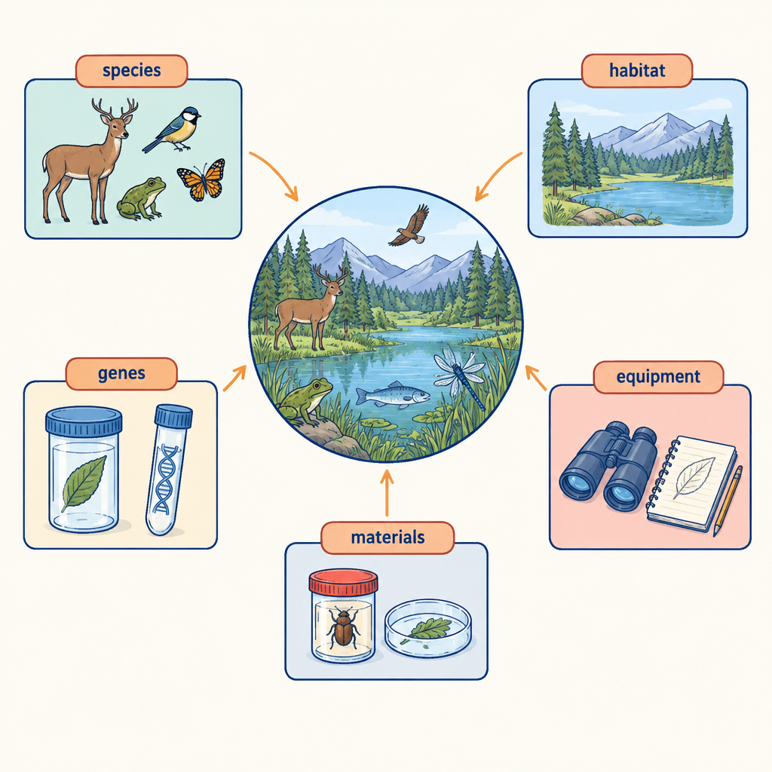
Grade 9 Unit A: Biological Diversity looks at how species need each other to survive. Scientists sort these relationships into three types: mutualism, commensalism, and parasitism (Outcome, Outcome). This puzzle asks you to use this system to solve a mystery about three organisms in the same wetland.

The puzzle
A wetland ecosystem has three organisms: a heron, a small fish called a minnow, and a leech.
Read the four clues below and figure out what type of symbiotic relationship exists between each pair of organisms. Each relationship must be classified as mutualism (both organisms benefit), commensalism (one benefits, the other is unaffected), or parasitism (one benefits, the other is harmed).
Clue 1: The heron eats minnows for food. The minnow population gets smaller where herons hunt, while the herons gain the energy they need to survive and raise their young.
Clue 2: The leech attaches to the heron's legs while the heron wades in shallow water. The leech feeds on the heron's blood. The heron's health gets worse from repeated blood loss, but the leech thrives.
Clue 3: A small bird called an egret stands beside the heron and grabs insects and small fish that the heron's movements stir up out of the mud. The heron does not appear to gain or lose anything from the egret's presence.
Clue 4: The minnow population and the leech population never interact directly. However, scientists notice that in years when minnows are abundant, herons spend less time wading (because they catch fish faster), and leech numbers drop.
Your task: classify the heron-minnow relationship, the heron-leech relationship, and the heron-egret relationship. Then explain, using Clue 4, why a change in one population can ripple through to affect a species it never touches directly.
Note: the heron-minnow relationship in this puzzle describes predation and its effect on population size, not one of the three symbiotic categories by itself. Think carefully about which of the three official categories (mutualism, commensalism, parasitism) actually fits it, or whether it fits none of them.

Hints
Hint 1: Start with the clearest case. In Clue 2, one organism is harmed and the other benefits. That single pattern matches only one of the three categories.
Hint 2: For Clue 3, ask whether the heron's survival or reproduction changes at all because of the egret. If nothing changes for the heron, that rules out two of the three categories immediately.
Hint 3: For the heron-minnow pair, remember that the three symbiotic categories describe organisms living closely together over time, where at least one depends on the relationship in an ongoing way. A predator eating prey occasionally is an ecological interaction, but check Outcome's own definition list: does it name "predation" as one of the three symbiotic categories, or only mutualism, commensalism and parasitism?

Answer key
Heron and leech: parasitism. The leech benefits by feeding on blood while the heron is harmed by blood loss. This matches the definition of parasitism in Outcome and Outcome.
Heron and egret: commensalism. The egret benefits from an easier food supply, while the heron's own survival and reproduction are unaffected. This matches the definition of commensalism in Outcome and Outcome.
Heron and minnow: this is predation, not one of the three symbiotic categories. Node:n2 and Outcome classify symbiotic relationships specifically as mutualism, commensalism, or parasitism. Predation is a different kind of ecological dependency. In predation, one species hunts another for food rather than living in an ongoing close association with it. A student who labels this "parasitism" has confused short-term feeding relationships with true symbiosis.
Clue 4 (the ripple effect): when minnows are plentiful, herons spend less time wading in shallow water because they catch food quickly. Less wading time means fewer chances for leeches to attach to heron legs, so the leech population drops. This happens even though minnows and leeches never touch. This illustrates the outcome in Outcome and Outcome that species survival can depend on webs of dependency running through a shared habitat, not just on direct contact between two organisms. A change in food abundance for one species (the heron's prey) alters the heron's behaviour, which then changes the fortunes of a completely separate species (the leech).

AILI game · en · claude-sonnet-5 · 2026-09-17

