Communities in Alberta: Who We Are and Who Looks After Us
A Grade 3 Social Studies lesson on Alberta's peoples, governments, and civic action
Audience: Grade 3 Social Studies students and their teacher, for a whole-class lesson in an Alberta elementary classroom.
Grades: Grade 3
Subjects: Social Studies
Time: about 60 minutes
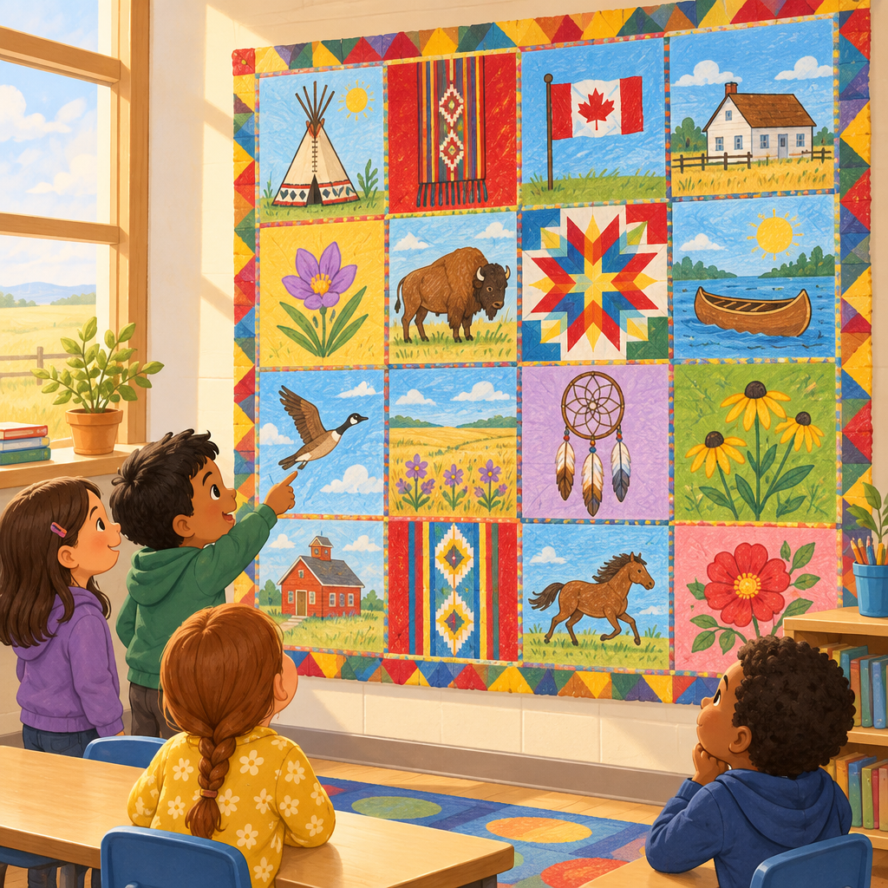

Overview
This lesson helps Grade 3 students explore who Albertans are and how their communities are cared for. Students meet First Nations, Métis, Francophone, settler, and immigrant communities that shape Alberta's identity (Knowledge, Knowledge, Understanding), then compare how municipal and provincial governments provide services and leadership (Understanding, Knowledge, Knowledge). The lesson closes with a personal reflection on civic action, connecting big ideas about community to something each student can do tomorrow (Knowledge, Skills).
The lesson addresses how students relate diversity to Alberta's western identity and compare municipal and provincial governments. The lesson includes exploring stories about symbols of diverse communities in Alberta and identifying Métis Settlements on a map.

Outcomes covered
- Students relate diversity to Alberta's western identity. (Outcome, Outcome)
Understanding Alberta's many communities helps students see themselves and their classmates as part of a shared, welcoming province.
- Students compare municipal and provincial governments. (Outcome)
Relating diversity to Alberta's western identity helps students understand how different perspectives shape their community.
- Students explore civic actions. (Guiding question, Knowledge, Skills)
Recognizing diversity helps students relate to Alberta's western identity and understand their place within it.

Materials
- Wall map of Alberta showing Métis Settlements
- Picture cards or slides: Blackfoot Confederacy flag, Kapawe'no First Nation flag, Métis sash, Red River cart, fleur-de-lis, prairie farm scene
- Alberta flag image, Alberta coat of arms image
- Large blank paper grid taped to the wall (the Community Quilt)
- Sticky notes, one per small group
- Service picture cards or icons: fire truck, library, hospital, school, provincial park, road, water tap (one set per pair)
- Whiteboards and markers (optional alternative to cards)
- Exit ticket cards or small paper squares, one per student
- Pencils and crayons

Sequence of activities

1. Who Belongs in Our Alberta Community? (Circle Chat) (10 min, whole class)
- Gather students in a circle on the carpet.
- Ask: "What is a community?" Take two or three answers. Guide toward: a group of people who live, work, or share something together.
- Show a simple map of Alberta (or point to a wall map).
- Say: "Alberta is home to many kinds of communities. Today we meet First Nations, Métis, Francophone, settler, and immigrant Albertans." (Knowledge, Knowledge)
- Ask: "Can you name a group of people who make up Alberta?" Accept any reasonable answer (family, cultural group, town).
- Tell students they will visit five learning stations about Alberta's peoples, then build a class "Community Quilt" together.
Keep this fast and welcoming. The goal is activating prior knowledge, not teaching content yet. If a child mentions their own family's heritage, thank them warmly and say we will hear more stories like that today.
Sources: Knowledge, Knowledge, Outcome

2. Alberta Peoples Stations: First Nations, Métis, Francophone, Settlers, Immigrants (22 min, small group)
- Split the class into 5 small groups. Each group visits one station for about 4 minutes, then rotates (5 stations × 4 minutes = 20 minutes, plus 2 minutes to settle).
- Station 1, First Nations: Show pictures of the Blackfoot Confederacy flag (tipi ring symbol) and Kapawe'no First Nation flag (standing bear). Say the words Cree (Nehiyaw), Blackfoot (Niitsitapi), and Dené aloud together. Tell students Alberta has 48 distinct First Nations communities. (Knowledge, Knowledge, Skills)
- Station 2, Métis: Show a picture of a Métis sash and a Red River cart. Explain Métis Settlements are communities where Métis people govern themselves. Mention the Michif language. Point to Métis Settlements on an Alberta map. (Knowledge, Knowledge, Skills)
- Station 3, Francophone: Show the fleur-de-lis symbol. Explain French was the first European language spoken in Alberta, brought by Francophone missionaries, and that Francophone Albertans today come from many parts of the world. (Knowledge, Knowledge, Skills)
- Station 4, Settlers: Show a simple picture of a prairie farm. Explain settlers came from many countries (Ukraine, the United States, China, and more) for free or low-cost farmland, and often faced isolation and language barriers. (Knowledge, Knowledge, Skills)
- Station 5, Immigrants: Explain people still move to Alberta today for jobs, family, land, or safety, and share examples of communities such as Jewish, Chinese, Muslim, Arab, Hindu, Sikh, and Filipino Albertans. (Knowledge, Knowledge, Skills)
- At each station, one adult or a student helper reads a short fact card aloud. Each group picks one word or picture to remember and draws it small on a sticky note.
Prepare 5 fact cards ahead of time with one image and 2-3 sentences each, matched to the steps above. If you cannot run five simultaneous stations, do this as one whole-class slideshow instead, spending about 4 minutes per group. Watch for respectful language when discussing cultures different from students' own.
Sources: Knowledge, Knowledge, Skills, Understanding

3. Build Our Community Quilt (10 min, whole class)
- Bring groups back together. Show a large blank paper "quilt" grid on the wall (one square per station group).
- Each group sticks their sticky note (from the stations activity) onto the quilt and says one sentence: "Our square shows ___ because ___."
- Ask: "Why might it feel good to see many different squares on one quilt?" Guide toward: everyone's community adds something special to Alberta. (Knowledge, Understanding)
- Point out the finished quilt shows Alberta is made up of diverse, pluralistic communities. (Knowledge)
- Briefly mention: sometimes people have been treated unfairly because of their culture or how they look, and learning about each other helps build empathy and unity. Ask students how they can be kind to someone from a different background. (Knowledge, Knowledge)
Keep the fairness discussion short, gentle, and hopeful. End on the empathy message so students leave feeling encouraged, not worried.
Sources: Knowledge, Knowledge, Understanding

4. Who Looks After Our Town? (Government Match-Up) (12 min, pairs)
- Explain that towns and the whole province need leaders and helpers to run services. (Understanding, Knowledge)
- Show pictures or words for: mayor, reeve, Chief, premier, MLA, lieutenant-governor. Explain municipal leaders (mayor, reeve, Chief) look after towns, cities, and First Nations communities, while the premier and MLAs look after the whole province at the Legislative Assembly. (Knowledge, Knowledge)
- Give each pair a small set of picture cards showing services: fire truck, library, hospital, school, provincial park, road, water tap.
- Pairs sort each card into two piles: "Municipal (our town)" or "Provincial (all of Alberta)." Answers: municipal = fire truck, library, road, water tap; provincial = hospital, school, provincial park. (Skills, Knowledge, Knowledge)
- Quick check: ask two pairs to share one card and explain their choice.
- Show the Alberta flag, coat of arms, wild rose, and the motto fortis et liber. Explain these are official symbols of Alberta's provincial government. (Skills, Knowledge, Knowledge)
If cards are not premade, draw simple icons on the board and have pairs write M or P on whiteboards instead. Correct sorting answers: fire truck-M, library-M, road-M, water tap-M, hospital-P, school-P, provincial park-P. Note both levels have elected representatives who meet to make decisions (Skills).
Sources: Understanding, Skills, Knowledge, Knowledge

5. My One Kind Act for Our Community (6 min, individual)
- Ask: "What is volunteering? What is charity?" Confirm: volunteering means giving your time to help others; charity means giving something to help others. (Knowledge)
- Ask students to think of one small action that could help their school or neighbourhood community feel safer, happier, or healthier. (Knowledge, Skills)
- Each student draws or writes their idea on an exit-ticket card (examples: pick up litter at the park, share toys, help a new student, collect food for a food bank).
- Collect the cards as students leave, or post them on a class "Community Helpers" board.
This closes the lesson by connecting identity and government learning to action. Accept any safe, realistic idea. Some students may want to talk about donating versus volunteering; both are valid answers (Skills).
Sources: Knowledge, Skills

Differentiation
Extension
- Ask early finishers at stations to compare two communities and name one similarity and one difference (Knowledge, Understanding).
- Invite students to research one more Alberta government symbol at home and share it the next day (Knowledge, Knowledge).
- Challenge students to write a short sentence explaining why both volunteering and charity help a community (Knowledge, Skills).
Support
- Provide picture-only fact cards at stations for students who need visual over text support (Knowledge, Skills).
- Pair emerging readers with a strong reader during the government sorting activity (Skills, Knowledge).
- Allow the exit ticket to be a verbal answer to the teacher or an educational assistant instead of writing (Knowledge, Skills).
Inclusive supports
- Use local First Nations languages and stories about symbols of diverse communities in Alberta to support student understanding.
- Organize activities to help students explore stories about early settlers in the land now known as Alberta and reflect on personal connections to language and culture.
- Invite, but never require, students to share personal family or cultural stories connected to the lesson content.

Assessment
Formative. During the stations activity, listen for each group correctly naming or pointing to one fact about their assigned Alberta community (First Nations, Métis, Francophone, settler, or immigrant).
Look for: Student can say or point to at least one accurate detail, such as a symbol, language name, or reason people came to Alberta. (Knowledge, Knowledge, Skills)
Formative. During the government match-up, check whether pairs correctly sort at least 5 of 7 service cards into municipal or provincial piles.
Look for: Pair sorts fire truck, library, road, and water tap as municipal, and hospital, school, and provincial park as provincial. (Skills, Knowledge, Knowledge)
Self. Exit ticket: each student draws or writes one action they could take to help their community.
Look for: The idea shows understanding that individuals can take actions, such as volunteering or charity, that improve quality of life for self and others. (Knowledge, Skills)

Vocabulary
- community: A group of people who live, work, or share something together, like a neighbourhood, a school, or a cultural group.
- First Nations: Diverse Indigenous peoples in Alberta with 48 distinct communities, languages, and histories, including Cree (Nehiyaw), Blackfoot (Niitsitapi), and Dené.
- Métis: A distinct culture that blends First Nations and European traditions, including the Michif language and Métis Settlements, where Métis people self-govern.
- Francophone: A French-speaking person or community. French was the first European language spoken in Alberta, and Francophone Albertans today come from many parts of the world.
- municipal government: The government that looks after a town or city, run by leaders like a mayor, reeve, or Chief, providing services such as fire departments, libraries, and roads.
- provincial government: The government that looks after the whole province of Alberta, led by the premier and MLAs, providing services such as education, health care, and provincial parks.
- volunteering: Giving your time to help other people or groups without being paid.
- charity: Giving money or things to help other people or groups.

For families
- Ask your child to tell you one Alberta community they learned about today, such as First Nations, Métis, Francophone, settlers, or immigrants.
- Point out the Alberta flag or coat of arms if you see one in your community and ask your child what it represents.
- Talk together about one small volunteering or charity action your family could try this month.

Sources
- Outcome: "Students relate diversity to Alberta's western identity."
- Outcome: "Students compare municipal and provincial governments."
- Skills: "Identify local First Nations languages."
- Understanding: "First Nations are diverse and contribute to the identity of Alberta."
- Knowledge: "Forty-eight distinct First Nations communities are represented in Alberta."
- Understanding: "Provincial and municipal governments are responsible for providing services and leadership in communities."
- Skills: "Differentiate between services provided by a municipal government and services provided by a provincial government."
- Knowledge: "Alberta's provincial government meets at the Legislative Assembly in the provincial capital."
- Knowledge: "Alberta is made up of diverse, pluralistic communities."
- Skills: "Explore stories about symbols of diverse communities in Alberta."
- Outcome: "Students relate diversity to Alberta's western identity."
- Understanding: "Immigrants from all over the world contribute to the diversity and identity of Alberta."
- Guiding question: "How can Albertans make an impact in their communities?"
- Knowledge: "Volunteering is the practice of spending time helping other people or groups."
- Skills: "Devise a plan to volunteer to improve the school or local community."
- Knowledge: "Municipal governments are responsible for services and programs for the local community"

All content presents Alberta's diverse communities and government roles factually and respectfully, uses age-appropriate language for Grade 3 students, and frames discussion of historical unfairness gently with a focus on empathy and inclusion.

AILI detailed pack · en · claude-sonnet-5 · 2026-09-17

