Addition and Subtraction Within 100
We can add and subtract numbers up to 100 by using strategies like making tens and thinking about place value.
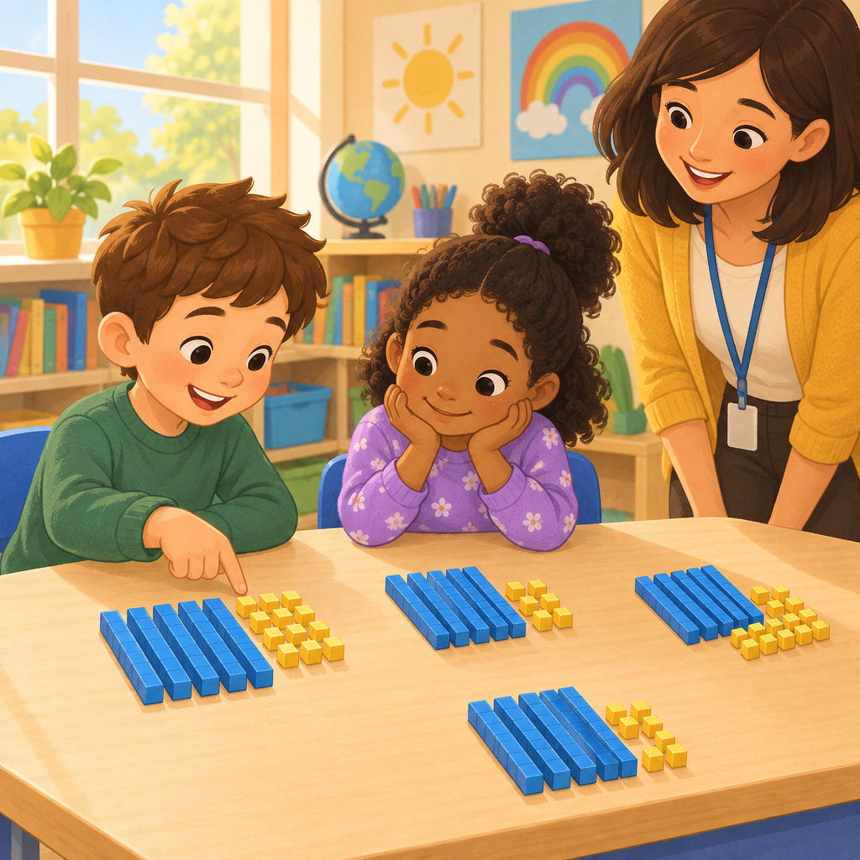

Learning intentions
We are learning to add and subtract numbers up to 100 using strategies that help us work with tens and ones (Outcome).

Success criteria
I can add two-digit numbers by making groups of ten (Knowledge).
I can subtract two-digit numbers using place value (Knowledge).
I can show that a sum can be made in more than one way (Understanding).
I can solve addition and subtraction problems with real objects or pictures (Understanding).

Curriculum alignment
Students investigate addition and subtraction within 100 (Outcome). Addition and subtraction strategies for two-digit numbers include making multiples of ten and using doubles (Knowledge). A sum can be composed in multiple ways (Understanding). Addition and subtraction can represent the sum or difference of countable quantities or measurable lengths (Understanding).

Materials
Base-10 blocks (tens rods and ones cubes), or draw them on paper if blocks are not available. Small objects such as counters, buttons, or dried beans. Paper and pencil. Whiteboard and marker. Picture cards showing groups of objects (optional).

Lesson sequence
1. Hook (5 minutes)
Show the class a pile of 23 base-10 blocks mixed together. Ask: "How many blocks do you think are here?" Let children guess. Then say: "Let's organize them into groups. Who can help me make tens?" Invite a child to group the blocks into one rod of ten and three ones. Say: "We have 2 tens and 3 ones. That is 23 blocks. Today we are going to add and subtract numbers by thinking about tens and ones."
2. Direct instruction: Making tens to add (10 minutes)
Write 24 + 13 on the board. Say: "Let's add 24 and 13. First, I'll show 24 with my blocks." Place 2 tens rods and 4 ones cubes in front of the class. "Now I'll show 13." Place 1 tens rod and 3 ones cubes next to the first group.
Ask: "How many tens do we have altogether?" Count together: 3 tens. "How many ones?" Count together: 7 ones. "So 24 + 13 equals 3 tens and 7 ones. What number is that?" Write 37 on the board. Say: "We can write this as 24 + 13 = 37."
Repeat with 32 + 15. Place 3 tens and 2 ones, then 1 tens and 5 ones. Ask: "How many tens now?" (4 tens) "How many ones?" (7 ones) "What number is 4 tens and 7 ones?" (47)
3. Guided practice: Adding with tens and ones (8 minutes)
Give each child or pair a set of base-10 blocks. Say: "Now you try. Show 31 with your blocks." Wait. "Now show 14 next to it. How many tens do you have?" Children count aloud together. "How many ones?" Count together. "What is the sum?" Write 31 + 14 = 45 on the board.
Repeat with 22 + 25. Children build 2 tens and 2 ones, then 2 tens and 5 ones. Ask: "How many tens altogether?" (4) "How many ones?" (7) "What is 22 + 25?" (47)
Ask: "Can we make 47 a different way?" Show 3 tens and 17 ones with blocks. Say: "This is also 47. We have 30 + 17. The sum is the same, but we made it differently." This shows that a sum can be composed in multiple ways (Understanding).
4. Direct instruction: Subtraction using place value (7 minutes)
Write 35 − 12 on the board. Say: "Now let's subtract. I'll show 35 with blocks." Place 3 tens rods and 5 ones cubes. "I need to take away 12. That is 1 tens and 2 ones. Watch me take them away." Remove 1 tens rod and 2 ones cubes.
Ask: "How many tens are left?" (2) "How many ones are left?" (3) "What number is 2 tens and 3 ones?" (23) Write 35 − 12 = 23 on the board.
Repeat with 48 − 15. Place 4 tens and 8 ones. Take away 1 tens and 5 ones. Ask: "How many tens and ones are left?" (3 tens and 3 ones, which is 33)
5. Independent practice: Adding and subtracting (8 minutes)
Give each child a worksheet or write these problems on the board. Children use blocks or draw tens and ones.
Add:
- 21 + 13
- 32 + 11
- 24 + 20
Subtract:
- 29 − 10
- 36 − 14
- 45 − 23
Circulate and ask: "How many tens do you have? How many ones? What is the number?"
6. Consolidation (2 minutes)
Gather the class. Ask: "What did we learn today?" Children share. Say: "When we add or subtract, we can think about tens and ones separately. Tens stay with tens. Ones stay with ones. Then we put them together to find the answer."

Differentiation
Support: Provide base-10 blocks for all independent practice. Do not require children to draw. Ask simpler problems with smaller numbers: 12 + 11, 15 − 10, 20 + 13. Check each answer with the child by counting the blocks together.
Extension: Ask children to solve problems where they need to regroup, such as 27 + 15 (which makes 4 tens and 2 ones, or 42). Ask: "If we have 7 ones and 5 more ones, do we have enough to make another ten?" Children can exchange 10 ones for 1 tens rod. Also ask: "Show me two different ways to make 50 using tens and ones." (5 tens and 0 ones; 4 tens and 10 ones; 3 tens and 20 ones, etc.)

Assessment
Formative check (during independent practice):
Give each child the problem 26 + 12. Ask them to build it with blocks or draw it. Look for:
- Does the child show 2 tens and 6 ones for 26?
- Does the child show 1 tens and 2 ones for 12?
- Does the child count the tens correctly (3)?
- Does the child count the ones correctly (8)?
- Does the child give the correct answer (38)?
If a child struggles, have them build only the first number with you, count the tens and ones aloud, and then add the second number one block at a time while counting.

AILI rapid lesson · en · claude-haiku-4-5-20251001 · 2026-09-17

