The Popsicle Mystery
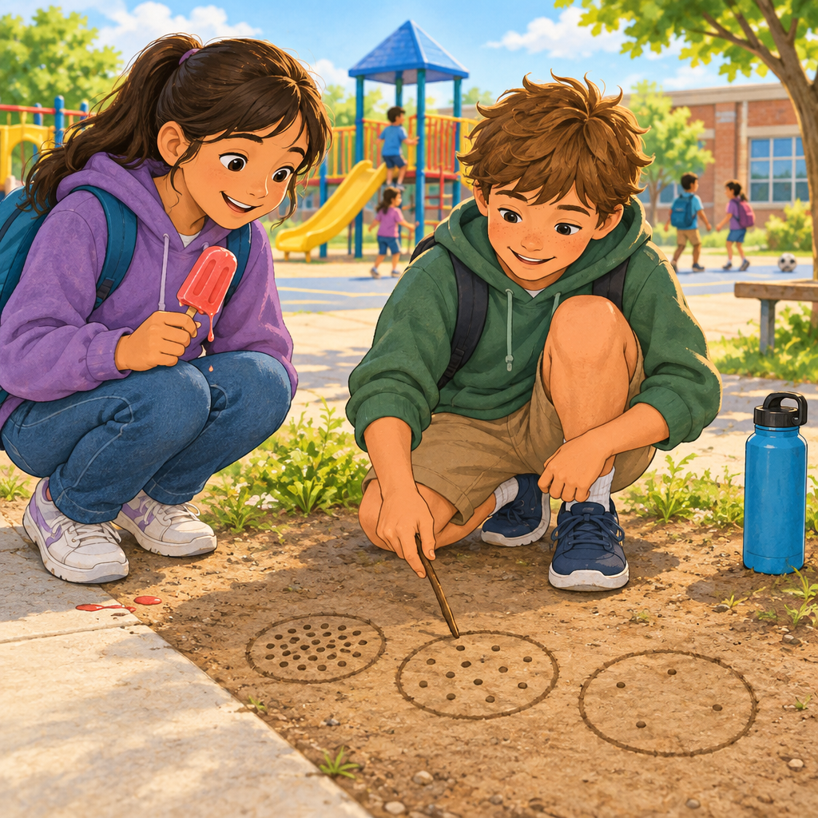
A popsicle is a solid with particles that are close together and vibrate in place. "Where did the ice go?" she asked.
Deo grinned. "Same particles, new arrangement. My aunt taught me this."
The particle model of matter can be represented using three boxes to show solids, liquids, and gases. "Solid, like the frozen popsicle. Particles packed close, just vibrating, barely moving. Strong pulling forces hold them tight."
"Then it melts," Mara said.
"Liquid now. Particles get space, slide past each other. The pull is weaker, so it drips."
"And if I left it out all day?"
"It'd turn to gas, vanish into the air. Particles fly apart, huge spaces, barely any pull holding them."
In a liquid like water, the particles are separated by spaces and can slide past each other. "Squishable?"
"Air compresses easy. Water barely budges. Different spacing, different squish."
She smiled. "Matter's just particles, rearranging."

Words to know
- particle: a very tiny piece of matter, too small to see, that all things are made of
- attractive force: a pull between particles that holds them together
- compressibility: how much a liquid or gas can be squeezed into a smaller space
- state of matter: whether something is a solid, a liquid, or a gas
Curriculum link: Guiding question, Outcome, Knowledge, Skills, Understanding, Knowledge, Skills, Understanding
Listen to the narration

AILI audio story · en · claude-sonnet-5 · 2026-09-17

