Enthalpy Changes and Calorimetry
Using calorimetry data to measure and interpret the energy released or absorbed in chemical reactions.
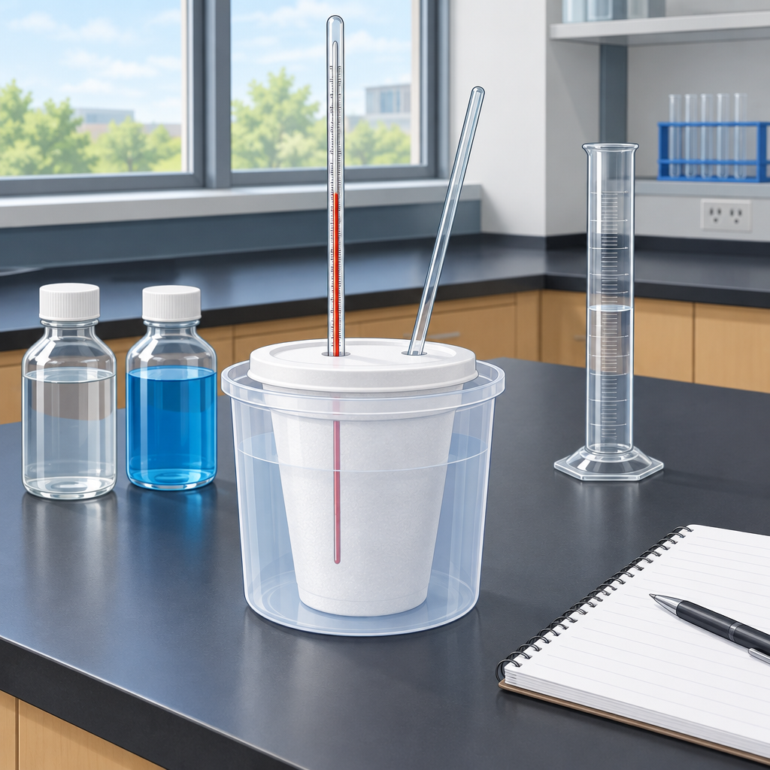

Learning intentions
We are learning to:
- apply the heat transfer equation Q = mcΔt to analyze calorimetry data (Outcome)
- define enthalpy and molar enthalpy and use ΔH notation to communicate energy changes (Outcome, Outcome)
- use calorimetry data to determine enthalpy changes in chemical reactions (Outcome)
- classify reactions as endothermic or exothermic (Outcome)

Success criteria
I can:
- calculate heat transferred in a calorimetry experiment using Q = mcΔt
- interpret ΔH values and predict whether a reaction is endothermic or exothermic
- determine the molar enthalpy of a reaction from experimental data
- explain the relationship between bond breaking, bond forming, and enthalpy change

Curriculum alignment
- General outcome: Students will determine and interpret energy changes in chemical reactions (Topic)
- Specific outcome 30-A1.1k: recall the application of Q = mcΔt to the analysis of heat transfer (Outcome)
- Specific outcome 30-A1.3k: define enthalpy and molar enthalpy for chemical reactions (Outcome)
- Specific outcome 30-A1.5k: use and interpret ΔH notation to communicate and calculate energy changes in chemical reactions (Outcome)
- Specific outcome 30-A1.8k: use calorimetry data to determine the enthalpy changes in chemical reactions (Outcome)
- Specific outcome 30-A1.10k: classify chemical reactions as endothermic or exothermic (Outcome)
- General outcome: Students will explain and communicate energy changes in chemical reactions (Topic)
- Specific outcome 30-A2.2k: explain the energy changes that occur during chemical reactions, referring to bonds breaking and forming (Outcome)

Materials
Per student or pair:
- Polystyrene cup calorimeter (or nested paper cups)
- Thermometer (accurate to 0.1°C)
- Graduated cylinder (100 mL)
- Stirring rod
- Watch or timer
- Distilled water
- Calcium chloride (solid, anhydrous) or sodium hydroxide solution (1 M)
- Hydrochloric acid solution (1 M)
- Safety goggles
- Lab coat or apron
- Paper towels
For demonstration:
- Projector or document camera
- Sample calorimetry data (printed or displayed)
- Energy diagram template (printed or displayed)

Lesson sequence

1. Hook (5 minutes)
Display a photograph or video clip of a hand-warmer pack (the kind that crystallizes when activated) or show a dramatic reaction such as calcium chloride dissolving in water in a beaker.
Ask: "What is happening to the temperature in this system? Where is the energy coming from or going?"
Take responses. Clarify that in this lesson, students will measure exactly how much energy is released or absorbed when chemicals react, and they will use that measurement to predict and classify reactions.

2. Direct instruction: Heat transfer and Q = mcΔt (8 minutes)
Explain that calorimetry measures the heat transferred between a chemical reaction and its surroundings. The heat absorbed or released by the water (or solution) in the calorimeter tells us about the reaction.
Write on the board:
Q = mcΔt
where Q is heat in joules, m is mass in grams, c is specific heat capacity (for water, c = 4.18 J/g°C), and Δt is the change in temperature in °C.
Work through a sample calculation:
"A calorimetry experiment measures the combustion of a fuel. The calorimeter contains 200 g of water. The temperature rises from 20.0°C to 35.5°C. Calculate the heat released.
Δt = 35.5 − 20.0 = 15.5°C
Q = mcΔt
Q = 200 g × 4.18 J/g°C × 15.5°C
Q = 12,958 J or 13.0 kJ"
Emphasize that a temperature increase means the reaction released heat to the water (exothermic). A temperature decrease means the reaction absorbed heat from the water (endothermic).

3. Direct instruction: Enthalpy and ΔH notation (6 minutes)
Define enthalpy as the heat content of a system. When a reaction occurs at constant pressure, the enthalpy change (ΔH) is the heat released or absorbed (Outcome).
Write the sign convention:
- ΔH is negative (ΔH < 0) for exothermic reactions (heat released)
- ΔH is positive (ΔH > 0) for endothermic reactions (heat absorbed)
Show the notation:
For the combustion example above, if 0.50 mol of fuel burned:
Molar enthalpy = 13.0 kJ ÷ 0.50 mol = 26 kJ/mol
The reaction is exothermic, so we write:
ΔH = −26 kJ/mol
or for the full reaction:
CH₄(g) + 2O₂(g) → CO₂(g) + 2H₂O(l) ΔH = −890 kJ/mol
(Outcome)
Clarify that the negative sign tells us the reaction releases energy. The magnitude tells us how much.

4. Guided practice: Analyzing calorimetry data (8 minutes)
Distribute or display the following calorimetry data:
"Experiment: 50 mL of 1 M HCl solution is mixed with 50 mL of 1 M NaOH solution in a calorimeter.
Initial temperature: 22.0°C
Final temperature: 29.8°C
Total mass of solution: 100 g (assume density = 1 g/mL)
Moles of HCl reacted: 0.050 mol"
Work through the calculation together:
Q = mcΔt
Δt = 29.8 − 22.0 = 7.8°C
Q = 100 g × 4.18 J/g°C × 7.8°C
Q = 3,260 J = 3.26 kJ
Since temperature increased, the reaction is exothermic. The reaction released 3.26 kJ.
Molar enthalpy = 3.26 kJ ÷ 0.050 mol = 65.2 kJ/mol
The reaction is exothermic, so ΔH = −65.2 kJ/mol (or −65 kJ/mol).
Have students check the calculation in pairs. Ask: "Is this reaction endothermic or exothermic? How do you know?"

5. Independent practice: Calorimetry calculation (8 minutes)
Distribute the following problem:
"A student burns 1.0 g of naphthalene (a solid hydrocarbon) in a bomb calorimeter. The calorimeter contains 1000 g of water. The temperature of the water rises from 25.0°C to 32.5°C. The molar mass of naphthalene is 128 g/mol.
(a) Calculate Q in kilojoules.
(b) Calculate the molar enthalpy of combustion of naphthalene.
(c) Is this reaction endothermic or exothermic? Explain."
Students work individually or in pairs. Circulate and check for correct use of the formula, correct sign interpretation, and correct unit conversion.

6. Consolidation: Connecting energy diagrams and bond energy (5 minutes)
Display or sketch an energy diagram for an exothermic reaction:
Diagram 2: An energy diagram showing a reaction pathway.
Explain: "In an exothermic reaction, the products have lower energy than the reactants. Energy is released. This happens because the bonds formed in the products are stronger (lower energy) than the bonds broken in the reactants. The difference in energy is ΔH" (Outcome).
Ask: "If we drew this diagram for an endothermic reaction, where would the product line be?" (Higher than the reactant line.)
Summarize the learning: Calorimetry lets us measure ΔH. The sign tells us the direction of heat flow. The magnitude tells us how much energy per mole of reaction.

Differentiation

Support
- Provide a worked example of Q = mcΔt with all steps labeled and units shown for each step. Have students annotate the example and identify where each value comes from.
- Offer a template for calorimetry calculations with blanks for Δt, Q, and molar enthalpy. Guide students to fill in the blanks step by step.
- Pair students with a stronger partner during independent practice. Ask the partner to explain each step aloud before the student writes the answer.
- Simplify the independent practice problem: reduce the number of steps or provide the value of Δt directly.

Extension
- Ask students to calculate the percent error in a calorimetry experiment if the calorimeter is not perfectly insulated. Provide the theoretical ΔH and ask them to compare it to their experimental value.
- Have students design a calorimetry experiment to measure the enthalpy of a reaction of their choice. They should predict the sign of ΔH and explain their prediction in terms of bond breaking and forming.
- Introduce the concept of heat capacity of the calorimeter itself. Ask students to recalculate Q if the calorimeter (with mass 50 g and specific heat capacity 0.90 J/g°C) must also be warmed.
- Ask students to explain why the specific heat capacity of water (4.18 J/g°C) is relatively high and what that means for the sensitivity of a calorimeter.

Assessment

Formative check during independent practice
Collect the student responses to the naphthalene combustion problem. Look for:
- Correct calculation of Δt: 32.5 − 25.0 = 7.5°C
- Correct substitution into Q = mcΔt: Q = 1000 × 4.18 × 7.5
- Correct result: Q = 31,350 J = 31.4 kJ (or 31 kJ)
- Correct conversion of mass to moles: 1.0 g ÷ 128 g/mol = 0.0078 mol
- Correct molar enthalpy: 31.4 kJ ÷ 0.0078 mol = 4,026 kJ/mol (or 4.0 × 10³ kJ/mol)
- Correct sign and reasoning: ΔH = −4,026 kJ/mol (exothermic because temperature increased)
If a student has the calculation correct but the sign wrong, or vice versa, prompt them to re-read the temperature change and explain what it means physically. If the unit conversion is wrong, review the molar mass calculation and the division step.

AILI rapid lesson · en · claude-haiku-4-5-20251001 · 2026-09-17

