Alberta Communities: Rights and Responsibilities Logic Puzzle
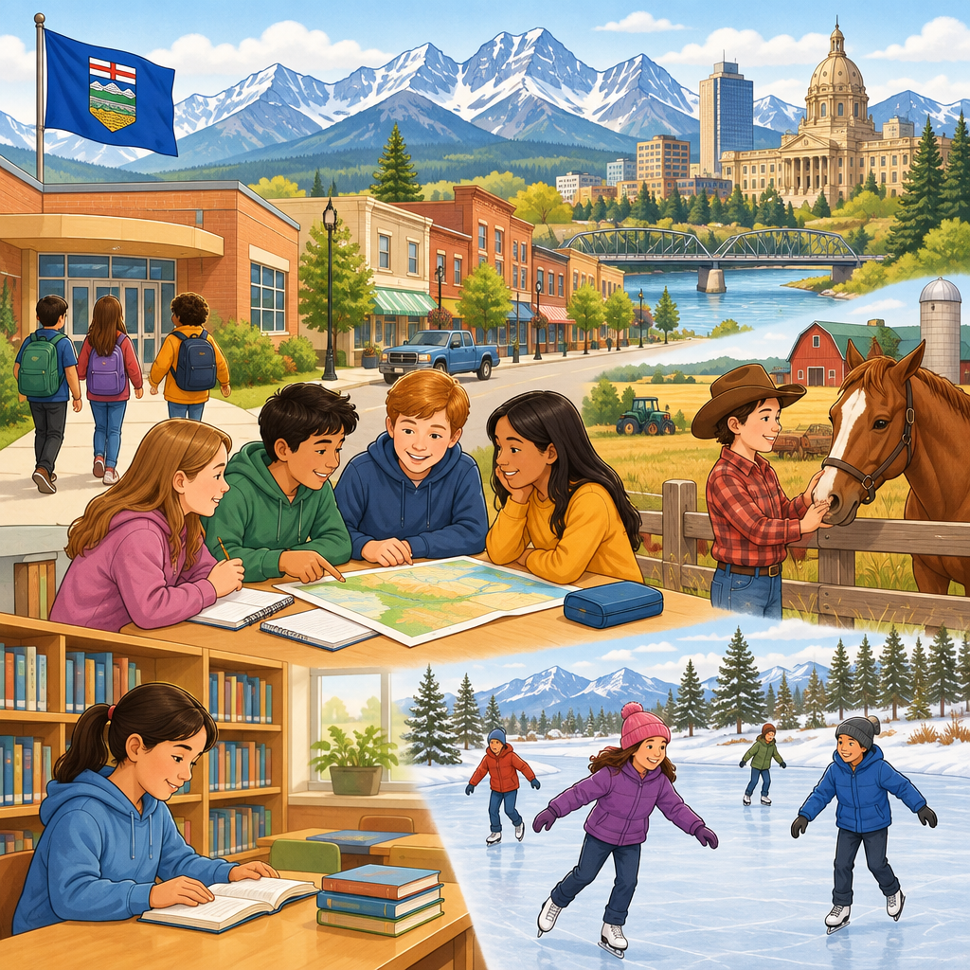
Every community in Alberta works because people understand their rights and their responsibilities to one another (Topic). This puzzle asks you to think like a citizenship detective. You will use clues about community roles to figure out who is who. Good citizens learn to contribute to their community and respect the rights of others (Outcome, Details).

How to play
- The puzzle is about 4 students and 3 categories. Each one has exactly one value in each category, and each value is used once.
- Read the 9 clues. Every clue is true. Use the grid to mark what is certain and cross out what is impossible.
- Exactly one arrangement fits every clue; the server has checked it. The hints go from gentle to direct, and the answer key shows the solution with the reasoning.

The puzzle
A grade 3 class is studying how people in Alberta communities help each other and follow rules. Each student picked a different way to show good citizenship in their community.
Amara, Ben, Chloe and Dmitri each have one item from every category below, and no two of them share an item.
- Way of showing citizenship: voting in the class election, respecting other people's rights, contributing to a community cleanup, helping a neighbour with chores
- The order of presenting to the class (in order, from first turn to fourth turn): first turn, second turn, third turn, fourth turn
- Community group: the school council, the recycling club, the neighbourhood watch, the community garden group
Use the clues to work out who has what. Mark in the grid what each clue rules out.
Name | Way of showing citizenship | The order of presenting to the class | Community group
Amara
Ben
Chloe
Dmitri

- Dmitri has helping a neighbour with chores.
- The student with the school council is between the student with contributing to a community cleanup and the student with respecting other people's rights in the order of presenting to the class.
- The student with the neighbourhood watch is between the student with the school council and the student with respecting other people's rights in the order of presenting to the class.
- The student with helping a neighbour with chores is between the student with voting in the class election and the student with respecting other people's rights in the order of presenting to the class.
- The student with the school council comes before the student with respecting other people's rights in the order of presenting to the class.
- The student with fourth turn does not have the recycling club.
- Ben does not have voting in the class election.
- Chloe does not have second turn.
- Ben does not have the community garden group.

Hints
- Start with clue 1. Mark in the grid what it rules out before you read on.
- Clues 1 to 4 together show that Dmitri has the neighbourhood watch.
- Dmitri has helping a neighbour with chores, third turn and the neighbourhood watch.

Answer key
Name | Way of showing citizenship | The order of presenting to the class | Community group
Amara | voting in the class election | second turn | the school council
Ben | contributing to a community cleanup | first turn | the recycling club
Chloe | respecting other people's rights | fourth turn | the community garden group
Dmitri | helping a neighbour with chores | third turn | the neighbourhood watch

Reasoning
- Clue 1: Dmitri has helping a neighbour with chores. This fixes Dmitri has helping a neighbour with chores; 3456 arrangements remain.
- Clue 2: The student with the school council is between the student with contributing to a community cleanup and the student with respecting other people's rights in the order of presenting to the class. Nothing is fixed yet; 576 arrangements remain.
- Clue 3: The student with the neighbourhood watch is between the student with the school council and the student with respecting other people's rights in the order of presenting to the class. Nothing is fixed yet; 48 arrangements remain.
- Clue 4: The student with helping a neighbour with chores is between the student with voting in the class election and the student with respecting other people's rights in the order of presenting to the class. This fixes Dmitri has the neighbourhood watch; 24 arrangements remain.
- Clue 5: The student with the school council comes before the student with respecting other people's rights in the order of presenting to the class. This fixes Dmitri has third turn; 12 arrangements remain.
- Clue 6: The student with fourth turn does not have the recycling club. Nothing is fixed yet; 6 arrangements remain.
- Clue 7: Ben does not have voting in the class election. Nothing is fixed yet; 4 arrangements remain.
- Clue 8: Chloe does not have second turn. This fixes Amara has voting in the class election, Amara has second turn and Amara has the school council; 2 arrangements remain.
- Clue 9: Ben does not have the community garden group. This fixes Ben has contributing to a community cleanup, Chloe has respecting other people's rights, Ben has first turn, Chloe has fourth turn, Ben has the recycling club and Chloe has the community garden group, and only one arrangement remains.

AILI game · en · claude-sonnet-5 · 2026-09-17

