Maya's Microscope
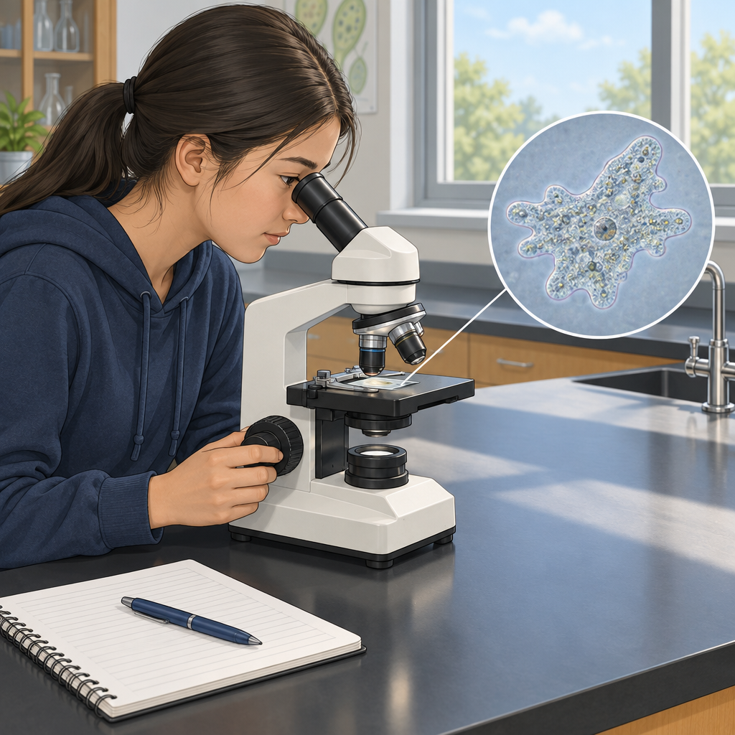
Maya aimed the microscope at the pond water sample. The single-celled amoeba moved across the glass slide like a tiny ghost. "Look at this," she said to her lab partner Kai. "It's just one cell, but it eats, moves, and responds to light. It performs basic life functions, but it's invisible to the naked eye." Kai leaned in. "So cells are the basic unit of life?" "Exactly. Every living thing, from bacteria to us, is made of cells. Some organisms have just one. We have trillions." Maya adjusted the focus. "And they work together as systems. Your heart pumps blood to carry oxygen and nutrients. Your lungs exchange gases. Your stomach breaks down food. All those systems keep us alive and healthy."

Words to know
- amoeba: a single-celled organism found in water that moves by changing shape
- cell: the smallest unit of life that can perform all the functions of a living thing
- system: a group of organs or parts working together to perform a function
- organism: any living thing
Curriculum link: Outcome, Outcome
Listen to the narration

AILI audio story · en · claude-haiku-4-5-20251001 · 2026-09-17

