Sam and the Sound Hunt
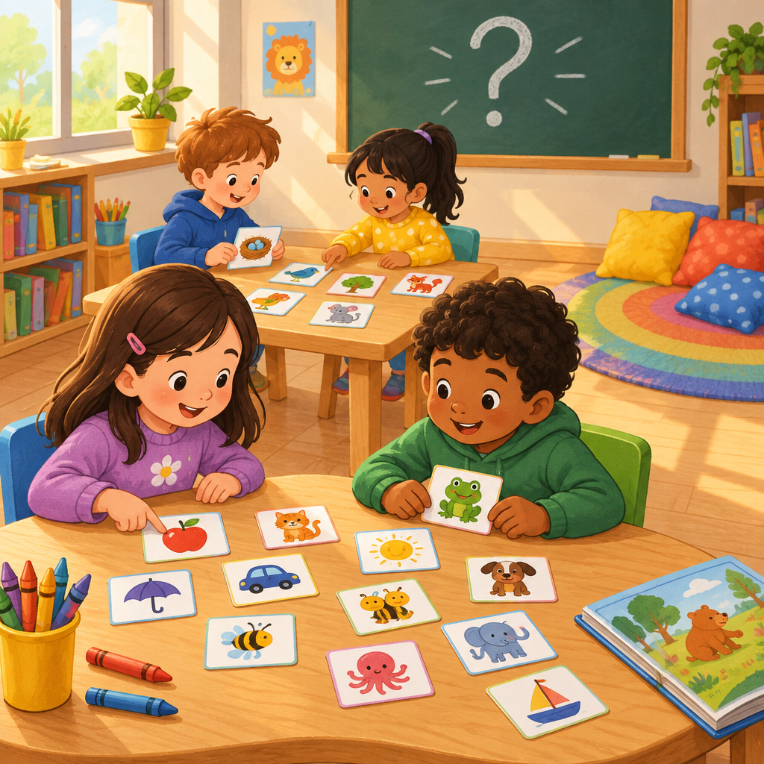
Sam held up a card. It said cat.
"C, a, t," said Sam slowly. "Cat!"
His friend Mia clapped. "You blended it fast!"
They kept hunting for words around the room.
Mia found the word the. "That one's tricky," she said. "I just know it by sight."
Sam found bird. "Listen," he said. "That r changes the vowel sound. It's not bir-d, it's birrrd."
They found ship too. "Two letters, one sound," said Mia. "Sh, sh, sh."
Then their teacher held up a sentence with a question mark.
"Read it like you're asking," she said.
Sam read it, voice rising at the end.
"Perfect," she said. "That's expression!"
They grinned and hunted for more words.

Words to know
- blend: putting sounds together to say a word
- sight word: a word you know by looking, not by sounding out
- expression: using your voice to show feeling when reading
- vowel: a letter like a, e, i, o, u
Curriculum link: Outcome, Knowledge, Skills, Understanding, Knowledge, Skills, Understanding, Knowledge, Skills, Knowledge, Skills, Knowledge, Skills
Listen to the narration

AILI audio story · en · claude-sonnet-5 · 2026-09-17

