Addition and Subtraction within 100
Central concept: Addition and subtraction within 100

Connections
- Addition and subtraction within 100 (builds on) -> Number facts
- Addition and subtraction within 100 (uses) -> Two-digit strategies
- Addition and subtraction within 100 (applies) -> Compose sums
- Addition and subtraction within 100 (solves) -> Real-world problems
- Two-digit strategies (includes) -> Make tens
- Two-digit strategies (includes) -> Doubles
- Number facts (demonstrates) -> Associative property
- Compose sums (helps) -> Visualize 100
- Addition and subtraction within 100 (verified by) -> Inverse operations
- Addition and subtraction within 100 (finds) -> Missing quantity
- Addition and subtraction within 100 (means) -> Interpret operations
- Real-world problems (may include) -> Missing quantity

Notes
- Addition and subtraction within 100: Students investigate how to add and subtract numbers up to 100. Outcome
- Number facts: Addition facts with addends to 10 and related subtraction facts. Skills
- Two-digit strategies: Methods for adding and subtracting two-digit numbers. Knowledge, Skills
- Make tens: Create multiples of ten to solve addition and subtraction. Knowledge, Resource, Resource
- Doubles: Use doubles to add and subtract two-digit numbers. Knowledge, Resource, Resource
- Compose sums: A sum can be made in multiple ways, including with more than two addends. Skills, Understanding
- Visualize 100: See 100 as made up of multiples of 10 in different ways. Skills, Skills
- Inverse operations: Use addition to check subtraction, and subtraction to check addition. Skills
- Missing quantity: Find an unknown number in an addition or subtraction problem. Skills
- Real-world problems: Solve problems using quantities or measurable lengths. Skills, Understanding
- Associative property: The order of adding more than two numbers does not change the sum. Knowledge
- Interpret operations: Addition and subtraction represent sums or differences of quantities. Guiding question, Understanding
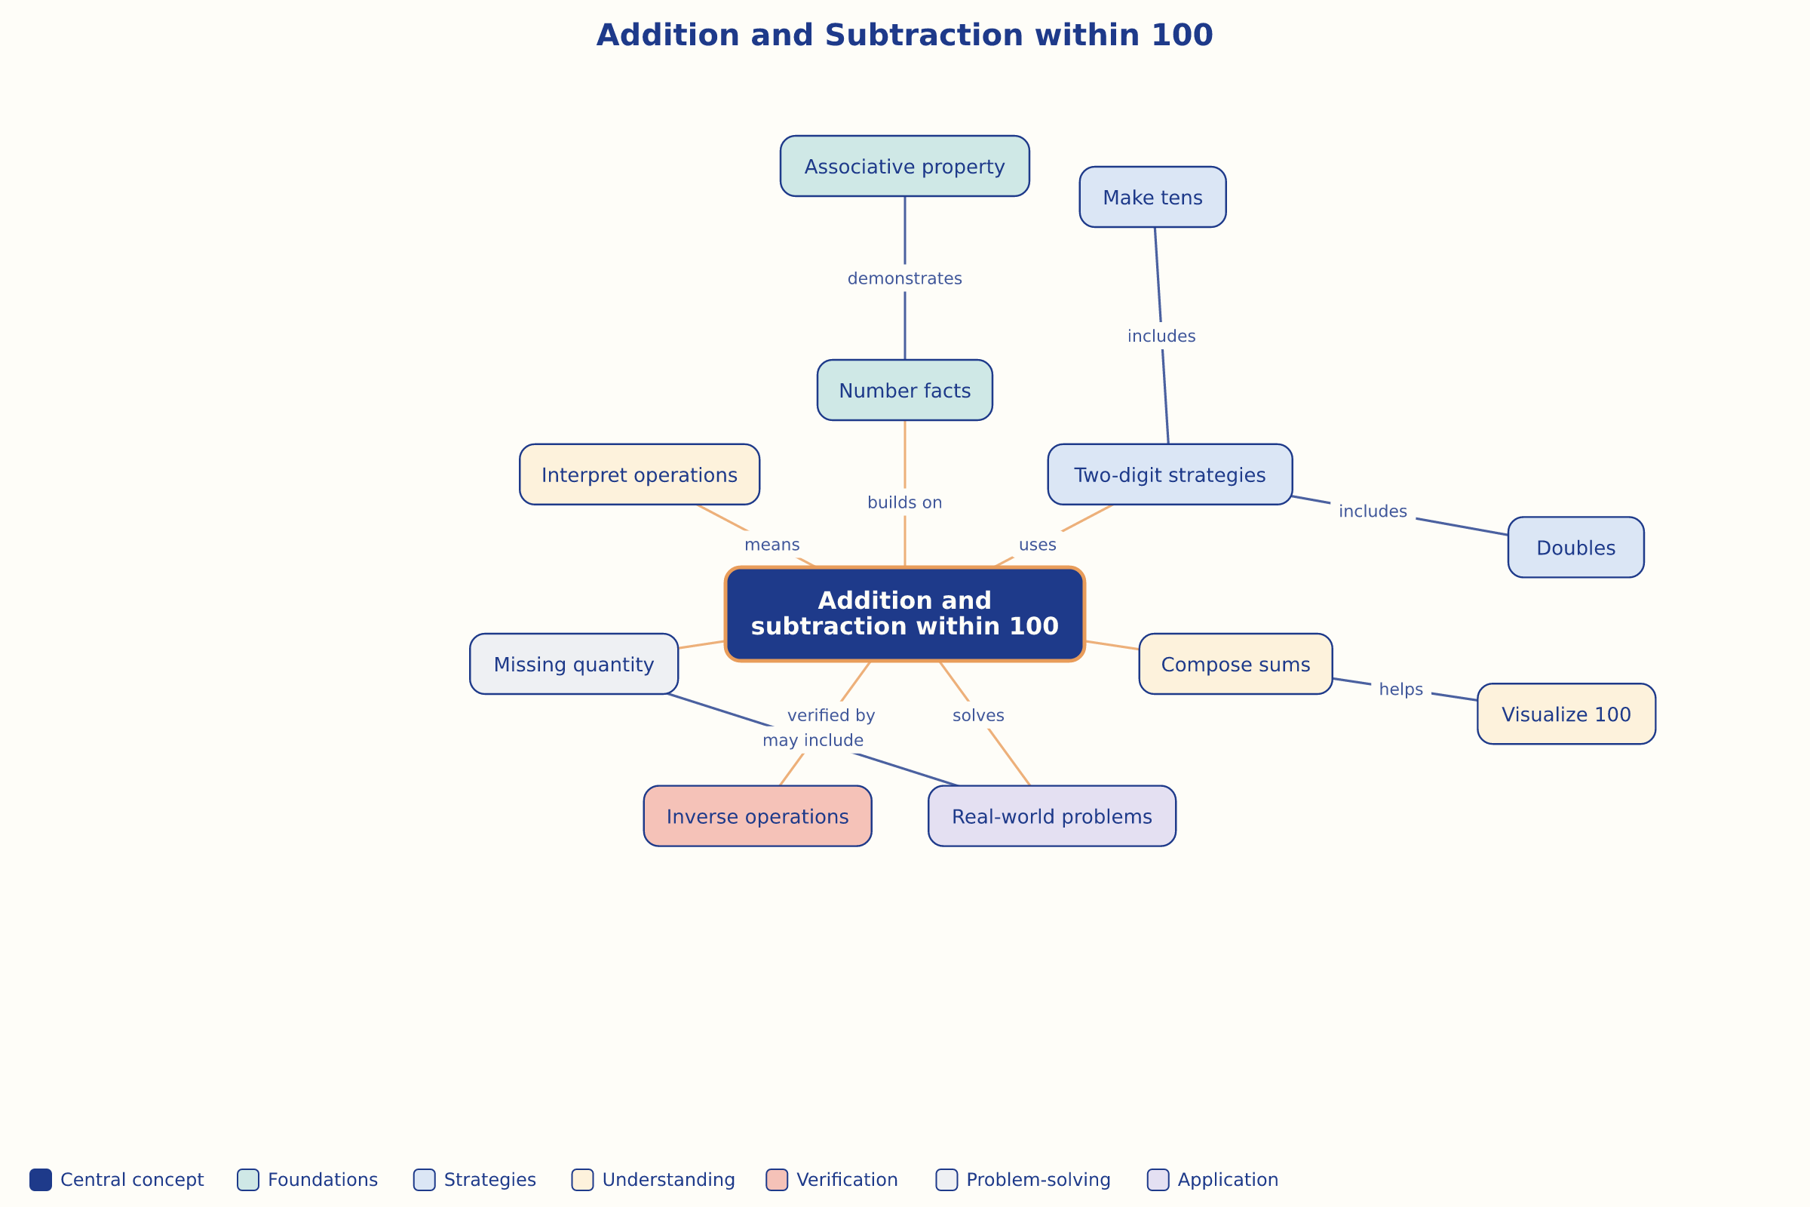

AILI word map · en · claude-haiku-4-5-20251001 · 2026-09-17

