The Calorimeter Mystery
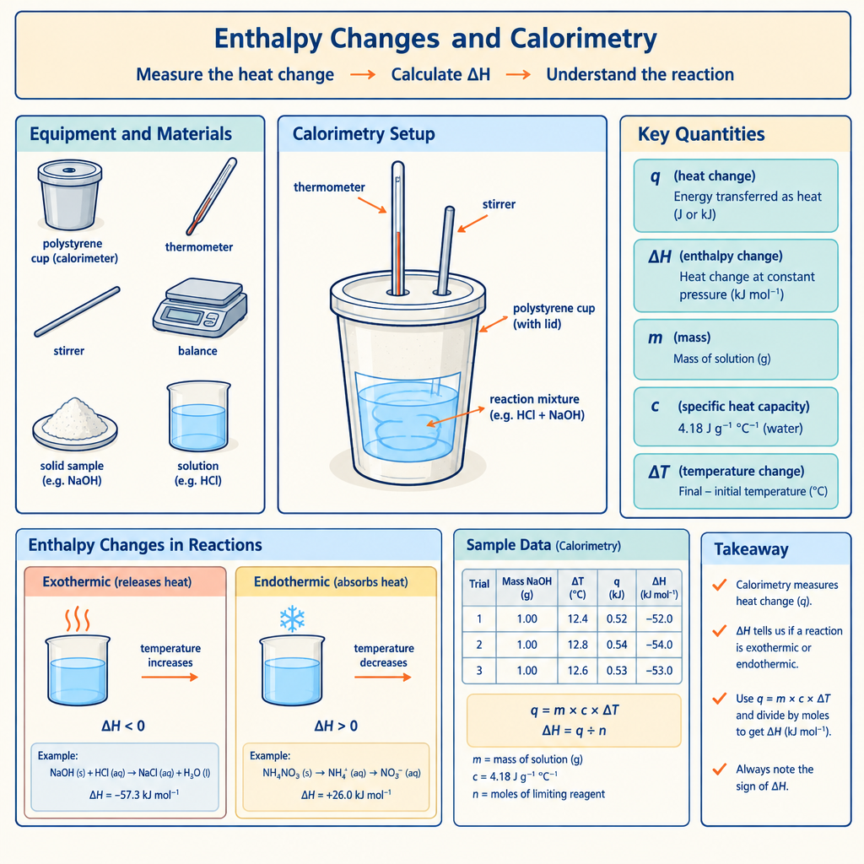
In Chemistry 30, you apply the relationship Q = mcΔt to analyze heat transfer in calorimetry experiments (Outcome). You also use calorimetry data to determine enthalpy changes in chemical reactions (Outcome) and interpret ΔH notation to communicate energy changes (Outcome). This puzzle challenges you to work backward from calorimetry results to find a missing piece of experimental data.

The puzzle
A student burns a food sample in a bomb calorimeter. The calorimeter contains 500 grams of water. After the combustion, the water temperature rises from 22°C to 28°C. The student records the heat released by the food as 12,600 joules.
However, the student forgot to record one crucial measurement: the specific heat capacity of water used in the calculation. The student knows that the specific heat capacity of pure water is 4.18 J/(g·°C), but wonders whether the value actually used in the Q = mcΔt equation matches this standard value.
Calculate what specific heat capacity value the student must have used in the Q = mcΔt equation to arrive at the recorded result of 12,600 joules. Show your reasoning. Does this value match the standard specific heat capacity of water?

Hints
Hint 1: Rearrange Q = mcΔt to solve for the unknown variable. What are you solving for?
Hint 2: You know Q (heat released), m (mass of water), and ΔT (temperature change). The only unknown is c, the specific heat capacity. Substitute the numbers you have and solve for c.
Hint 3: Calculate ΔT first: 28°C − 22°C = 6°C. Then divide Q by the product of m and ΔT to find c. Your answer should be in units of J/(g·°C).

Answer key
The answer: The specific heat capacity used was approximately 4.2 J/(g·°C).
The reasoning:
Start with Q = mcΔt and rearrange to solve for c:
c = Q ÷ (m × ΔT)
Substitute the known values:
c = 12,600 J ÷ (500 g × 6°C)
c = 12,600 J ÷ 3,000 g·°C
c = 4.2 J/(g·°C)
This value is very close to the standard specific heat capacity of pure water, 4.18 J/(g·°C). The small difference (4.2 versus 4.18) results from the rounded values chosen for this puzzle. The student's calculation is sound and consistent with the accepted value for water.

AILI game · en · claude-haiku-4-5-20251001 · 2026-09-17

