The Calorimetry Detective
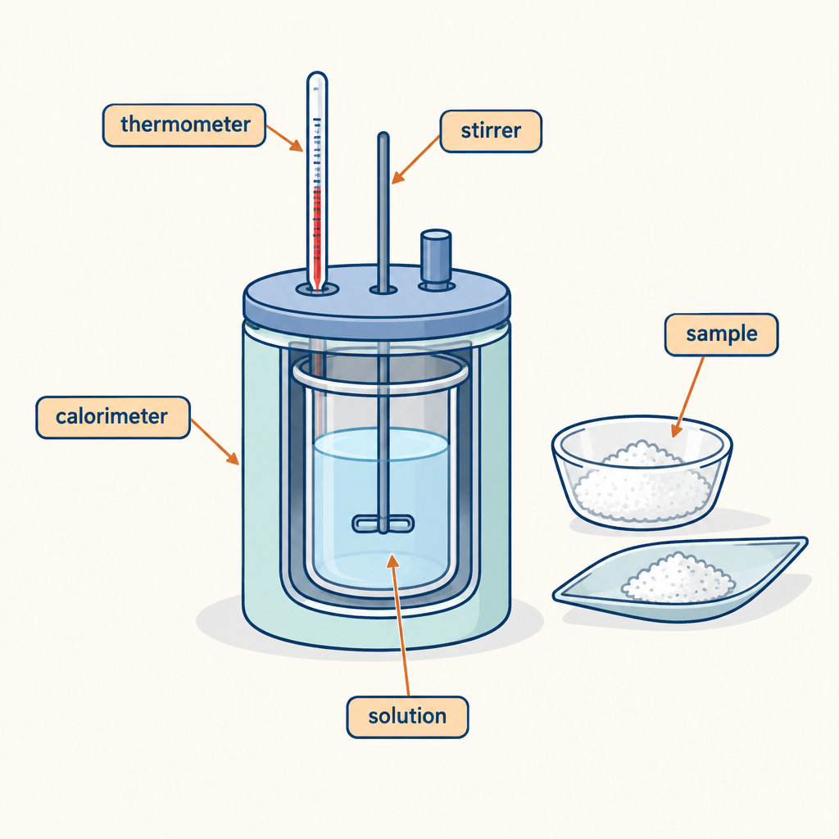
This puzzle challenges you to apply the heat transfer equation Q = mcΔt and interpret enthalpy data from a calorimetry experiment (Outcome, Outcome). You will determine energy changes in chemical reactions by working backwards from thermal measurements (Topic).

The puzzle
A student burns a food sample in a calorimeter. The calorimeter contains 200 grams of water. Before the reaction, the water temperature is 22°C. After the reaction, the water temperature rises to 38°C.
The student then repeats the experiment with a different food sample of the same mass. This time the water temperature rises from 22°C to 45°C.
The specific heat capacity of water is 4.18 J/(g·°C).
Your task: Calculate the heat released by each food sample. Then determine which sample released more energy per gram of food burned, and by how much (in joules).

Hints
Hint 1: Use the equation Q = mcΔt for each trial. Remember that ΔT is the change in temperature, not the final temperature.
Hint 2: The mass of water is the same in both trials. The specific heat capacity is the same. Only the temperature change differs between the two experiments.
Hint 3: Once you have calculated Q for each sample, compare the two values. The difference between them is the additional energy released by the second sample.

Answer key
First sample:
ΔT = 38°C − 22°C = 16°C
Q = mcΔt = 200 g × 4.18 J/(g·°C) × 16°C = 13,376 J
Second sample:
ΔT = 45°C − 22°C = 23°C
Q = mcΔt = 200 g × 4.18 J/(g·°C) × 23°C = 19,228 J
Difference:
19,228 J − 13,376 J = 5,852 J
The second food sample released 5,852 joules more energy than the first sample.
Reasoning: Calorimetry measures the heat transferred from a chemical reaction to the surroundings (the water). The larger the temperature change in the water, the more heat was released by the reaction. By applying Q = mcΔt to both trials and comparing the results, you determine that the second food sample is a more energy-dense fuel (Outcome, Outcome). This type of calculation is central to determining enthalpy changes from experimental data (Outcome).

AILI game · en · claude-haiku-4-5-20251001 · 2026-09-17

