Enthalpy Changes and Calorimetry
Using temperature data to calculate the heat and molar enthalpy change of a chemical reaction.
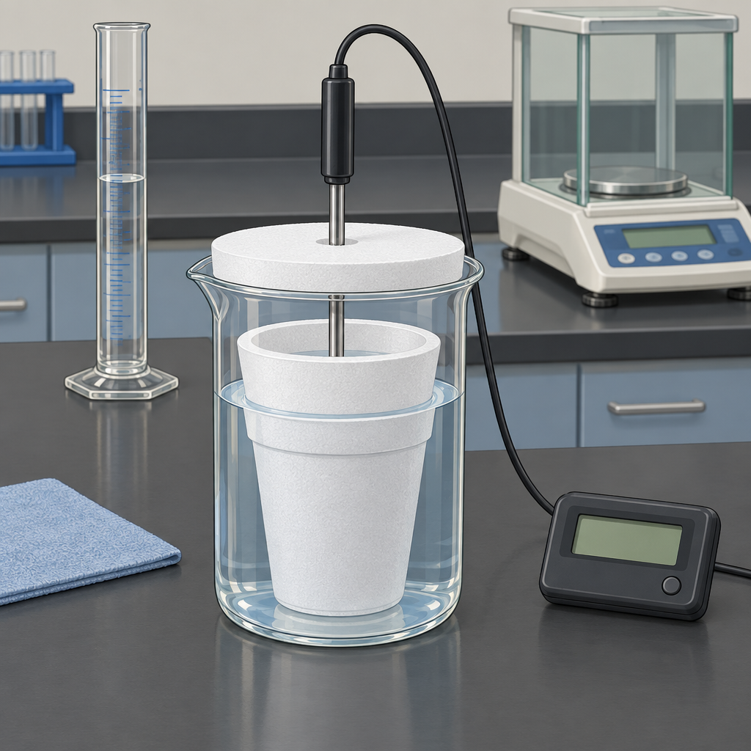

Learning intentions
We are learning to:
- Define enthalpy and molar enthalpy for a chemical reaction.
- Apply Q = mcΔt to calculate heat transferred during a reaction.
- Use calorimetry data to calculate the molar enthalpy change of a reaction and express it using correct ΔH notation.

Success criteria
I can:
- State what enthalpy and molar enthalpy mean in the context of a chemical reaction.
- Calculate Q using Q = mcΔt, with correct units, from given mass, specific heat capacity and temperature change.
- Convert a heat value into a molar enthalpy change (kJ/mol) using moles of limiting reactant.
- Write the enthalpy change using ΔH notation, including the correct sign.

Curriculum alignment
- 30-A1.3k: define enthalpy and molar enthalpy for chemical reactions (Outcome, Outcome)
- 30-A1.1k: recall the application of Q = mcΔt to the analysis of heat transfer (Outcome, Outcome)
- 30-A1.8k: use calorimetry data to determine the enthalpy changes in chemical reactions (Outcome)
- 30-A1.5k: use and interpret ΔH notation to communicate and calculate energy changes in chemical reactions (Outcome)
- 30-A1.2s: perform calorimetry experiments and use temperature probes appropriately when measuring temperature changes (Outcome)
- 30-A1.3s: analyze data and apply mathematical models to determine energy changes (Outcome)

Materials
- Whiteboard or projector for worked examples
- Student handout with the calorimetry problem set (create from examples below)
- Scientific calculators
- One demonstration calorimeter set-up: polystyrene cups, thermometer or temperature probe, graduated cylinder, hot plate or kettle, balance (for a quick live demo or to reference photographs from Resource)
- Sticky notes or mini whiteboards for the exit check

Lesson sequence
1. Hook (5 minutes)
Ask the class: "If I dissolve 5.0 g of solid sodium hydroxide in 100 mL of water in a foam cup, and the temperature rises from 21.0°C to 33.5°C, where did that energy come from, and where did it go?"
Take two or three verbal answers. Push for the idea that the chemical reaction released energy and the water absorbed it. Write on the board: "Today we calculate exactly how much energy, and express it per mole of reactant."
2. Direct instruction (10 minutes)
Define terms on the board:
- Enthalpy (H): the heat content of a system at constant pressure. Enthalpy change (ΔH) is the heat absorbed or released by a reaction (Outcome, Outcome).
- Molar enthalpy (ΔHmol): the enthalpy change per mole of a specified reactant or product, in kJ/mol (Outcome, Outcome).
- ΔH is negative for exothermic reactions and positive for endothermic reactions (Outcome).
Write the calorimetry equation: Q = mcΔt, where Q is heat transferred (J), m is mass of the calorimeter fluid (g), c is specific heat capacity (J/(g·°C), usually 4.19 for water), and Δt is the temperature change (°C) (Outcome, Outcome).
Work through this example on the board:
"25.0 g of water absorbs heat as a reaction proceeds. The water temperature rises from 20.0°C to 27.4°C. Calculate Q."
Q = mcΔt
Q = (25.0 g)(4.19 J/(g·°C))(7.4°C)
Q = 775 J
Q = 0.775 kJ
Then extend it to molar enthalpy: "This heat was released by 0.010 mol of reactant. Calculate the molar enthalpy change and write it with correct notation."
ΔHmol = Q ÷ n = 0.775 kJ ÷ 0.010 mol = 77.5 kJ/mol
Since the water gained heat, the reaction released heat, so the reaction itself is exothermic: ΔH = −77.5 kJ/mol (Outcome, Outcome).
Point out the sign convention explicitly: heat gained by the water is heat lost by the reacting system, so the sign flips when you assign ΔH to the reaction.
3. Guided practice (10 minutes)
Put this problem on the board and work it with the class, calling on different students for each step:
"In a calorimetry experiment, 50.0 g of water is heated by the combustion of a small sample of fuel. The water temperature increases from 22.0°C to 46.0°C. The fuel sample used has a mass corresponding to 0.0050 mol.
a) Calculate Q.
b) Calculate the molar enthalpy change of combustion.
c) Write the value using ΔH notation, including its sign."
Guide students to:
a) Q = mcΔt = (50.0 g)(4.19 J/(g·°C))(24.0°C) = 5028 J = 5.03 kJ
b) ΔHmol = 5.03 kJ ÷ 0.0050 mol = 1006 kJ/mol
c) ΔH = −1006 kJ/mol (exothermic, since the water gained heat)
Pause here for a checkpoint (see Assessment section) before moving to independent work.
Reference Resource briefly: "This is the same reasoning used in the nut-combustion calorimetry lab, where burning a food sample heats a known mass of water."
4. Independent practice (10 minutes)
Students work individually or in pairs on two problems, written on the handout:
Problem 1: "75.0 g of water in a calorimeter increases in temperature from 19.5°C to 28.0°C when 0.0125 mol of a salt dissolves. Calculate Q, calculate the molar enthalpy of dissolution, and write ΔH with the correct sign."
Problem 2: "A student burns 0.80 g of ethanol (molar mass 46.0 g/mol) under 100.0 g of water. The water temperature rises by 32.0°C. Calculate the moles of ethanol burned, calculate Q, calculate the molar enthalpy of combustion, and write ΔH with the correct sign."
Circulate while students work. Prompt students who get stuck on Problem 2 with: "What do you need before you can calculate ΔHmol? How many moles of ethanol actually reacted?"
5. Consolidation (5 minutes)
Cold-call for answers to Problem 1 and Problem 2, and correct any sign errors on the board.
Ask: "Why does calorimetry only give us an experimental value for ΔH, rather than the true value?" Draw out ideas such as heat loss to the surroundings, the calorimeter absorbing some heat, and incomplete reactions. Note this connects to Resource, where students test calorimeter precision directly.
Close with a one-sentence exit prompt written on the board: "In your own words, what is the difference between enthalpy and molar enthalpy?"

Differentiation
Extension: Ask early finishers to research why the value of ΔH for a reaction obtained experimentally often differs from the accepted literature value, and to list two sources of experimental error specific to a polystyrene-cup calorimeter (reference Resource). Extend Problem 2 by asking students to compare their experimental ΔH of combustion for ethanol to a published value and calculate a percent difference.
Support: Provide a written step-by-step template for Problems 1 and 2 that separates the Q calculation from the ΔHmol calculation into two labelled boxes. Provide a reference card with Q = mcΔt, ΔHmol = Q ÷ n, and the sign rule (system loses heat → ΔH negative; system gains heat → ΔH positive) for students to keep at their desks. Allow calculators with stored formulas and pair support students with a stronger peer for the independent practice.

Assessment
Formative check: During the guided practice checkpoint, ask students to hold up mini whiteboards or sticky notes showing only their calculated Q value for the combustion problem before revealing the class answer.
Look for:
- Correct substitution into Q = mcΔt with matching units (mass in grams, c in J/(g·°C), Δt in °C).
- Correct handling of Δt (final minus initial, always positive when temperature rises).
- Whether students convert J to kJ correctly before the next step.
Use the spread of answers to decide whether to slow down before independent practice or move ahead as planned.

AILI rapid lesson · en · claude-sonnet-5 · 2026-09-17

