Cells and Systems: Building Blocks of Living Things
A lesson on why every living thing, from a single amoeba to a teenager sprinting the 100 metres, is built from cells doing organized work.
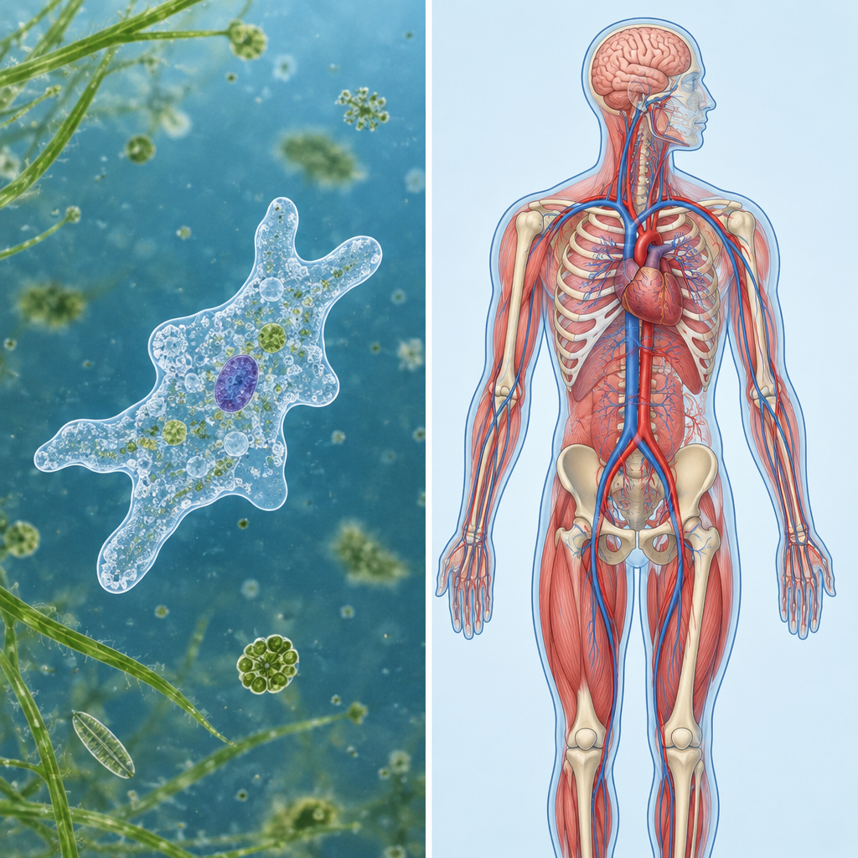

Learning intentions
We are learning to:
- Describe cells as the basic unit of life and explain how cells differ between plants and animals.
- Explain how cells, tissues and organs work together to keep an organism functioning.

Success criteria
I can:
- State that cells are the basic unit of life and give one reason why.
- Name at least two differences between a plant cell and an animal cell.
- Explain, in my own words, how cells build tissues, tissues build organs, and organs build systems.

Curriculum alignment
- Describe the role of cells as a basic unit of life, and distinguish between plant and animal cells (Outcome, Outcome).
- Examine plant and animal structures and identify the contributing roles of cells, tissues and organs (Outcome, Outcome).
- Apply the concept of system to describe the general structure and function of living things (Outcome, Outcome).
- Connect to the unit's key concepts of organisms, cells, organs, tissues, and systems (Topic).

Materials
- Whiteboard or projector
- Diagram or slide showing a plant cell and an animal cell side by side (cell wall, cell membrane, nucleus visible)
- Sticky notes or small paper strips, four per student
- Student notebooks
- Optional: prepared microscope slides of onion skin (plant cell) and cheek cells (animal cell), plus microscopes, if available

Lesson sequence
1. Hook (5 minutes)
Write this question on the board: "What do a mushroom, a mosquito and you have in common?"
Give students 60 seconds to talk to a partner, then take two or three quick answers. Steer the discussion toward: they are all made of cells. Ask: "If cells are so small you can't see them without a microscope, why do scientists say they're the most important building block in biology?" Let two students respond, then say: "By the end of today you'll be able to answer that yourself."
2. Direct instruction (10 minutes)
Explain: "Every living thing, whether it has one cell or trillions, is built from cells. A cell is the basic unit of life. That means it's the smallest thing that can carry out all the activities of being alive: taking in energy, getting rid of waste, and reproducing" (Outcome).
Show the plant cell / animal cell diagram. Ask students to copy a simple two-column table into their notebooks: Plant Cell / Animal Cell. Walk through these points and have students fill in the table as you go:
- "Plant cells have a cell wall, a stiff outer layer that gives the plant support, like the frame of a tent. Animal cells don't have a cell wall, only a cell membrane" (Outcome).
- "Both plant and animal cells have a cell membrane, which controls what moves in and out."
- Ask: "Why might a tree need something stiffer than an animal cell needs?" Take one or two answers (support, staying upright without a skeleton).
Introduce diffusion briefly: "Gases and liquids move into and out of cells by diffusion and osmosis, moving from where there's more of them to where there's less. That's how oxygen gets into a cell and carbon dioxide gets out" (Outcome). Keep this at a general level; the outcome does not require mechanism detail.
3. Guided practice (10 minutes)
Draw four boxes on the board in a row, labelled left to right: cell, tissue, organ, system. Do not fill in the labels yet, just draw the boxes.
Explain the organization ladder using the human body as the example: "A single muscle cell can't lift a backpack on its own. Muscle cells group together to form muscle tissue. Muscle tissue combines with other tissues to form an organ, like your heart. Your heart works together with blood vessels to form your circulatory system" (Outcome, Outcome).
Ask the class to help you label the four boxes as you go, then add the human example above each box: cell (muscle cell) → tissue (muscle tissue) → organ (heart) → system (circulatory system).
Now ask a check question: "Using the same pattern, what's the plant version? Start with a leaf cell." Cold-call two or three students to build it together on the board: leaf cell → leaf tissue → leaf (organ) → the plant's whole structure. This applies the concept of system to a different organism, as the curriculum asks (Outcome, Outcome).
4. Independent practice (10 minutes)
Hand out four sticky notes per student. Ask each student to pick one human body system from this list: respiration, circulation, digestion, or excretion (Outcome).
On their four sticky notes, they write:
- The name of their chosen system.
- One organ that belongs to that system.
- One job that organ does.
- One way the body changes when it's working hard (for example: "heart rate increases during exercise" or "you breathe faster after running").
Circulate while they work. Prompt any student who is stuck with: "Think about what happens to your body right after gym class. What changes, and which system is responsible?" (Outcome).
5. Consolidation (5 minutes)
Ask two or three volunteers to read their four sticky notes aloud. As each student shares, ask the class: "Which box does that fit in: cell, tissue, organ, or system?"
Close with this exit question, answered in one sentence in their notebooks: "Why do scientists describe living things as systems rather than just piles of cells?" Collect notebooks on the way out, or have students hold their answer up for a quick visual check.

Differentiation
Extension: Ask students who finish early to research one real single-celled organism (such as an amoeba or a paramecium) and compare it, in two or three sentences, to a multicelled organism like a grizzly bear or a poplar tree, noting how the single cell still manages to carry out all life functions on its own (Outcome).
Support: Provide a partially filled organization ladder (cell → tissue → organ → system) with the human example already written in, so students only need to complete the plant example. For the sticky note task, give a sentence starter: "The ___ system includes the ___, which helps the body by ___."

Assessment
Formative check: collect the exit question responses at the end of class.
Look for whether students can connect the idea of "system" to cells working together, rather than describing cells as isolated parts. A strong answer names at least two levels of organization (for example, cells forming tissues, tissues forming organs) and explains that the body needs all levels working together to stay healthy (Outcome, Outcome). Students who only describe cells in isolation, without mentioning how they combine or cooperate, need a follow-up mini-lesson revisiting the cell-tissue-organ-system ladder before moving to the next lesson on body systems in detail.

AILI rapid lesson · en · claude-sonnet-5 · 2026-09-17

