Comprehending and Responding to Texts (ELA 30-1)
Central concept: Comprehend and respond to texts

Connections
- Comprehend and respond to texts (requires) -> Construct meaning from text
- Comprehend and respond to texts (requires) -> Connect self, text, culture
- Construct meaning from text and context (requires) -> Understand and interpret content
- Construct meaning from text (depends on) -> Discern and analyze context
- Construct meaning from text (uses) -> Engage prior knowledge
- Construct meaning from text (includes) -> Analyze narrative elements
- Construct meaning from text (supported by) -> Use reference strategies
- Understand textual forms (includes) -> Relate devices to effects
- Connect self, text, culture (leads to) -> Evaluate texts critically
- Connect self, text, culture (leads to) -> Appreciate artistry
- Evaluate texts critically (supports) -> Form conclusions
- Appreciate artistry (supports) -> Form conclusions

Notes
- Comprehend and respond to texts: Core outcome: comprehend literature and texts in multiple forms and respond personally, critically and creatively Topic
- Construct meaning from text: Use strategies to understand texts; analyze relationships among ideas; understand contextual elements and subtext Outcome, Outcome
- Discern and analyze context: Explain text creator's purpose; analyze communication situation; understand text and context interplay; identify personal context impact Outcome, Outcome
- Engage prior knowledge: Reflect on comprehension strategies; assess prior knowledge of contexts and forms; identify variations from conventional devices Outcome
- Understand textual forms: Relate form and structure to purpose and audience; analyze organizational patterns; assess text structure effectiveness Outcome
- Relate devices to effects: Assess rhetorical devices, stylistic techniques, figurative language, symbol and imagery; analyze irony and satire Outcome
- Analyze narrative elements: Assess setting, plot, character and atmosphere; analyze character traits and motivations; relate tone to moral stance Outcome, Outcome
- Connect self, text, culture: Identify personal and cultural perspectives; form positions on issues; assess character choices; respond to cultural influences Outcome
- Evaluate texts critically: Identify evaluation criteria; assess interpretation appropriateness; analyze authenticity of settings and characters; assess theme significance Outcome
- Appreciate artistry: Use appropriate terminology; appreciate text creator's craft; recognize shape and substance of literature Outcome
- Use reference strategies: Use reference strategies and technologies; formulate questions; explore sources; create personalized reference materials Outcome
- Form conclusions: Synthesize ideas by integrating information with prior knowledge; draw appropriate conclusions; support with relevant detail Outcome
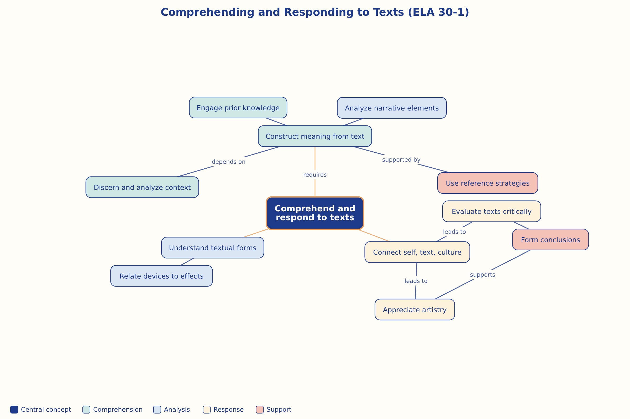

AILI word map · en · claude-haiku-4-5-20251001 · 2026-09-17

