Cell Systems Crossword of Clues
This puzzle draws on the Science Grade 8 outcomes for interpreting living things through the ideas of cells, tissues, organs and systems (Topic, Outcome), the role of cells as the basic unit of life (Outcome), and the distinction between plant and animal cells based on structures such as the cell wall and cell membrane (Outcome).

The puzzle
A biology lab has mixed up its specimen labels. Four structures, four functions. Your task is to match each structure to its correct function using only the clues below. Biological systems rely on each other, and structures within systems can perform multiple functions to support vital biological processes.
The four structures: cell wall, cell membrane, tissue, organ.
The four functions: controls what substances move into and out of the cell; gives a plant cell rigid support and shape; is a group of similar cells working together; is made up of different tissues working together to perform a specific job.
Clues:
- The structure that gives rigid support and shape is found only in plant cells, never in animal cells (Outcome).
- The structure that controls movement of substances is present in both plant and animal cells (Outcome).
- A tissue is not the same level of organization as an organ. An organ is built from more than one tissue type (Outcome).
- Diffusion and osmosis, which move gases and liquids into and out of cells based on concentration differences, happen at the structure that controls what enters and leaves the cell, not at the structure that gives shape (Outcome).
Work out which structure matches which function. Write your four matched pairs on your answer sheet before checking the key.
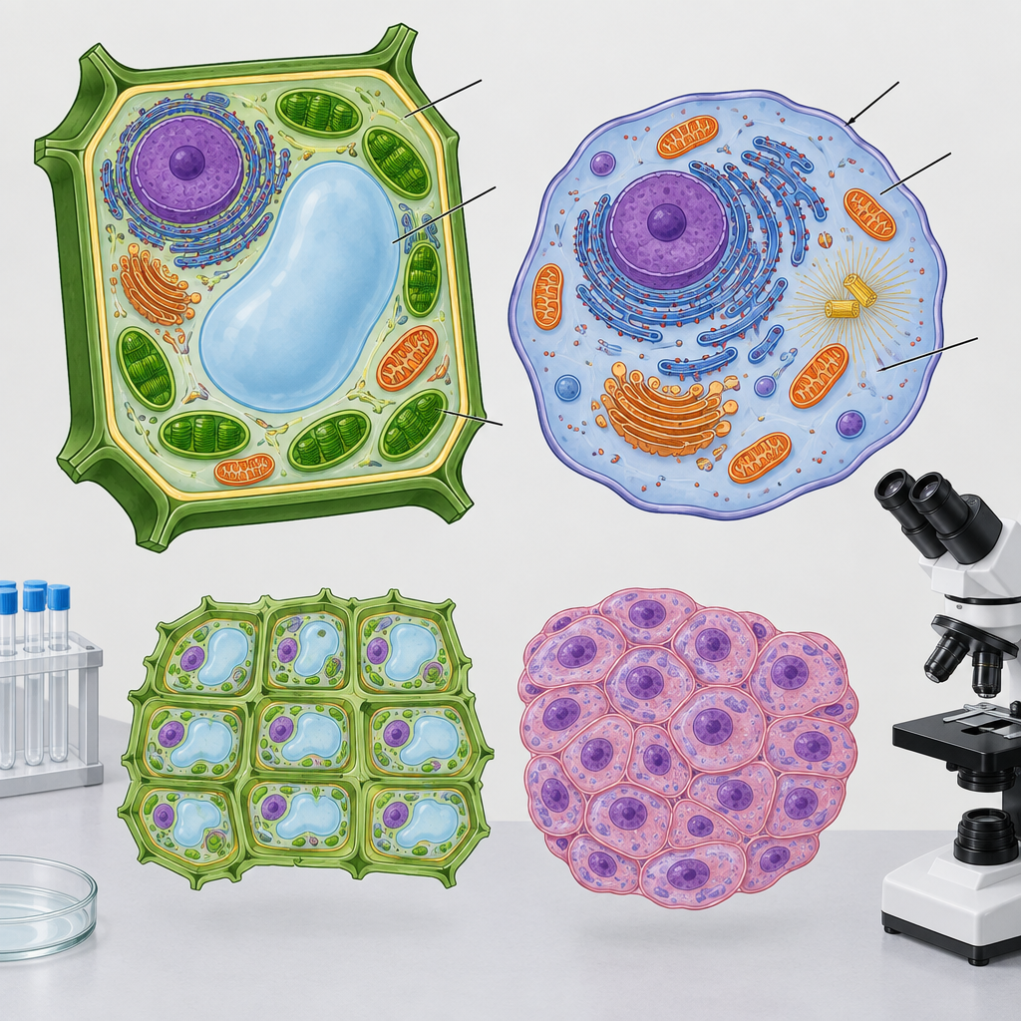

Hints
Hint 1: Start with the structure that only appears in one type of cell. That narrows down one pair immediately.
Hint 2: Once you know which structure gives shape and support, the remaining cell-level structure must handle the job of controlling movement in and out.
Hint 3: For the two organization-level terms, remember that the smaller unit is a group of similar cells, and the larger unit is built from more than one type of that smaller unit.

Answer key
Cell wall matches "gives a plant cell rigid support and shape." Clue 1 states this structure exists only in plant cells, and the cell wall is the plant-only structure named in the puzzle (Outcome).
Cell membrane matches "controls what substances move into and out of the cell." Clue 2 confirms this structure exists in both plant and animal cells, and clue 4 confirms diffusion and osmosis occur at this location (Outcome).
Tissue matches "is a group of similar cells working together." This follows from clue 3, which distinguishes tissue as the smaller unit of organization (Outcome).
Organ matches "is made up of different tissues working together to perform a specific job." Clue 3 establishes that an organ is built from more than one tissue type, placing it above tissue in the organization scale from cell to tissue to organ (Outcome, Topic).

Note: 2 learning outcome blocks were left out to fit the 4000-token curriculum budget for this kind of material. Use "Split into parts" to generate one document per organizing idea.

AILI game · en · claude-sonnet-5 · 2026-09-17

