Biological Diversity: Variation and Species Survival
Variation, niches and symbiosis in Grade 9 Unit A
Audience: Grade 9 science students studying Unit A: Biological Diversity
Grades: Grade 9
Subjects: Science
Time: about 50 minutes
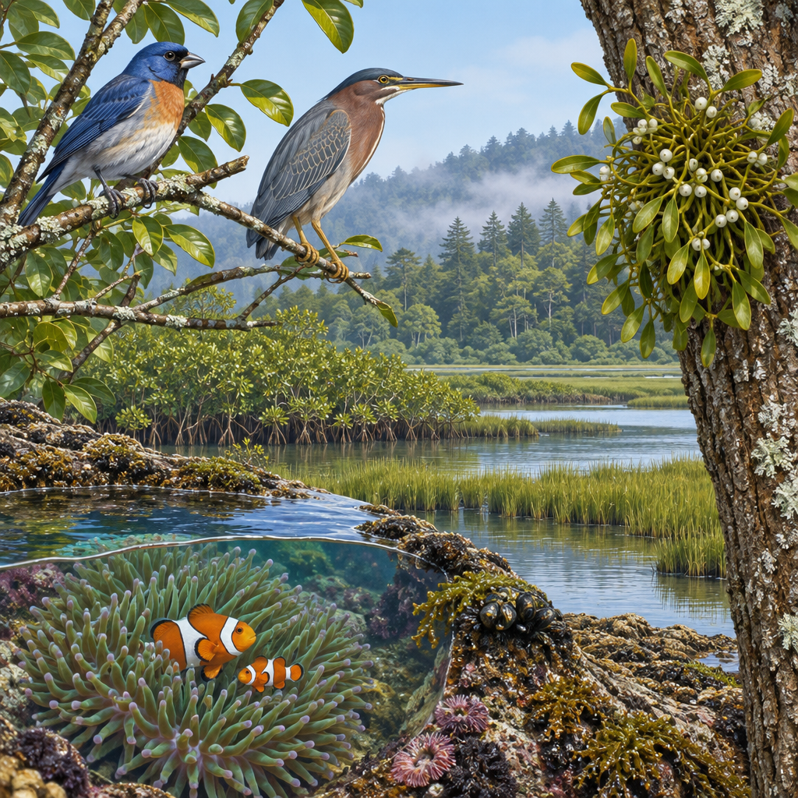

Overview
This lesson opens Unit A: Biological Diversity by focusing on why variation exists within a species and how diversity is maintained through natural processes of reproduction(Topic). Students distinguish discrete variation (such as hand-clasping preference) from continuous variation (such as height), and examine examples of variation of characteristics within a species(Outcome, Outcome, Outcome).
The lesson uses a hands-on card-sort activity so students actively classify relationships rather than only listening to definitions. It builds directly on Grade 7 Unit A: Interactions and Ecosystems and sets up the next lessons on reproduction, heredity and genetic material (Topic, Outcome, Outcome).

Outcomes covered
- Investigate and interpret diversity among species and within species, and describe how diversity contributes to species survival. (Outcome, Outcome)
Understanding why variation exists helps students explain real events, like why some organisms survive a disease outbreak or environmental change while others do not.
- Identify examples of niches, and describe the role of variation in enabling closely related living things to survive in the same ecosystem; identify examples of symbiotic relationships and classify them as mutualism, commensalism or parasitism. (Outcome, Outcome)
Classifying relationships between species builds the vocabulary students need to analyze food webs and ecosystem dependencies in later units and courses.
- Describe examples of variation of characteristics within a species, and identify examples of both discrete and continuous variation. (Outcome)
Recognizing examples of discrete and continuous variation prepares students for understanding how characteristics are transmitted from parents to offspring.

Materials
- Whiteboard or chart paper for the focusing question
- Sets of 8 pre-made card-sort cards per group (organism relationship and variation examples)
- Exit ticket handout or projected questions (3 short-answer questions)
- Criteria list or exemplar bank for peer checking exit tickets
- Optional: images or sketches of birds, clownfish and anemone, mistletoe on a tree

Sequence of activities

1. Warm-up: What makes a species survive? (8 min, whole class)
- Project or sketch two images on the board: a peppered moth population with light and dark forms, and a finch flock with different beak shapes.
- Ask: Why don't all members of a species look identical? Take three or four quick answers, no judgment yet.
- Introduce the term variation and write the focusing question on the board: What is biological diversity, and how does it help species survive? (Topic)
- Tell students that today's lesson connects variation within species to survival, using symbiosis and reproduction as two mechanisms that maintain diversity.
Accept any reasonable answer (food, predators, mutation). The goal is to activate prior knowledge from Grade 7 Unit A: Interactions and Ecosystems (Topic), not to mark right or wrong yet.
Sources: Topic

2. Direct instruction: Diversity within and among species (12 min, whole class)
- Define biological diversity as the range of species in an environment plus the variation found within a single species (Topic, Outcome).
- Show or describe an example: two closely related bird species in the same park that eat different foods because of differently shaped beaks. Ask students to name the niche each bird occupies (Outcome).
- Explain that variation can be discrete (either/or, like hand-clasping preference) or continuous (a range, like hand length) (Outcome). Have students silently classify two more examples you give (e.g., blood type vs. height) and check with a neighbour.
- Introduce symbiosis and its three categories: mutualism (both benefit), commensalism (one benefits, other unaffected), parasitism (one benefits, other harmed) (Outcome, Outcome). Give one real example of each: bees and flowers (mutualism), barnacles on a whale (commensalism), tapeworms in a host (parasitism).
- Ask: how does variation help a population survive a disease outbreak or a harsh winter? Identify the role of variation in species survival under changing environmental conditions, such as resistance to disease and ability to survive in severe environments.
Watch for students confusing commensalism with mutualism; reinforce that commensalism means one organism is unaffected, not slightly helped. Keep examples local where possible (e.g., lichen on trees, mistletoe on host trees) to ground the concept in Alberta ecosystems.
Sources: Outcome, Outcome, Outcome, Topic

3. Small group station work: Classify the relationship, classify the variation (18 min, small group)
- Divide the class into groups of three or four. Give each group a set of eight cards describing real organism relationships and variation examples (see list below).
- Groups sort cards into two piles: symbiosis type (mutualism, commensalism, parasitism) and variation type (discrete or continuous) as appropriate to each card.
- Card examples (write these on cards or read aloud):
- Clownfish living among sea anemone tentacles (mutualism)
- Remora fish attached to a shark, eating scraps (commensalism)
- Head lice living on a human scalp (parasitism)
- Human eye colour categories (discrete)
- Human height measured in centimetres (continuous)
- Wolf pack cooperating to hunt (not symbiosis; same species, discuss why)
- Mistletoe drawing water and nutrients from a host tree (parasitism)
- Number of leaves on a clover plant (discrete)
- Each group identifies one example of sexual or asexual reproduction from the lesson. Correct misclassifications together.
- Groups record their final sort on a shared answer sheet for the formative check.
Answer key: clownfish/anemone = mutualism; remora/shark = commensalism; lice/scalp = parasitism; eye colour = discrete; height = continuous; wolf pack hunting = not symbiosis (intraspecies cooperation, a good discussion point about the difference between symbiosis and social behaviour); mistletoe/tree = parasitism; leaf count = discrete. Circulate to catch groups who mix up commensalism and mutualism.
Sources: Outcome, Outcome, Outcome

4. Consolidation: Exit ticket and class discussion (12 min, individual)
- Hand out or read aloud three exit-ticket questions:
- Question 1: Describe one example of discrete variation and one example of continuous variation within a species.
- Question 2: Name one example of asexual reproduction (such as binary fission, budding, or spore production) and describe how it differs from sexual reproduction.
- Question 3: Choose one trait that shows variation within a species and identify whether it is an example of discrete or continuous variation.
- Students answer individually in five to six minutes.
- Collect tickets or have students trade with a partner for a quick peer check against a shared criteria list.
- Close with a whole-class share: ask one student to read their answer to Question 3 aloud, then connect it forward to the next lesson on reproduction and heredity (Outcome, Outcome).
Use exit tickets as the main formative data point for this lesson. A strong Question 3 answer names a specific trait (such as disease resistance or drought tolerance) and links it to differential survival, not just 'diversity is good.'
Sources: Outcome, Outcome, Outcome

Differentiation
Extension
- Ask students to research one Alberta-specific symbiotic relationship (such as pine beetles and blue stain fungus) and classify it, then present a two-minute summary to a small group.
- Have advanced students explain why sexual reproduction, described in Outcome, might produce more variation for natural selection to act on than asexual reproduction, connecting to today's survival discussion.
Support
- Provide the card-sort groups with a pre-filled example row (one mutualism, one commensalism, one parasitism) as a model before they sort the rest.
- Give a simplified glossary card with one-line definitions of mutualism, commensalism, parasitism, discrete and continuous variation for students to keep on their desk during the station activity.
- Students may focus their responses on reproductive processes and variation to address key concepts about how characteristics are transmitted from parents to offspring.
Inclusive supports
- Read all card-sort and exit-ticket text aloud for students who benefit from auditory input.
- Allow students to answer the exit ticket verbally to the teacher or an educational assistant instead of in writing.
- Use large-print cards for the station activity for students with visual needs.

Assessment
Formative. Card-sort station activity where groups classify symbiotic relationships and variation types.
Look for: Correct sorting of mutualism, commensalism and parasitism examples, and correct identification of discrete versus continuous variation, with groups able to justify at least one classification aloud. (Outcome, Outcome, Outcome)
Formative. Exit ticket with three short-answer questions on symbiosis, variation and species survival.
Look for: Students correctly classify a symbiotic example, correctly distinguish discrete from continuous variation, and link variation to survival under changing conditions such as disease or drought. (Outcome, Outcome)
Peer. Partner check of exit tickets against a shared criteria list before submission.
Look for: Students can identify a peer's error and explain the correct classification using the vocabulary introduced in the lesson. (Outcome, Outcome)

Vocabulary
- Biological diversity: The range of species found in an environment, plus the variation in characteristics found within a single species.
- Niche: The specific role an organism plays in its ecosystem, including what it eats, where it lives and how it interacts with other species.
- Symbiosis: A close, long-term relationship between two different species. The three types covered in this lesson are mutualism, commensalism and parasitism.
- Mutualism: A symbiotic relationship in which both species benefit, such as bees pollinating flowers while feeding on nectar.
- Commensalism: A symbiotic relationship in which one species benefits and the other is neither helped nor harmed, such as a remora fish riding on a shark.
- Parasitism: A symbiotic relationship in which one species benefits at the expense of the other, such as a tapeworm living inside a host animal.
- Discrete variation: A trait that falls into distinct, separate categories with no in-between values, such as hand-clasping preference (left thumb over right, or right over left).
- Continuous variation: A trait that varies gradually along a range of values, such as human height or hand length.

For families
- Ask your teenager to point out an example of symbiosis they notice outside, such as birds nesting in a tree or moss growing on a rock, and talk about whether it helps, harms or has no effect on each organism.
- Compare heights or other physical traits among family members and discuss which ones seem to vary gradually (continuous) versus which fall into clear categories (discrete).

Sources
- Outcome: "describe examples of variation of characteristics within a species, and identify examples of both discrete and continuous variation"
- Outcome: "identify examples of symbiotic relationships... classify symbiotic relationships as mutualism, commensalism, parasitism"
- Outcome: "investigate and interpret dependencies among species that link the survival of one species to the survival of others"
- Topic: "Biological diversity is reflected in the range of species found in local and global environments and by subtle variations in characteristics found within individual species."
- Outcome: "describe the relative abundance of species on Earth and in different environments"
- Outcome: "compare sexual and asexual reproduction, in terms of the advantages and disadvantages"

All examples (clownfish, remora, lice, mistletoe, bird beaks, human traits) are age-appropriate, scientifically accurate and free of culturally sensitive content for Grade 9 students.

AILI detailed pack · en · claude-sonnet-5 · 2026-09-17

