The Knee Jerk
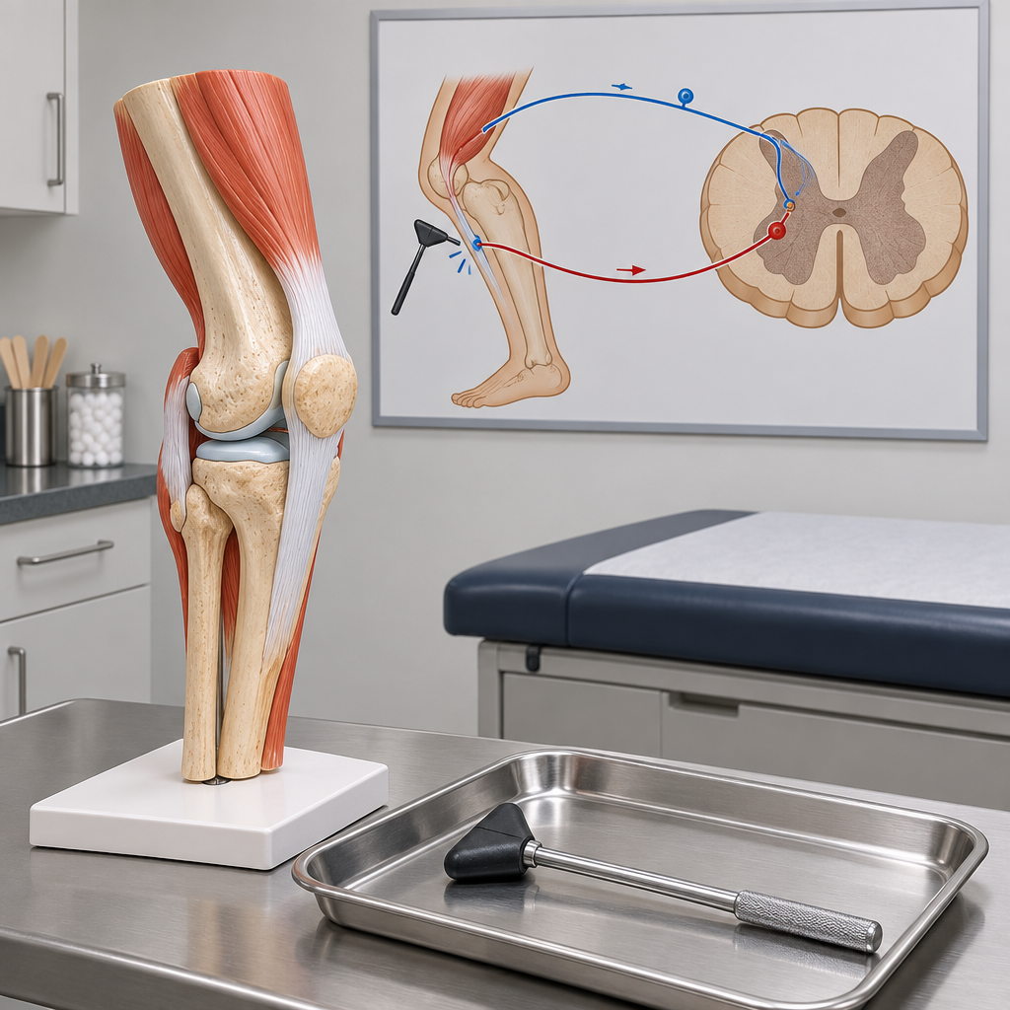
Malik sat on the exam table while Dr. Osei tapped his patellar tendon with a small rubber hammer. His leg kicked out before he even registered the tap.
"That felt automatic," Malik said.
"It is," she said. "A stretch receptor sent a signal along a sensory neuron straight to your spinal cord. A motor neuron fired back to your leg muscle before your brain even got the memo. That's a reflex arc."
"So my brain wasn't involved at all?"
"Not for that loop. Acetylcholine crossed the synapse, cholinesterase cleared it, done. Fast, involuntary, protective."
Malik flexed his knee, grinning. "My cerebellum's still going to take credit for balancing on it."
"Your cerebellum," she laughed, "always does."

Words to know
- reflex arc: The neural pathway from sensory receptor to spinal cord to motor response, producing an automatic, involuntary reaction.
- patellar reflex: The knee-jerk reflex triggered by tapping the tendon below the kneecap, a classic example of a spinal reflex arc.
- acetylcholine: A neurotransmitter that carries a signal across a synapse between neurons or between a neuron and a muscle.
- cholinesterase: An enzyme that breaks down acetylcholine in the synapse, stopping the signal so the neuron can reset.
- cerebellum: The brain structure responsible for coordinating balance, posture, and fine motor movement.
Curriculum link: Outcome, Outcome
Listen to the narration

AILI audio story · en · claude-sonnet-5 · 2026-09-17

