Healthy Bodies, Happy Kids
We learn how food and movement help us feel good and play well.
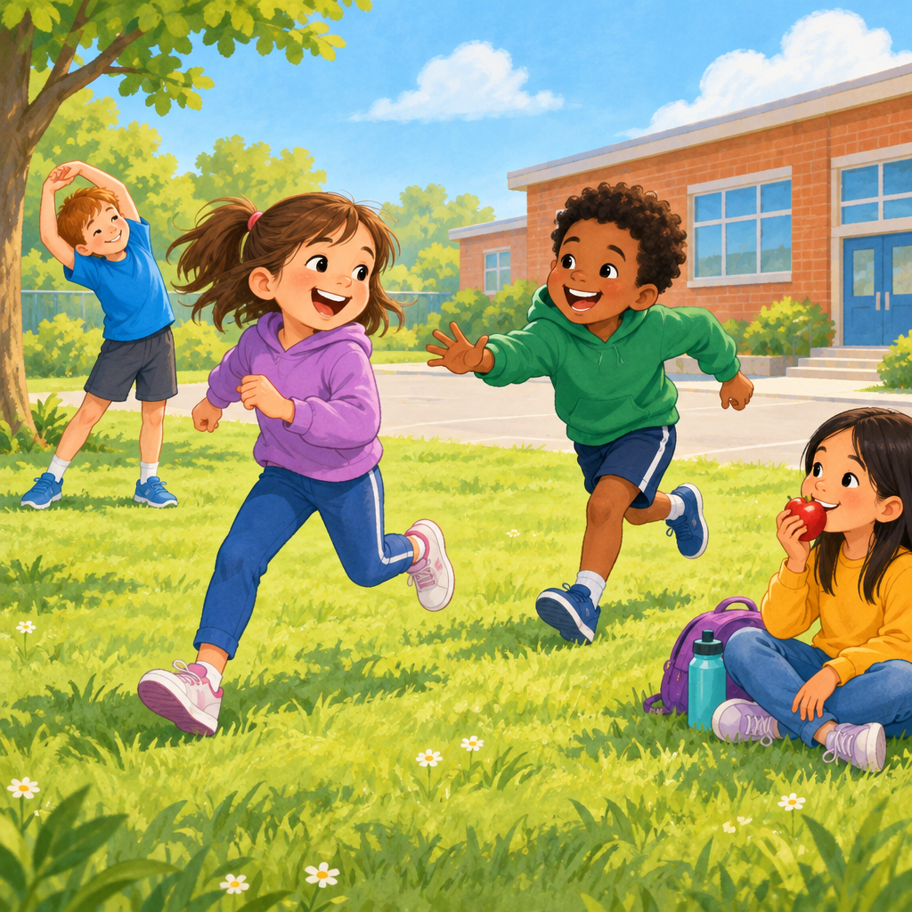

Learning intentions
We are learning to identify how food and physical activity affect how we feel and how our bodies work.

Success criteria
I can name foods that give my body energy.
I can describe what my body feels like during light, moderate, and vigorous activity.
I can explain why my body needs food and water before, during, and after play.
I can tell you one way activity makes me feel happy or calm.

Curriculum alignment
Students investigate physical activity and relate it to personal experience (Outcome). Students examine internal and external factors that influence food choices and decisions (Outcome). Factors influencing physical activity include peers, family, culture, natural environments, and built environments (Knowledge). Preparation for and recovery from physical activity include nutrition and hydration (Knowledge). Cues associated with hunger include stomach growling, low energy, and irritability (Knowledge). Physical activity can require varying degrees of exertion and energy (Understanding).

Materials
Sticky notes (one per child).
Markers or crayons.
Chart paper and a marker for the teacher.
A water bottle.
Pictures of foods (printed or drawn): apple, banana, carrot, chicken, bread, cheese, cookie, candy.
A timer or clock.
Open space for movement (gymnasium or outdoor area).

Lesson sequence
1. Hook: What does your body tell you? (5 minutes)
Gather children in a circle on the floor or carpet.
Ask: "Raise your hand if your stomach has ever made a noise. What was that telling you?"
Listen for answers like "I was hungry" or "I needed to eat."
Say: "Your body is smart. It talks to you. When your tummy growls, it says 'Feed me.' When your mouth feels dry, it says 'Give me water.'"
Ask: "What does your body feel like right now? Are you tired? Do you have lots of energy? Are you happy?"
Explain: "Today we are going to learn how the food we eat and the moving we do change how our bodies feel."
2. Direct instruction: Food gives us energy (8 minutes)
Show the pictures of foods one at a time.
Say: "Some foods help our bodies work really well. Some foods give us quick energy. Some foods help us grow strong."
Hold up the apple. Ask: "Who has eaten an apple? How did it make you feel?"
Hold up the banana. Ask: "Bananas have something called potassium. It helps our muscles work. Have you eaten a banana before playing?"
Hold up the chicken. Say: "Chicken has protein. Protein helps us grow and stay strong."
Hold up the cookie. Ask: "Cookies are yummy. But do they give our bodies the same help as an apple? What do you think?"
Explain: "Healthy foods like apples, bananas, chicken, bread, and cheese help our bodies do hard things. They help us run, jump, and play for a long time."
Point to the water bottle. Say: "Water is just as important as food. When we play hard, we get hot. Water cools us down. Water helps our brains think. Water helps our muscles work."
Ask: "Who drinks water before playing? Who drinks water after playing?"
3. Guided practice: Feel the difference (10 minutes)
Say: "Now we are going to move and feel what our bodies do."
Take children to the open space.
Say: "First, we are going to do light activity. Light activity means moving slowly and gently. Watch me."
Demonstrate slow walking, gentle arm circles, and easy stretching.
Say: "Your turn. Walk around the room slowly. Reach your arms up to the sky. Stretch your legs. This is light activity."
Let them move for one minute.
Ask: "How does your body feel? Are you breathing hard? Is your heart beating fast? Are you warm?"
Listen for answers. Affirm: "Light activity is gentle. Your body does not need as much energy."
Say: "Now we are going to do moderate activity. Moderate means medium. Not slow, not super fast."
Demonstrate: walk faster, do arm swings, march in place.
Say: "Your turn. March around the room. Swing your arms. Move a little faster than before."
Let them move for one minute.
Ask: "How does your body feel now? Is your breathing different? Can you feel your heart? Are you warmer?"
Say: "Moderate activity makes your heart work a little harder. Your body needs more energy."
Say: "Last, we are going to do vigorous activity. Vigorous means very active. Fast and energetic."
Demonstrate: running in place, jumping, dancing.
Say: "Your turn. Run in place. Jump up and down. Dance. Move as fast as you can."
Let them move for one minute.
Ask: "How does your body feel now? Are you breathing hard? Can you feel your heart beating? Are you very warm? Are you tired?"
Say: "Vigorous activity uses lots of energy. Your body works very hard. That is why we need good food and water before we play hard."
Gather children back to the circle, sitting down.
Ask: "Which activity made you breathe the hardest? Which one made your heart beat the fastest?"
4. Independent practice: My body needs food (10 minutes)
Give each child a sticky note and a marker or crayon.
Say: "Think about a time you played hard. Maybe you ran around at recess. Maybe you danced or played tag. What did your body need after that?"
Ask: "Did you feel hungry? Did you feel thirsty? Did you feel tired?"
Say: "Draw a picture of a food or drink that helps your body after you play hard. It can be an apple, water, bread, cheese, or anything healthy you like."
Walk around and talk to children as they draw.
Ask questions like: "Why did you pick that food? How does it help your body? Have you eaten it before playing?"
After five minutes, ask children to share their drawings with a partner.
Say: "Tell your partner why you picked that food or drink."
Collect the sticky notes and post them on the chart paper titled "Foods that Help Our Bodies."
5. Consolidation: Our bodies are amazing (7 minutes)
Gather children back in a circle.
Say: "Let's remember what we learned today."
Ask: "What does your body tell you when it is hungry?" (Stomach growls, low energy, irritability.)
Ask: "What does your body tell you when it is thirsty?" (Dry mouth, low energy, headache.)
Ask: "What are three foods that help your body?" (Accept any healthy food: apple, banana, carrot, chicken, bread, cheese.)
Ask: "What happens to your body when you do light activity?" (You move slowly, breathing stays easy, heart does not beat very fast.)
Ask: "What happens to your body when you do vigorous activity?" (You breathe hard, your heart beats fast, you get warm, you use lots of energy.)
Say: "Your body is amazing. It tells you what it needs. It gets stronger when you move. It feels better when you eat healthy food and drink water. When you take care of your body, you can play longer, run faster, and feel happier."
Ask: "Who will drink water today? Who will eat a healthy snack? Who will play hard at recess?"
Affirm all responses.
Say: "Great. You are taking care of your amazing bodies."

Differentiation
Extension
Ask children to keep a simple log for one day: What did I eat? When did I play? How did I feel? Children can draw pictures or use words. Discuss patterns: Did they feel better after eating fruit than after eating candy? Did they have more energy after drinking water?
Invite children to teach a family member one of the activities they learned (light, moderate, or vigorous). Ask them to describe how their body felt during each one.
Support
Pair children who are unsure about the hunger and thirst cues with a partner who can explain them.
During the movement section, allow children to move at their own pace. Some children may need to walk instead of run, or stretch instead of jump. Affirm all effort.
For the drawing activity, offer a choice: draw a food, point to a picture of a food, or tell an adult what food to draw.

Assessment
Formative checkpoint: During guided practice (movement section)
Watch and listen as children move through light, moderate, and vigorous activities.
What to look for:
Can the child identify a difference in how their body feels during each level of activity? Listen for answers like "I was breathing harder," "My heart was beating fast," "I was warm," or "I was tired."
Can the child move at different speeds and intensities? Do they attempt to walk slowly for light activity, move faster for moderate activity, and run or jump for vigorous activity?
Do they understand that different activities use different amounts of energy? This shows they are beginning to connect physical activity to how their body feels.
If a child struggles: Pair them with a peer model during the next movement activity. Ask simpler questions: "Is this slow or fast? Are you breathing hard or easy?" Repeat the activity on another day.
If a child shows understanding: Ask them to lead a small group through one of the activities, or ask them to show you a vigorous activity they do at home.

AILI rapid lesson · en · claude-haiku-4-5-20251001 · 2026-09-17

