Reading Between the Lines: Comprehension Strategies in Action
Predicting, inferring, and reflecting on strategy use with a shared text
Audience: Grade 6 students in an English Language Arts and Literature classroom
Grades: Grade 6
Subjects: English Language Arts and Literature
Time: about 60 minutes
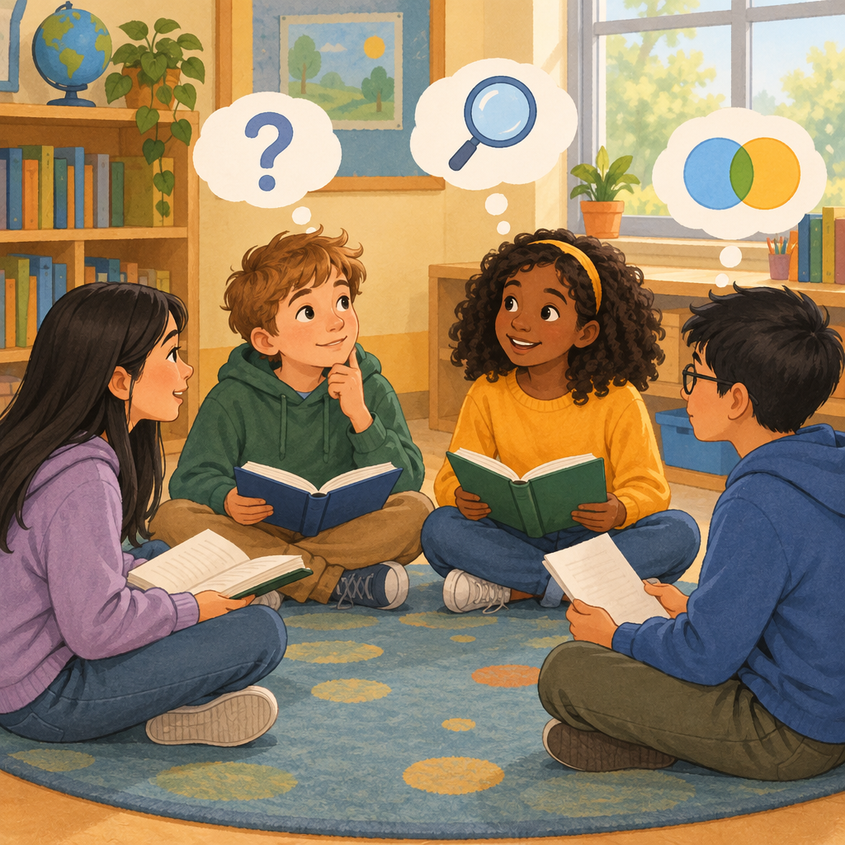

Overview
This Grade 6 lesson gives students a full cycle of comprehension work: predicting before reading, applying strategies during reading, and reflecting on which strategy worked best afterward. Students practice inferring meaning from context clues, distinguishing stated from implied information, and analyzing how and why a character's perspective might shift over the course of a text (Guiding question, Knowledge, Skills, Knowledge).
The lesson also introduces students to thinking critically about bias and author's purpose, asking them to consider whether a text presents information fairly (Knowledge, Skills, Knowledge). By the end of the lesson, students name a comprehension strategy that helped them most and justify their choice with evidence from the text, building the self-monitoring skills named in the Grade 6 outcome (Skills, Understanding, Understanding).

Outcomes covered
- Students interpret and respond to texts through application of comprehension strategies. (Outcome)
This learning outcome guides the whole lesson: every activity asks students to actively use a strategy, such as predicting, inferring, or connecting, rather than passively read.
- Incorporate a variety of strategies to comprehend, interpret, and manage information from texts. Evaluate the effectiveness of comprehension strategies used to interpret texts read independently. Apply a variety of self-monitoring skills to comprehend and interpret texts. (Skills)
Naming which strategy helped and why builds the self-monitoring habit good readers use for the rest of their lives, in school and beyond.
- Respond to texts by summarizing main ideas and providing supporting evidence from the texts. Make connections between new ideas and information in texts and known ideas and information. Analyze ideas and information to support comprehension and interpretation of texts. Synthesize ideas and information in texts to confirm or expand understandings. (Skills)
These skills let students move beyond simply recalling facts to explaining how ideas in a text fit together and connect to their own lives.
- Revise or confirm predictions based on new or additional information and sources. Infer meanings from texts based on context clues. Interpret and draw conclusions from texts, using stated and implied ideas or information. Distinguish between information that is stated and inferred. Analyze ideas and information, using text evidence. (Skills)
Distinguishing stated from inferred information is a foundational reading skill that supports accurate interpretation in every subject, not only Language Arts.
- Connect perspectives reflected in texts to personal experiences. Analyze factors that cause characters in texts to change their perspectives. Compare personal perspectives to varied perspectives found in texts. Consider whether an author or a text creator presents information with or without bias. (Skills)
Recognizing how and why perspectives change, and noticing bias, helps students become more thoughtful and empathetic readers of both fiction and real-world media.

Materials
- A short shared text appropriate for Grade 6 (a short story, picture book excerpt, or news article of about one to two pages)
- Chart paper or a shared worksheet for each small group
- Whiteboard or chart paper for recording predictions
- Exit ticket handout or displayed prompts
- Sticky notes (optional, for marking context clues in the text)
- Coloured pencils or highlighters (optional, for the support differentiation strategy)

Sequence of activities

1. Strategy Warm-Up: Predict and Connect (8 min, whole class)
- Show the class the title and cover of a short text (a picture book excerpt, news article, or short story works well - for example, a story about a kid who finds an old backpack in a school lost-and-found).
- Ask: 'Based on the title and any images, what do you predict this text is about?' Take two or three predictions and write them on the board.
- Ask: 'Does this remind you of anything you've read, seen, or experienced?' Prompt for text-to-self, text-to-text, or text-to-world connections (Knowledge).
- Explain that today's lesson focuses on how good readers use strategies like predicting, inferring, connecting, summarizing, synthesizing, and evaluating to understand texts more deeply (Knowledge).
- Tell students they will revisit their predictions at the end of the lesson to see if they still hold up (Skills).
Choose a text that has some ambiguity in the title or cover so predictions vary. Keep this brisk - the goal is to activate strategy thinking, not to fully discuss the text yet.
Sources: Knowledge, Knowledge, Skills

2. Shared Reading with Strategy Stops (15 min, whole class)
- Read the chosen text aloud together (or have students read along silently while you read aloud), stopping at three planned points.
- Stop 1 (early in the text): Ask 'What context clues - words, phrases, punctuation, or details in an image - help you understand what's happening here?' (Knowledge). Example: if the text says the character's hands 'trembled' as they opened the backpack, ask what that word suggests about the character's feelings.
- Stop 2 (middle of the text): Ask 'What can you infer here that the author didn't say directly?' Distinguish between what is stated and what is inferred (Skills). Example: if the text never says the backpack belongs to someone who moved away, but mentions a faded bus ticket and an address crossed out, ask what students can infer.
- Stop 3 (near the end): Ask 'Has your prediction changed? What new information caused you to revise or confirm it?' (Skills).
- After finishing the text, ask one or two students to summarize the main idea in one or two sentences, using evidence from the text to support it (Skills).
Model your own thinking aloud at least once before asking students to answer, especially for the inference stop. If a chapter book excerpt is used, choose a passage that has clear context clues (dialogue, punctuation, or an image) so all students can access at least one clue type.
Sources: Knowledge, Skills, Skills

3. Small Group Task: Analyze, Connect, and Consider Perspective (15 min, small group)
- Divide students into groups of three or four. Give each group the same short text passage (or a follow-up excerpt from the shared reading text).
- Each group answers four questions on a shared worksheet or chart paper:
- Analyze: What are two important pieces of information in this text, and how do they relate to each other? (Knowledge)
- Connect: Has a character's perspective changed in this text? What caused the change - time, experience, context, or new information? (Knowledge, Skills)
- Evidence: What evidence from the text supports your answer? (Skills)
- Bias check: Does the author present this information fairly, or does it seem to favour one side or person? Explain your thinking (Knowledge, Skills).
- Circulate and prompt groups that are stuck with questions like 'What does the character do differently after this event?' or 'Whose side of the story are we not hearing?'
- Making text to self, text to text, and text to world connections can support analyzing, summarizing, and synthesizing texts.
Support struggling groups by highlighting the specific paragraph where the character's perspective shifts. For groups moving quickly, ask them to also identify one example of an author presenting information to influence the reader, such as in an advertisement or social media post (Knowledge).
Sources: Knowledge, Knowledge, Skills, Knowledge

4. Whole Class Share and Synthesis (12 min, whole class)
- Invite two or three groups to share their answer to the perspective and bias questions from the small group task.
- As groups share, ask the rest of the class: 'Do you agree? What evidence would you add?' This models evaluating the effectiveness of different interpretations (Skills).
- Revisit the predictions written on the board at the start of the lesson. Ask: 'Which predictions were confirmed? Which were revised, and what new information changed them?' (Skills).
- As a class, synthesize the discussion into one or two sentences that combine the main idea, an inference, and a perspective observation, for example: 'The story is about a lost backpack, but it's really about how finding someone else's belongings can build empathy for a person you've never met' (Skills, Understanding).
- Ask students to reflect out loud: 'Which strategy - predicting, inferring, connecting, summarizing, or evaluating - helped you understand this text the most today, and why?' (Skills).
This step is where the self-monitoring and self-evaluation piece of the outcome comes through - students are not just doing the strategies, they are naming which one worked for them and why. Accept varied answers; the goal is metacognitive awareness, not a single right choice.
Sources: Skills, Understanding, Skills, Skills

5. Exit Ticket: Strategy Reflection (10 min, individual)
- Hand out or display the exit ticket with three short prompts:
- One thing I inferred today that wasn't directly stated in the text was...
- One connection I made (text-to-self, text-to-text, or text-to-world) was...
- The comprehension strategy that helped me most today was ___ because...
- Students complete the exit ticket independently in full sentences, using evidence from today's text where possible (Skills, Skills).
- Collect exit tickets as a quick formative check before students leave or move to the next subject.
This is the key formative assessment moment for evaluating whether each student can name and justify a strategy (Skills). Keep a simple checklist while reading responses: can the student distinguish inference from stated fact, and can they name a strategy with a reason.
Sources: Skills, Skills, Skills

Differentiation
Extension
- Ask students to find a second short text (an advertisement, social media post, or news headline) and identify how the creator may be presenting information to influence the audience (Knowledge).
- Challenge students to compare the perspective of a character in today's text with a character from a book they have read independently, explaining how the two perspectives are similar or different (Skills).
- Have students write a short paragraph evaluating which comprehension strategy was least helpful for this particular text and why, deepening the self-monitoring skill named in the outcome (Skills).
Support
- Provide a shorter or simplified version of the text with the same context clues highlighted in a different colour so struggling readers can locate them quickly.
- Give sentence starters for the exit ticket, such as 'I inferred that ___ because the text said ___' to reduce the writing load while keeping the thinking demand.
- Pair a student who needs support with a peer for the small group task and assign that pair the analyze and connect questions rather than all four.
Inclusive supports
- Offer the shared reading text in audio form for students who benefit from listening while following along visually.
- Allow students to respond to the exit ticket orally to the teacher or through a recorded voice note if writing is a barrier.
- Use visual anchor charts with icons for each comprehension strategy (a question mark for predicting, a magnifying glass for inferring, a chain link for connecting) so all students can reference the strategy names throughout the lesson.

Assessment
Formative. During the shared reading strategy stops, listen for whether students can distinguish information that is directly stated in the text from information they are inferring using context clues.
Look for: Student responses correctly separate 'the text says' from 'I think this means' and reference a specific word, phrase, punctuation mark, or image as evidence. (Knowledge, Skills)
Formative. During the small group task, circulate and check whether groups can identify a change in a character's perspective and link it to a cause such as time, experience, context, or new information.
Look for: Group chart paper or worksheet names a specific perspective shift and correctly attributes a cause from the list of reasons perspectives can evolve. (Knowledge, Skills)
Summative. Collect the exit ticket and assess each student's ability to name a comprehension strategy they used, justify why it helped, and support at least one claim with text evidence.
Look for: The exit ticket names a specific strategy (not a vague answer like 'reading carefully'), gives a reason tied to the day's text, and includes one inference or connection supported by a detail from the text. (Skills, Skills)

Vocabulary
- Predicting: Making a smart guess about what will happen in a text, based on clues like the title, pictures, or what has already happened.
- Inferring: Figuring out something the author does not say directly, by combining clues in the text with what you already know.
- Context clues: Hints in a text that help you understand meaning, including words, phrases, punctuation, dialogue, or information shown in pictures, diagrams, charts, or graphs.
- Synthesizing: Combining ideas and information from a text with what you already know to build a new or deeper understanding.
- Perspective: A particular way of seeing or thinking about something, which can change over time because of new experiences, context, or information.
- Bias: Favouring one person, group, or idea over another in a way that is usually considered unfair.

For families
- Ask your child what they predicted about today's story and whether that prediction turned out to be true. This kind of conversation reinforces the predicting strategy without needing to read the text yourself.
- At home, when reading together, pause and ask 'What clues tell you that?' when your child makes a guess about a character's feelings or motives. This builds the same inferring skill practiced in class.
- Encourage your child to notice bias in everyday texts like advertisements, packaging, or social media posts, and ask them who might benefit from the way the information is presented.

Sources
- Guiding question: "How do comprehension strategies enhance interpretations of texts?"
- Outcome: "Students interpret and respond to texts through application of comprehension strategies."
- Knowledge: "Comprehension strategies can be used to interpret and respond to increasingly complex texts and include predicting, inferring, making connections, summarizing, synthesizing, evaluating."
- Skills: "Incorporate a variety of strategies to comprehend, interpret, and manage information from texts."
- Understanding: "Comprehension, interpretation, and management of information from increasingly complex texts are enhanced through application of a variety of critical-thinking strategies and skills."
- Knowledge: "Making text to self, text to text, and text to world connections can support analyzing, summarizing, and synthesizing texts."
- Skills: "Respond to texts by summarizing main ideas and providing supporting evidence from the texts."
- Understanding: "Comprehension of texts includes analyzing, summarizing, and synthesizing information and ideas."
- Knowledge: "Context clues in texts include words, phrases, punctuation, dialogue, information in pictures, diagrams, charts, or graphs."
- Skills: "Infer meanings from texts based on context clues."
- Understanding: "Comprehension and interpretation of texts requires attention to explicit and implicit contextual information and ideas."
- Knowledge: "Perspectives can evolve for a variety of reasons, including passage of time, experience, context, new information."
- Skills: "Analyze factors that cause characters in texts to change their perspectives."
- Understanding: "Interaction with texts can deepen comprehension, expand perspectives, and help readers learn more about themselves and the world."
- Knowledge: "Authors or text creators may present information to deliberately influence an audience's beliefs, perspectives, values, or understandings, such as advertising or social media."
- Skills: "Analyze texts to determine contextual information that supports how a text can be understood."
- Understanding: "Historical, social, and cultural contexts can support readers in examining influences on texts."

All text excerpts, discussion questions, and examples in this lesson are age-appropriate for eleven and twelve year old students and use neutral, respectful scenarios with no culturally sensitive or unsafe content.

AILI detailed pack · en · claude-sonnet-5 · 2026-09-17

