Kinematics: Motion Description and Analysis
Central concept: Kinematics

Connections
- Kinematics (uses) -> Scalar and Vector Quantities
- Kinematics (describes) -> Displacement
- Kinematics (describes) -> Velocity
- Kinematics (describes) -> Acceleration
- Kinematics (includes) -> Uniform Motion
- Kinematics (includes) -> Uniformly Accelerated Motion
- Kinematics (applies) -> Graphical Analysis
- Kinematics (extends to) -> Relative Motion
- Kinematics (extends to) -> Two-Dimensional Motion
- Velocity (rate of change) -> Displacement
- Acceleration (rate of change) -> Velocity
- Graphical Analysis (includes) -> Velocity-Time Graphs
- Velocity-Time Graphs (derives) -> Kinematic Equations
- Uniform Motion (analyzed by) -> Graphical Analysis
- Uniformly Accelerated Motion (analyzed by) -> Graphical Analysis
- Relative Motion (uses) -> Scalar and Vector Quantities
- Two-Dimensional Motion (uses) -> Scalar and Vector Quantities

Notes
- Kinematics: Description of motion in terms of displacement, velocity, acceleration and time Topic
- Scalar and Vector Quantities: Operationally defined and contrasted quantities in motion analysis Outcome, Outcome
- Displacement: Defined qualitatively and quantitatively as change in position Outcome
- Velocity: Defined qualitatively and quantitatively as rate of change of displacement Outcome
- Acceleration: Defined qualitatively and quantitatively as rate of change of velocity Outcome
- Uniform Motion: Constant velocity motion explained using written, numerical and graphical data Outcome
- Uniformly Accelerated Motion: Constant acceleration motion explained using written, numerical and graphical data Outcome
- Graphical Analysis: Construct and analyze graphs showing relationships among kinematic variables Outcome, Resource
- Velocity-Time Graphs: Acceleration from slope; displacement from area under curve Outcome
- Kinematic Equations: Mathematical models connecting acceleration, velocity and displacement Resource
- Relative Motion: Motion of one object relative to another using displacement and velocity vectors Outcome
- Two-Dimensional Motion: Motion in horizontal or vertical plane using vector components Outcome
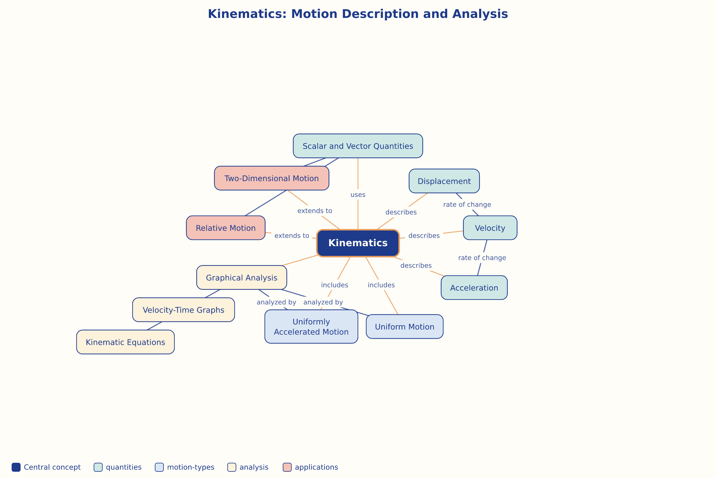

AILI word map · en · claude-haiku-4-5-20251001 · 2026-09-17

