Personal Choices and Well-Being
Career and Life Management, Grade 10: building on Health and Life Skills outcomes from Grades 7 to 9

Slide 1: Personal Choices and Well-Being
Health and Life Skills: tracing choice and consequence from Grade 7 through Grade 9
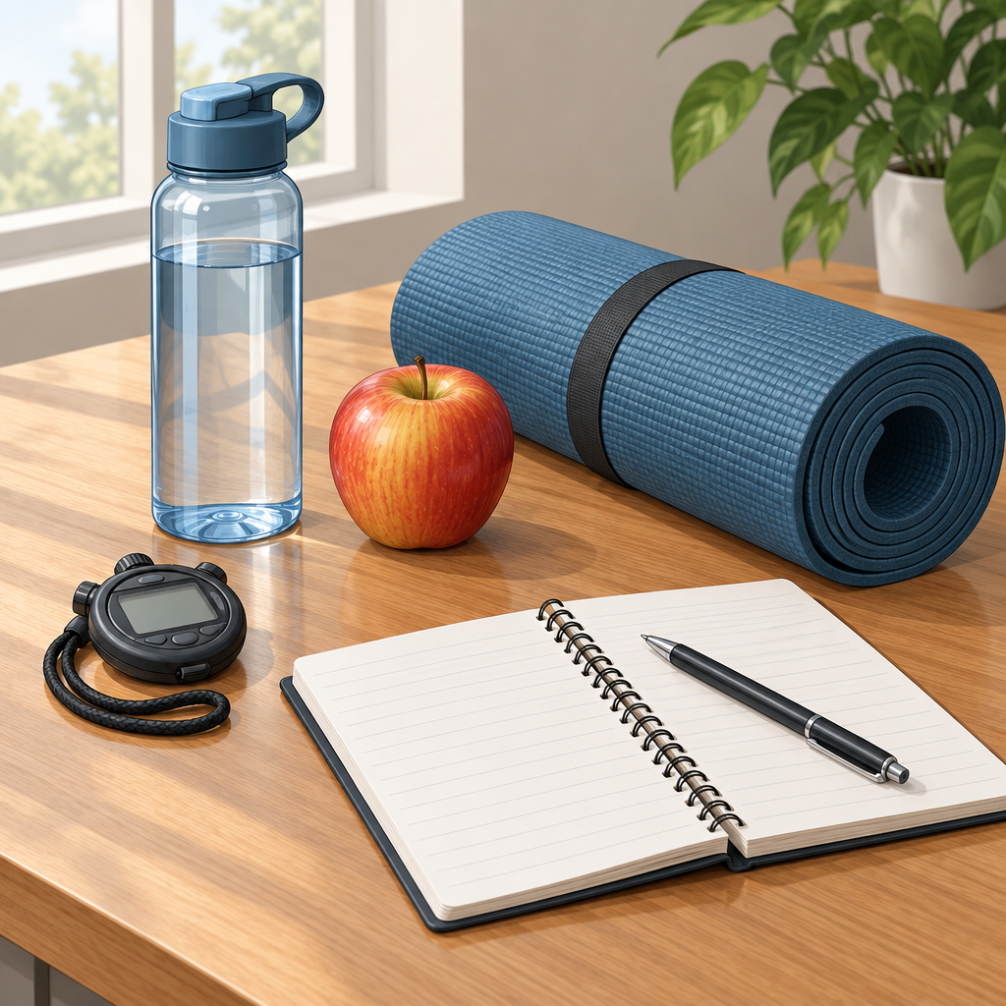
Notes: Introduce the lesson by explaining that well-being is built from a sequence of everyday choices, not a single decision. Frame the lesson as a review of how the Alberta Health and Life Skills program develops the theme of personal responsibility for health from Grade 7 through Grade 9, preparing students to apply this thinking at the Grade 10 CALM level.

Slide 2: Grade 7: Comparing Choices to Health Standards
- Compare personal choices around physical activity, nutrition, relaxation, sleep and reflection against health standards (Outcome).
- Examine grooming and cleanliness habits, including how cosmetic advertising shapes those choices (Outcome).
- Link food choices to adolescent nutritional needs, considering finances, media, peer pressure, hunger, body image and activity level (Outcome).
- Analyze the social factors that influence whether a person avoids or uses particular substances (Outcome).
Sources: Topic, Topic, Outcome, Outcome, Outcome, Outcome
Notes: This slide covers Grade 7 Personal Health outcomes under the topic of making responsible, informed choices for health and safety (Topic, Topic). Ask students to identify one personal health standard they already compare themselves against, such as recommended sleep hours. Formative check: have students name two personal health choices, such as sleep and nutrition, and compare each to its health standard, confirming their response states both the choice and the matching standard.

Slide 3: Grade 8: From Choice to Consequence
Seeing the Link
Grade 8 students examine the direct relationship between a choice and its consequence, such as how smoking affects appearance, feeling and performance (Outcome). They also analyze how health needs change across the life span, including shifting requirements for sleep and calcium (Outcome).
Handling Pressure
Students develop personal strategies for resisting pressure to adopt a particular look or lifestyle, including learning to accept individual appearance (Outcome). This builds on W-7.2 work on grooming and cleanliness, and the evaluation of grooming and cosmetic advertisements (Outcome).
Sources: Topic, Topic, Outcome, Outcome, Outcome, Outcome, Outcome
Notes: This slide sits within the Grade 8 topic of making responsible and informed health and safety choices, under Personal Health (Topic, Topic). Discuss with students how a single choice, such as sleep timing, produces a visible consequence within days versus one that accumulates over years, such as calcium intake and bone health.

Slide 4: Grade 9: Extending Healthy Choices Outward
- Family and Community: Use knowledge of an active, healthy lifestyle to promote and encourage involvement among family, peers and the community (Outcome).
- Approaches to Health: Analyze how positive health habits can be supported by varied health practices and treatments, such as acupuncture (Outcome).
- Nutrition Strategies: Develop strategies that promote healthy nutritional choices for self and others, such as setting healthy-eating goals or advocating for nutritious vending machine options (Outcome).
Sources: Topic, Topic, Outcome, Outcome, Outcome
Notes: These outcomes fall under the Grade 9 topic of making responsible and informed choices for health and safety, Personal Health (Topic, Topic). Have students draft one strategy they could realistically use to encourage a family member or peer toward a healthier habit, connecting personal choice to social influence.

Slide 5: Tracing the Progression, Grade 7 to Grade 9
- Compare and Examine: Grade 7: compare personal habits to health standards and examine outside influences on grooming and food choices (Outcome, Outcome).
- Connect Cause and Effect: Grade 8: link specific choices to specific consequences, such as how choosing to smoke affects how one looks, feels and performs(Outcome, Outcome).
- Build Resistance Strategies: Grade 8: develop personal strategies to withstand pressure over appearance or lifestyle (Outcome).
- Extend to Others: Grade 9: apply healthy-lifestyle knowledge to encourage family, peer and community involvement (Outcome).
- Grade 9: analyze how positive health habits can be supported by a variety of approaches to health practices and treatments (Outcome, Outcome).
Sources: Outcome, Outcome, Outcome, Outcome, Outcome, Outcome, Outcome, Outcome
Notes: Use this flowchart to show the deliberate scaffolding across three grade levels: from personal comparison, to cause-and-effect reasoning, to strategy-building, to community-level application. This progression supports students' understanding of personal health choices and standards for health.

Slide 6: Choices, Consequences and Community
Summary: In Grade 7, the Health and Life Skills program establishes a foundation by having students compare personal health choices to standards for health(Outcome, Outcome, Outcome, Outcome). Well-being emerges from this accumulation of informed, responsible daily decisions.
Question: Which one habit from your own routine, sleep, nutrition, activity or how you respond to peer pressure, would you change first, and what consequence would you expect to see?
Sources: Outcome, Outcome, Outcome, Outcome

AILI presentation · en · claude-sonnet-5 · 2026-09-17

