Cells and Systems: Building Blocks of Living Things
From single cells to whole-body systems: building the cell-tissue-organ-system chain
Audience: Grade 8 Science students, ages 13 to 14, in an Alberta classroom studying Unit B: Cells and Systems.
Grades: Grade 8
Subjects: Science
Time: about 60 minutes
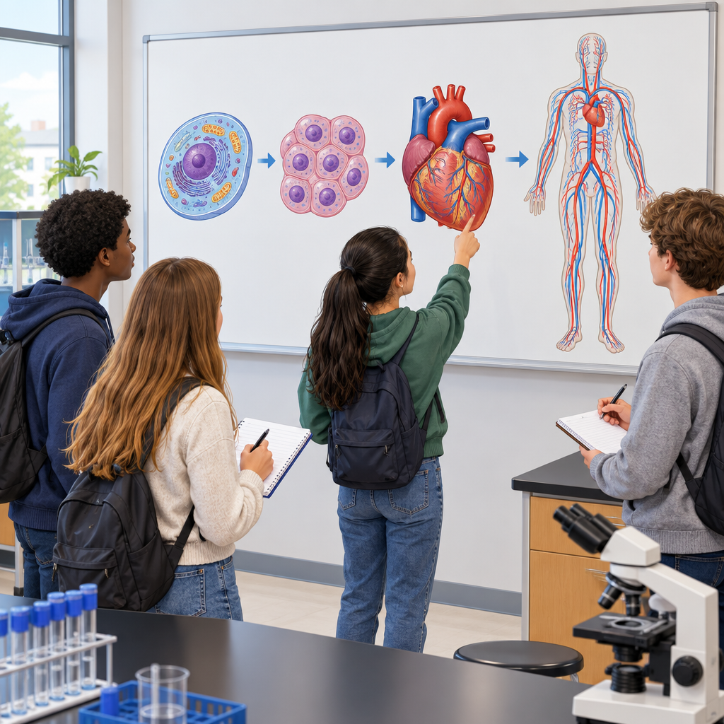

Overview
This lesson opens Grade 8 Unit B: Cells and Systems by building the chain of organization that underlies all of biology: cells, tissues, organs and systems (Topic). Students compare plant and animal cells, distinguish single-celled from multicelled organisms, watch a live demonstration of diffusion, and then work in small groups to trace how cells build up into one of the five human body systems named in the curriculum: respiration, circulation, digestion, excretion and sensory awareness (Outcome, Outcome).
The lesson favours short, hands-on tasks over long explanations. A card-sort Venn diagram gets students distinguishing cell structures without lecture, a food-colouring demonstration makes diffusion visible, and a jigsaw-style group task has each team become the class expert on one body system before teaching it to their peers. The lesson closes with a short written exit ticket so the teacher has evidence of understanding before moving to the next lesson on research into body systems, which draws on Outcome.

Outcomes covered
- Investigate and describe the role of cells within living things: describe the role of cells as a basic unit of life, analyze similarities and differences between single-celled and multicelled organisms, distinguish between plant and animal cells, describe the movement of gases and liquids into and out of cells during diffusion and osmosis based on concentration differences, and examine plant and animal structures to identify contributing roles of cells, tissues and organs. (Outcome, Outcome)
This outcome gives students the vocabulary and mental model, cell, tissue, organ, system, that they will use for the rest of the unit and in future biology study, including high school.
- Interpret the healthy function of human body systems, and illustrate ways the body reacts to internal and external stimuli, including describing body systems for respiration, circulation, digestion, excretion and sensory awareness, the role of individual organs and tissues, the contribution of various types of cells, and changes in body function in response to changing conditions. (Outcome)
Understanding how their own body systems work and respond to change helps students make sense of everyday experiences like getting out of breath, feeling their heart race, or shivering in the cold.
- Investigate living things; and identify and apply scientific ideas used to interpret their general structure, function and organization, applying the concept of system in describing familiar organisms and their general structure and function. (Outcome, Outcome)
Seeing the human body as one example of a living system helps students transfer the same thinking to any organism they study, from bacteria to trees.

Materials
- Whiteboard or chart paper for class notes
- Pre-made Venn diagram templates (one per pair)
- Card sets with cell structure names: cell membrane, cell wall, nucleus, cytoplasm, chloroplast, mitochondria, vacuole
- Comparison worksheet: amoeba versus grizzly bear
- Clear cup of warm water and food colouring or a tea bag for the diffusion demonstration
- Cell-tissue-organ-system worksheet, one per small group, with five versions for the five assigned body systems
- Exit ticket slips, one per student
- Optional: labelled plant and animal cell diagrams from a textbook or printed handout

Sequence of activities

1. What is a cell? Quick review and cell analogy hook (8 min, whole class)
- Ask students: "What is the smallest unit of a living thing?" Take two or three answers.
- Show students two labelled diagrams side by side (from a textbook or drawn on the board): a plant cell and an animal cell.
- Ask: "What is one structure you see in both? What is one structure you see in only one of them?" Take answers and record on the board under two columns: Plant Cell / Animal Cell.
- Introduce the term basic unit of life (Outcome). Explain that every living thing, from a single amoeba to a person made of trillions of cells, is built from cells.
- Pose the focusing question for the lesson: "What do a single-celled organism and a multicelled organism like you have in common, and where do they differ?" (Outcome, Topic)
This is a diagnostic check, not new teaching. Listen for misconceptions such as students thinking only animals have cells, or that cell walls and cell membranes are the same structure. Correct gently and move on; the Venn diagram activity will fix this in more depth. Keep this brisk, the goal is to activate prior knowledge from earlier grades.
Sources: Outcome, Outcome, Topic

2. Plant vs animal cell Venn diagram and single-celled vs multicelled comparison (15 min, pairs)
- Pair up students. Give each pair a large Venn diagram template (two overlapping circles labelled Plant Cell and Animal Cell) and a card set with structure names: cell membrane, cell wall, nucleus, cytoplasm, chloroplast, mitochondria, vacuole.
- Students sort the cards into the correct part of the Venn diagram (shared middle, plant-only, animal-only). Circulate and prompt pairs that place cell wall or cell membrane incorrectly (Outcome).
- Once diagrams are done, give each pair a comparison sheet with two organisms: an amoeba (single-celled) and a grizzly bear (multicelled). Ask pairs to write two similarities and two differences in general terms, for example both need energy and both respond to their environment, but the bear's cells are organized into tissues and organs while the amoeba's one cell does everything (Outcome).
- Cold-call two or three pairs to share one similarity and one difference with the class.
- Teacher records a master list on the board: Similarities (need energy, grow, respond to environment, reproduce) and Differences (number of cells, presence of tissues/organs, complexity of structure).
Expected correct sort: shared middle = cell membrane, nucleus, cytoplasm, mitochondria; plant-only = cell wall, chloroplast, (large) vacuole; note some diagrams simplify vacuole as animal-too in small amounts, accept reasonable answers. Watch for the common error of confusing cell wall with cell membrane; clarify that all cells have a membrane, only plant cells (and some others) also have a rigid wall outside it. This activity directly covers Outcome's requirement to distinguish plant and animal cells and to analyze single-celled versus multicelled organisms.
Sources: Outcome

3. Diffusion in action: teacher demonstration and prediction (10 min, whole class)
- Set up a clear cup of warm water. Ask students to predict what will happen if you drop a small piece of food colouring or a tea bag into the water without stirring.
- Drop it in and let the class watch the colour spread over one to two minutes while continuing with the next step.
- Ask: "Why does the colour move from where it started to fill the whole cup, even without stirring?" Guide students to the idea that particles move from an area of higher concentration to an area of lower concentration.
- Introduce the terms diffusion and osmosis. Explain that diffusion is this same movement happening for gases and dissolved substances moving into and out of cells, and osmosis is the specific case of water moving across a cell membrane, both driven by concentration differences (Outcome).
- Connect to real life: ask students where gases move into and out of cells in their own body right now (in the lungs, oxygen moving into blood cells; carbon dioxide moving out).
Outcome Outcome specifically notes this requires only a general understanding of the process, not detailed mechanisms, so keep the explanation at the level of concentration differences causing movement, without introducing terms like semi-permeable membrane transport proteins or active transport. If no food colouring is available, describe the classic demonstration and use a diagram or short video clip instead, then ask the same prediction question orally.
Sources: Outcome

4. Cells, tissues, organs, systems: build the human body chain (20 min, small group)
- Divide the class into five groups. Assign each group one human body system: respiration, circulation, digestion, excretion, sensory awareness (Outcome).
- Give each group a worksheet with four boxes in a chain: Cell, Tissue, Organ, System. Groups must fill in one example of each for their assigned system. Example for circulation: red blood cell, blood tissue, heart, circulatory system (Outcome, Outcome).
- Each group also answers: "What is the main job of this system, and name one organ in it and what that organ does?" For example, lungs exchange oxygen and carbon dioxide, or bronchia provide a passageway for air (Outcome).
- Each group answers a stimulus-response question specific to their system, for example: "What happens to your circulatory system during exercise?" (heart rate increases) or "What happens to your digestive system after a big meal?" (Outcome).
- Groups present their chain and answers to the class in under one minute each. Teacher records one key fact per system on the board to build a class reference chart covering all five systems.
- Whole class discussion: ask how individual cells (nerve, muscle, blood, skin, bone) contribute to keeping the whole body healthy, drawing at least two examples from different groups (Outcome).
This activity is the core of the lesson and directly builds the cells-tissues-organs-systems hierarchy required by Outcome and the body systems content required by Outcome. Sample answers to prepare in advance: Respiration - lungs, bronchia, alveoli; job is gas exchange; response example is faster breathing during exercise. Circulation - heart, blood vessels, blood cells; job is transporting oxygen and nutrients; response example is increased heart rate during exercise or stress. Digestion - stomach, intestines; job is breaking down food for nutrient absorption; response example is increased digestive activity after eating. Excretion - kidneys, skin (sweat); job is removing waste; response example is more sweating in heat. Sensory awareness - nerves, skin, eyes; job is detecting stimuli; response example is a reflex pulling a hand away from something hot. If a group finishes early, have them add a second organ or a second stimulus-response example.
Sources: Outcome, Outcome

5. Exit ticket: cells to systems check (7 min, individual)
- Distribute a small exit slip with three questions:
a) Name one structure found in a plant cell but not an animal cell.
b) Put these in order from smallest to largest: organ, cell, tissue, system.
c) Give one example of your body changing its function in response to a change around you or inside you (for example exercise, cold weather, or a scare).
- Students complete the slip individually and silently in the last minutes of class.
- Collect slips on the way out as a quick formative check before the next lesson on research into body systems (Outcome).
Correct answers: a) cell wall or chloroplast; b) cell, tissue, organ, system; c) any reasonable stimulus-response pair such as heart rate rising during exercise, shivering in cold, or pupils widening in the dark. Use these slips to decide whether to re-teach the cell hierarchy or move ahead to Outcome content on research and body system health next class.
Sources: Outcome, Outcome, Outcome

Differentiation
Extension
- Ask fast-finishing groups in the body systems activity to research and add one example of what happens when that system malfunctions, connecting forward to research on dysfunctions (Outcome).
- Challenge advanced pairs to explain why a single-celled organism like an amoeba can survive without lungs or a heart, using the idea of diffusion happening directly across its one cell membrane (Outcome).
- Have students design a diagram showing a food-gathering structure in a different organism and compare it to human digestion, connecting to the idea that different organisms meet similar needs in different ways (Outcome).
Support
- Provide a pre-filled Venn diagram with two or three structures already placed correctly so struggling pairs can pattern-match the rest.
- Give a simplified word bank for the cell-tissue-organ-system worksheet, listing possible organs and tissues for each system so students choose rather than recall from nothing.
- Allow the exit ticket to be completed orally with the teacher or an educational assistant for students who need it.
Inclusive supports
- Use visual card sorts and diagrams alongside verbal explanation so students who process visually or who are English language learners can access the content without relying only on written text.
- Keep group presentations short and low-stakes, allowing a student who prefers not to speak to a full class to instead explain their group's chain quietly to the teacher during circulation.
- Offer the exit ticket in a large-print or digital format for students who need it, and allow extra time without penalty.

Assessment
Formative. Venn diagram card sort and single-celled versus multicelled comparison sheet completed in pairs during the second activity.
Look for: Correct placement of cell wall, chloroplast and vacuole as plant-only, and cell membrane, nucleus, cytoplasm and mitochondria as shared; at least two accurate similarities and two accurate differences between an amoeba and a grizzly bear stated in general terms. (Outcome)
Formative. Verbal predictions and explanations during the diffusion demonstration.
Look for: Students explain, in their own words, that particles move from higher to lower concentration and can name at least one example of this happening in the body, such as oxygen moving into blood. (Outcome)
Formative. Group presentation of the cell-tissue-organ-system chain and stimulus-response example for an assigned body system.
Look for: The group correctly names one cell, tissue and organ example for their system, states the system's main job, and gives a plausible stimulus-response example such as heart rate increasing during exercise. (Outcome, Outcome)
Summative. Exit ticket with three short-answer questions on plant cell structures, the cell-tissue-organ-system hierarchy, and a stimulus-response example.
Look for: All three answers correct or reasonably close, indicating the student can distinguish plant and animal cells, order the levels of biological organization, and describe a body response to changing conditions. (Outcome, Outcome)

Vocabulary
- cell: The basic unit of life; the smallest structure that can carry out the functions needed to stay alive, on its own in a single-celled organism or as part of a larger multicelled organism.
- tissue: A group of similar cells working together to perform a specific job, such as blood tissue or muscle tissue.
- organ: A structure made of two or more types of tissue working together, such as the heart or the lungs.
- system: A group of organs and tissues working together to carry out a major function of the body, such as the circulatory system or the digestive system.
- cell membrane: The thin outer layer found in every cell, plant and animal, that controls what moves into and out of the cell.
- cell wall: A rigid outer layer found in plant cells, outside the cell membrane, that gives the cell extra support and shape; animal cells do not have one.
- diffusion: The movement of gases or dissolved substances from an area of higher concentration to an area of lower concentration, such as oxygen moving into a blood cell.
- osmosis: The movement of water across a cell membrane, from an area of higher water concentration to an area of lower water concentration.
- stimulus: A change inside or outside the body that causes a body system to react, such as exercise, cold temperature, or a sudden loud noise.

For families
- Ask your child to explain, in their own words, what a cell is and name one thing a plant cell has that an animal cell does not.
- Next time your child exercises or comes in from the cold, ask them what their body is doing differently and why, connecting it to what they learned about body systems responding to change.
- Look at a piece of fruit or vegetable together and talk about how it is made of many plant cells working together, just like the human body is made of many kinds of cells.

Sources
- Outcome: "Investigate living things; and identify and apply scientific ideas used to interpret their general structure, function and organization"
- Outcome: "Investigate and describe the role of cells within living things"
- Outcome: "Interpret the healthy function of human body systems, and illustrate ways the body reacts to internal and external stimuli"
- Outcome: "distinguish between plant and animal cells (e.g., distinguish between cell walls and cell membranes)"
- Outcome: "Describe areas of scientific investigation leading to new knowledge about body systems and to new medical applications"
- Outcome: "apply the concept of system in describing familiar organisms and analyzing their general structure and function"
- Topic: "Living things take a variety of forms as reflected in their structures, internal processes and ways of responding to their environments."

All content, materials and demonstrations (a cup of warm water with food colouring or a tea bag) are safe, age-appropriate for Grade 8 students, and free of culturally sensitive material.

AILI detailed pack · en · claude-sonnet-5 · 2026-09-17

