Kinematics: Describing Motion
Physics 20, Unit A

Slide 1: Kinematics
Physics 20, Unit A: describing motion with displacement, velocity, acceleration and time
Sources: Topic
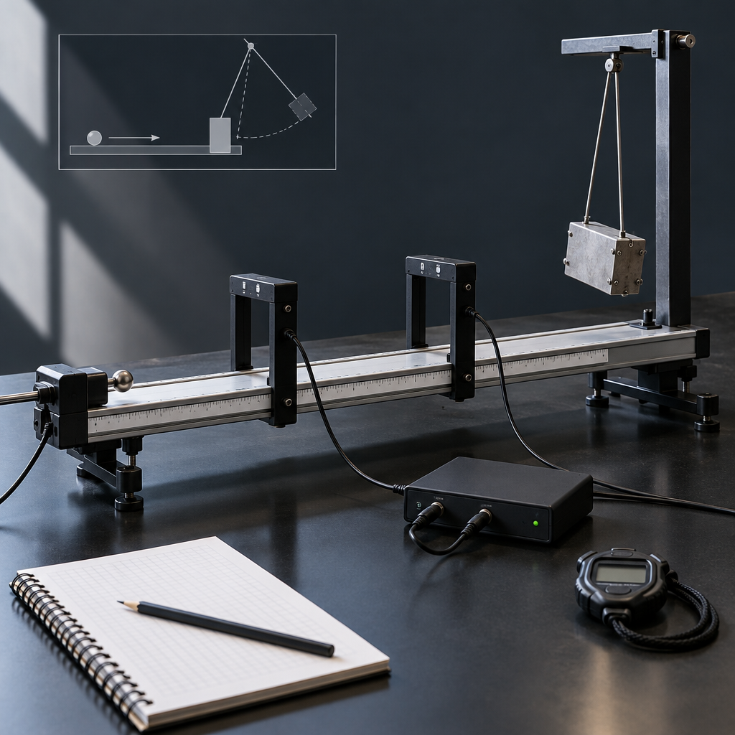
Notes: Introduce the unit theme of Change and Systems. Explain that kinematics is the study of motion without reference to its causes, and that this unit is worth about 15% of course time (Topic). Preview the two focusing questions and connect to prior learning from Science 10 Unit B.

Slide 2: Learning Intentions and Success Criteria
- I can define displacement, velocity and acceleration qualitatively and quantitatively (Outcome).
- I can compare and contrast scalar and vector quantities using operational definitions (Outcome).
- I can explain uniform and uniformly accelerated motion from written, numerical and graphical data (Outcome).
- I can interpret the motion of one object relative to another using displacement and velocity vectors (Outcome).
- I can explain two-dimensional motion in a horizontal or vertical plane using vector components (Outcome).
- This unit builds on Science 10 Unit B and prepares students for dynamics and Newton's laws (Topic).
Sources: Outcome, Outcome, Outcome, Outcome, Outcome, Topic
Notes: Read success criteria aloud and have students self-assess familiarity with each (thumbs 1-5) as a diagnostic checkpoint. Materials: whiteboard, unit outcomes handout. Timing: 8 minutes. Differentiation: provide sentence starters for the 'I can' statements for students who need support; extension students can draft their own example applying each criterion.

Slide 3: Scalar vs. Vector Quantities
Scalar Quantities
A scalar quantity has magnitude only. Examples include distance and speed. Scalars are added using ordinary arithmetic, without regard to direction (Outcome).
Vector Quantities
A vector quantity has both magnitude and direction. Examples include displacement, velocity and acceleration. Displacement, velocity, and acceleration can be defined qualitatively and quantitatively(Outcome, Outcome).
Sources: Outcome, Outcome
Notes: Materials: ruler, protractor, graph paper for scale diagrams. Timing: 12 minutes. Model one worked example: a student walks 4 m east then 3 m north; compare total distance (7 m, scalar) to resultant displacement (5 m at 37 degrees north of east, vector). Formative checkpoint: exit-ticket question asking students to classify five quantities as scalar or vector. Support: provide a labelled diagram of the walking example before students attempt their own. Extension: ask students to find the resultant of three displacement vectors at different angles.

Slide 4: From Motion Diagram to Velocity-Time Graph
- Collect position-time data: Use photogates or interval timers to record displacement at set time intervals (Outcome).
- Graph displacement vs. time: Plot data points and identify whether the motion is uniform or uniformly accelerated (Outcome).
- Determine slope: The slope of a position-time graph gives velocity; the slope of a velocity-time graph gives acceleration (Outcome).
- Determine area: The area under a velocity-time graph gives displacement (Outcome).
- Interpret the relationship: State the mathematical relationship among displacement, velocity, acceleration and time shown by the graph (Outcome).
Sources: Outcome, Outcome
Notes: Materials: motion sensors or photogates, computers with graphing software, ruler. Timing: 25 minutes lab activity. This addresses the Performing and Recording and Analyzing and Interpreting outcomes directly. Formative checkpoint: circulate and check that students correctly identify slope as acceleration and area as displacement before they proceed to the analysis questions. Support: give partially completed graphs with slope calculation scaffolded. Extension: have students analyze a velocity-time graph with a changing slope (non-uniform acceleration) and describe the motion in words.

Slide 5: Applying Kinematics: Projectile Motion
An aircraft launched from a carrier deck must reach a minimum velocity before leaving the ramp, an everyday application of acceleration and displacement calculations (Outcome). In two-dimensional motion, horizontal and vertical components are treated independently: horizontal velocity stays constant while vertical velocity changes under gravitational acceleration (Outcome). Students solve projectile motion problems near Earth's surface, ignoring air resistance, using vector components (Outcome).
Common applications of kinematics include determining the average speed of a run, bike ride or car trip, or the acceleration required to launch an aircraft from a carrier.
An aircraft launched from a carrier deck must reach a minimum velocity before leaving the ramp, an everyday application of acceleration and displacement calculations (Outcome). In two-dimensional motion, horizontal and vertical components are treated independently: horizontal velocity stays constant while vertical velocity changes under gravitational acceleration (Outcome). Students solve projectile motion problems near Earth's surface, ignoring air resistance, using vector components (Outcome).
Sources: Outcome, Outcome, Outcome
Notes: Materials: launcher or ball-and-track apparatus, metre stick, stopwatch (optional, if class does a projectile launch demonstration). Timing: 15 minutes. Walk through a worked example: an object launched horizontally off a table, find time of flight and horizontal range using component analysis. Formative checkpoint: pair students to solve a similar problem about average speed or acceleration and check their work. Support: provide a template table separating horizontal and vertical variables. Extension: pose an angled-launch projectile problem requiring initial velocity to be resolved into components.

Slide 6: Bringing Kinematics Together
Summary: This unit develops the vocabulary and mathematical tools to describe motion: displacement, velocity, acceleration and time, treated as scalars or vectors depending on the quantity (Topic, Outcome, Outcome). Students construct and interpret graphs of uniform and uniformly accelerated motion, relate slope and area to physical quantities, and extend their analysis to relative motion and two-dimensional projectile motion (Outcome, Outcome, Outcome, Outcome). These skills prepare students for the study of dynamics and Newton's laws later in the course (Topic).
Question: If you doubled an object's launch speed off a horizontal ramp, would its time in the air change? Would its horizontal range change? Justify your answer using vector components.
Sources: Topic, Topic, Outcome, Outcome, Outcome, Outcome, Outcome, Outcome
Notes: Use the closing question as an exit ticket or think-pair-share to check for understanding of independence of horizontal and vertical components before moving to the next lesson on relative motion. Revisit the unit's two focusing questions from Topic as a bridge to upcoming lessons.

AILI presentation · en · claude-sonnet-5 · 2026-09-17

