The Nervous System
Biology 30, Unit A: Equilibrium and Systems

Slide 1: The Nervous System
Biology 30, Unit A: Equilibrium and Systems
Sources: Topic
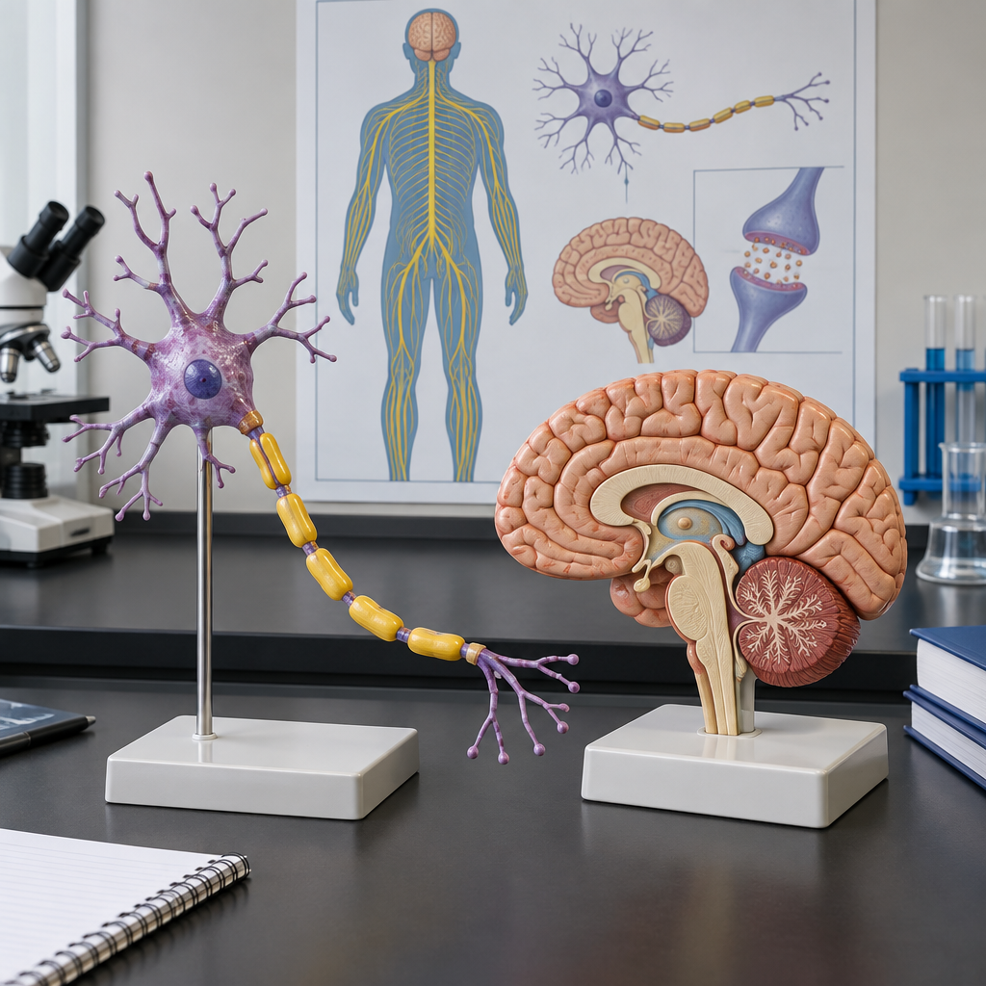
Notes: Frame this unit within the theme of equilibrium and systems: the nervous system helps the body maintain homeostasis by sensing and responding to internal and external stimuli (Topic). Preview that students will study neurons, the CNS/PNS, reflex arcs, and sensory organs.

Slide 2: Unit Overview and Learning Outcomes
- The nervous system contributes to homeostasis through its response to internal and external stimuli (Topic).
- Students will explain how the nervous system controls physiological processes (Topic).
- This unit builds on Biology 20, Unit D: Human Systems, and Science 10, Unit C: Cycling of Matter in Living Systems (Topic).
- Key concepts include neurons, nerve impulse transmission, reflex arcs, and sensory receptors (Topic).
- Unit A occupies approximately 25 percent of instructional time in Biology 30 (Topic).
Sources: Topic, Topic
Notes: Learning intention: students can state the general outcome for this unit and connect it to prior learning. Students will explain how the nervous system controls physiological processes and explain how the endocrine system contributes to homeostasis. Students will build on prior knowledge from Biology 20, Unit D: Human Systems.

Slide 3: The Neuron and the Nerve Impulse
- Resting neuron: Structure of the neuron and myelin sheath sets up conditions for signal transmission (Outcome).
- Action potential formation: Stimulus triggers an all-or-none action potential; intensity of response depends on frequency, not amplitude (Outcome).
- Transmission along the axon: The impulse propagates along the neuron, assisted by the myelin sheath (Outcome).
- Synaptic transmission: Signal crosses the synapse using chemical transmitters (Outcome).
- Chemical messengers: Norepinephrine and acetylcholine transmit the signal; cholinesterase breaks down acetylcholine to end the response (Outcome).
Sources: Outcome
Notes: Learning intention: students describe the formation and transmission of an action potential, including the all-or-none response, and explain synaptic transmission with named neurotransmitters (Outcome). Materials: neuron diagram handout, whiteboard for labelling. Formative checkpoint: cold-call students to label a diagram of a synapse. Support: provide a word bank of the three chemicals. Extension: ask students to explain why cholinesterase is necessary for repeated signalling.

Slide 4: Organizing the Nervous System
- Central nervous system: Cerebral hemispheres and lobes, cerebellum, pons, medulla oblongata, hypothalamus, and spinal cord regulate voluntary and involuntary processes (Outcome).
- Peripheral nervous system: Sympathetic and parasympathetic divisions, along with the sensory-somatic nervous system, carry signals to and from the CNS (Outcome).
- Reflex arcs: Neurons organize into nerves and reflex arcs, illustrated by the patellar and pupillary reflexes (Outcome).
- The eye: Cornea, lens, sclera, choroid, retina, rods and cones, fovea centralis, pupil, iris, and optic nerve each perform a distinct function in vision (Outcome).
- The ear: Pinna, auditory canal, tympanum, ossicles, cochlea, organ of Corti, auditory nerve, semicircular canals, and Eustachian tube support hearing and balance (Outcome).
- Other senses: Olfactory receptors, proprioceptors, taste receptors, and skin receptors provide additional information about the environment and spatial orientation (Outcome).
Sources: Outcome, Outcome, Outcome, Outcome, Outcome
Notes: Learning intention: students identify principal structures of the CNS and PNS and explain their regulatory functions (Outcome), describe reflex arc composition (Outcome), and describe the structures of the eye (Outcome) and ear (Outcome), plus other sensory receptors (Outcome). Materials: labelled models or diagrams of the principal structures of the central and peripheral nervous systems. Checkpoint: students identify the principal structures of the central and peripheral nervous systems and explain their functions. Differentiation: support students with a labelled diagram matching activity for the principal nervous system structures; extension students explain the functions of multiple structures in regulating voluntary and involuntary systems.

Slide 5: Nervous and Endocrine Systems Working Together
The nervous and endocrine systems act together to maintain homeostasis. A stressful stimulus is detected and processed rapidly by the nervous system, which then signals the adrenal gland to release hormones that sustain the body's response over a longer period. Comparing the two control systems highlights differences in speed, duration, and mechanism of action, while showing how they complement each other in coordinating a whole-body response (Outcome).
The stress response and the adrenal gland
The nervous and endocrine systems act together to maintain homeostasis. A stressful stimulus is detected and processed rapidly by the nervous system, which then signals the adrenal gland to release hormones that sustain the body's response over a longer period. Comparing the two control systems highlights differences in speed, duration, and mechanism of action, while showing how they complement each other in coordinating a whole-body response (Outcome).
Sources: Outcome
Notes: Learning intention: students compare the endocrine and nervous control systems and explain how they act together, using the stress response and adrenal gland as an example (Outcome). Materials: case study handout describing a stressful scenario (e.g., sudden loud noise). Checkpoint: students draw a flowchart showing nervous signal followed by hormonal response. Support: provide sentence starters comparing speed and duration. Extension: ask students to predict what happens if cortisol release is chronically elevated.

Slide 6: Bringing It Together
Students will describe the general structure and function of a neuron and myelin sheath, explaining the formation and transmission of an action potential, including all-or-none response and intensity of response; the transmission of a signal across a synapse; and the main chemicals and transmitters involved, i.e., norepinephrine, acetylcholine and cholinesterase.52)).
Question: If the myelin sheath along a neuron were damaged, as occurs in some neurological disorders, how would this affect the speed and reliability of nerve impulse transmission?
Sources: Outcome, Outcome, Outcome, Outcome, Outcome, Outcome, Outcome
Notes: Use this slide as a review checkpoint before assessment. Ask students to answer the closing question individually in writing, then discuss as a class. This connects back to Outcome (structure and function of the myelin sheath) and requires students to apply their understanding rather than simply recall it. Consider using this as an exit slip or bridge into a lab on reaction time and reflexes.

AILI presentation · en · claude-sonnet-5 · 2026-09-17

