The Particle Model of Matter
All matter is made of tiny particles that move and have spaces between them.
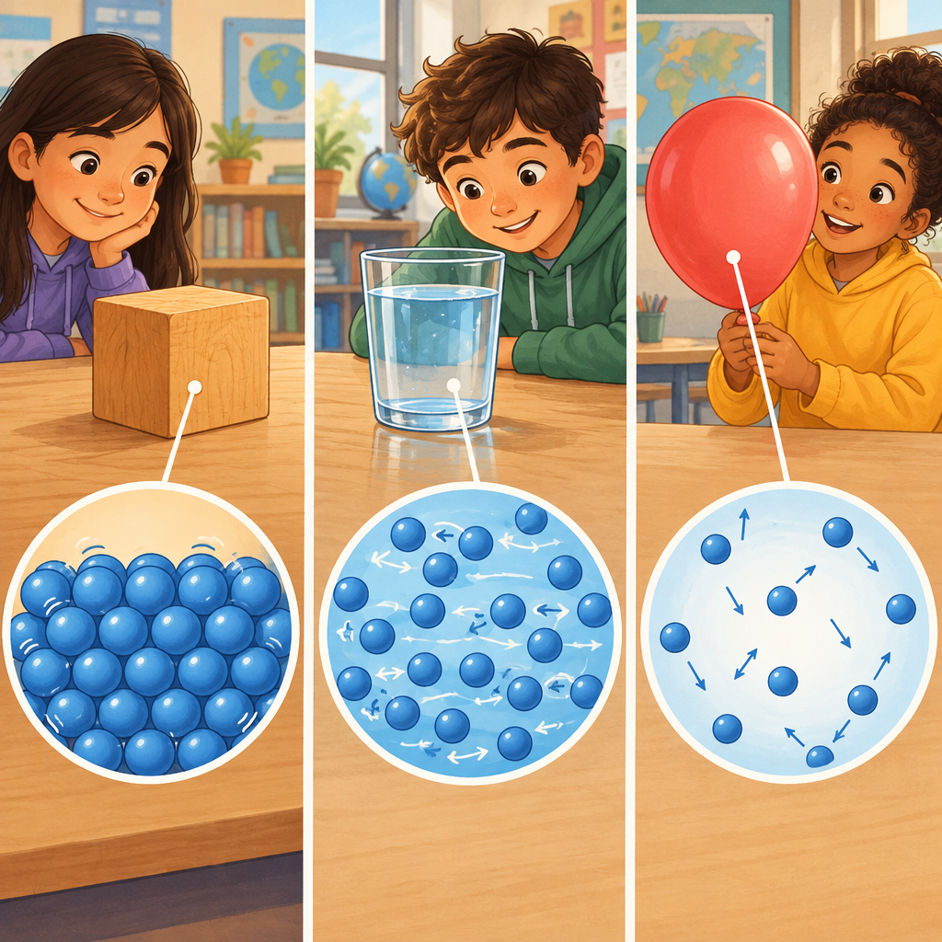

Learning intentions
We are learning to understand how the particle model of matter explains the behaviour of solids, liquids, and gases.

Success criteria
I can describe how particles are arranged and move in solids, liquids, and gases.
I can explain how attractive forces between particles change from solids to gases.
I can represent the three states of matter using the particle model.

Curriculum alignment
Students investigate the particle model of matter in relation to the physical properties of solids, liquids, and gases (Outcome). The particle model of matter explains the behaviour of particles in matter (Understanding). All matter is made up of small particles; particles of matter are always moving; particles of matter have spaces between them (Knowledge). In solids, particles are close together and vibrate in place. In liquids, particles are separated by spaces and can slide past each other. In gases, particles are separated by large spaces and are constantly moving in all directions (Knowledge). Attractive forces between particles are strongest in solids and weakest in gases (Knowledge).

Materials
For each pair of students:
- 20 small foam balls or ping-pong balls
- 1 shallow plastic tray or box lid
- 1 clear plastic cup or container
- 1 sheet of paper (to use as a barrier)
For the whole class:
- Video: Matter - Movement and Arrangement of Particles (Resource)
- Chart paper and markers
- Three labelled containers (one with a solid object, one with water, one with air)
- Diagram template (three boxes, one for each state of matter)

Lesson sequence
1. Hook: What are things made of? (5 minutes)
Show the class three objects: a wooden block, a cup of water, and an inflated balloon. Ask: "What do you think these three things are made of?" Take responses. Then ask: "If we could zoom in really, really close, like with a super-powerful microscope, what would we see inside each one?" Explain that today we are going to learn that everything is made of tiny particles, and the way those particles move and sit next to each other explains why a solid is hard, why a liquid flows, and why a gas spreads out.
2. Direct instruction: Introducing the particle model (8 minutes)
Explain that all matter is made up of small particles (Knowledge). These particles are so tiny we cannot see them with our eyes. Three big ideas help us understand how particles work:
First, particles of matter are always moving (Knowledge). They do not sit still. Even in a solid, the particles are vibrating, like they are jiggling in place.
Second, particles of matter have spaces between them (Knowledge). There is empty space between every particle.
Third, particles are attracted to each other (Knowledge). This attraction is like an invisible glue that pulls particles together. The stronger the attraction, the closer the particles stay.
Show the video: Matter - Movement and Arrangement of Particles (Resource). As you watch, ask students to notice how the particles move differently in each state.
3. Guided practice: Modelling particles in solids (8 minutes)
Give each pair of students a shallow tray and 20 foam balls. Say: "These balls are like particles. Let us build a solid." Have students pack the balls tightly together in the tray. Ask: "Can the particles move around?" (No, they are stuck in one place.) Now say: "But particles are always moving. Even in a solid, they vibrate." Have students gently shake the tray so the balls jiggle in place without moving to new positions. Ask: "What do you notice? Do the particles stay close together?" (Yes.) Explain: In solids, particles are close together and vibrate in place (Knowledge). The attraction between them is very strong, so they do not move away from each other.
4. Guided practice: Modelling particles in liquids (8 minutes)
Now have students spread the same 20 balls out a little more in the tray. Say: "Now these particles have spaces between them, like in a liquid." Tilt the tray gently so the balls slide past each other. Ask: "What happens when you tilt the tray?" (The particles slide around and change position.) "Can they move freely?" (They can move, but they stay in the tray because they are still attracted to each other.) Explain: In liquids, particles are separated by spaces and can slide past each other (Knowledge). The attraction is weaker than in solids, so particles can move around, but they stay together as a group.
5. Guided practice: Modelling particles in gases (6 minutes)
Have students remove the balls from the tray and place them in an open area on the floor or table. Say: "Now imagine these particles have huge spaces between them and they are moving very fast in all directions." Have students toss the balls gently into the air or roll them across the table in different directions. Ask: "What do you notice? Do the particles stay together?" (No, they spread out.) "Why do they not stay in one spot?" (There is very little attraction between them, and they have lots of space to move.) Explain: In gases, particles are separated by large spaces and are constantly moving in all directions (Knowledge). The attraction between them is very weak, so they spread out to fill any space they can.
6. Independent practice: Drawing the particle model (4 minutes)
Give each student a diagram template with three boxes labelled solid, liquid, and gas. Ask students to draw circles or dots to represent particles in each state. Remind them:
- Solid: particles close together, vibrating in place
- Liquid: particles with spaces between them, able to slide past each other
- Gas: particles far apart, moving in all directions
As students work, circulate and ask: "Why did you draw the particles this way?" and "How would you show that they are moving?"
7. Consolidation: Connecting to real life (1 minute)
Bring the class together. Ask: "Where do you see solids, liquids, and gases in your classroom right now?" (Desks are solids, water in the sink is a liquid, air around us is a gas.) Say: "The particle model helps us understand why each one behaves the way it does. A solid keeps its shape because particles are held tightly together. A liquid flows because particles can slide past each other. A gas spreads out because particles are far apart and moving fast."

Differentiation
Support
- Provide students with a labelled diagram showing particle arrangement in each state before they draw their own.
- Use the foam ball model longer with students who need concrete practice. Have them predict what will happen before moving the balls.
- Pair students with a partner who can explain their thinking aloud.
Extension
- Ask students to explain what happens to particles when ice melts into water, or when water boils into steam. (Particles gain energy and move faster; spaces between them increase.)
- Have students predict what would happen if particles moved even faster in a gas. (They would spread out even more.)
- Challenge students to explain why you can squeeze a sponge but not a rock, using the particle model. (A sponge has air spaces that can be compressed; a rock's particles are tightly packed and cannot be pushed closer together.)

Assessment
Formative check: Exit ticket
As students leave, ask each one: "Show me with your hands how particles move in a solid" (vibrating in place), "in a liquid" (sliding past each other), and "in a gas" (spreading out in all directions). Look for:
- Solid: small, localized vibrating motion
- Liquid: sliding or flowing motion while staying together
- Gas: spreading arms or hands outward, showing movement in different directions
If a student cannot show the difference, ask: "Are the particles close together or far apart?" to help them think through the arrangement first.

AILI rapid lesson · en · claude-haiku-4-5-20251001 · 2026-09-17

