Cell City: The System Sabotage
This brain teaser draws on the idea that cells act as the basic unit of life, that plant and animal cells differ in structure, and that materials move into and out of cells by diffusion and osmosis based on concentration differences (Outcome). It also uses the understanding that living things function as systems built from cells, tissues, and organs working together (Outcome).

The puzzle
A microbiologist is studying four unlabeled cell samples taken from a mixed garden and lab sample tray. Each sample is a single cell, and each one has exactly one identifying feature circled under the microscope. Use the four clues below to match each sample (W, X, Y, Z) to its correct identity: Onion skin cell, Cheek cell (human), Root hair cell, Elodea (pond weed) leaf cell.
Clues:
- Sample W has a rigid cell wall but no visible green structures inside it.
- Sample X has no cell wall at all, and its outline is irregular rather than boxy.
- Sample Y has both a cell wall and visible chloroplasts.
- Sample Z has a cell wall and a long, thin, hair-like extension for absorbing water, but no chloroplasts.
Determine which sample (W, X, Y, or Z) corresponds to each of the four cell types listed above.
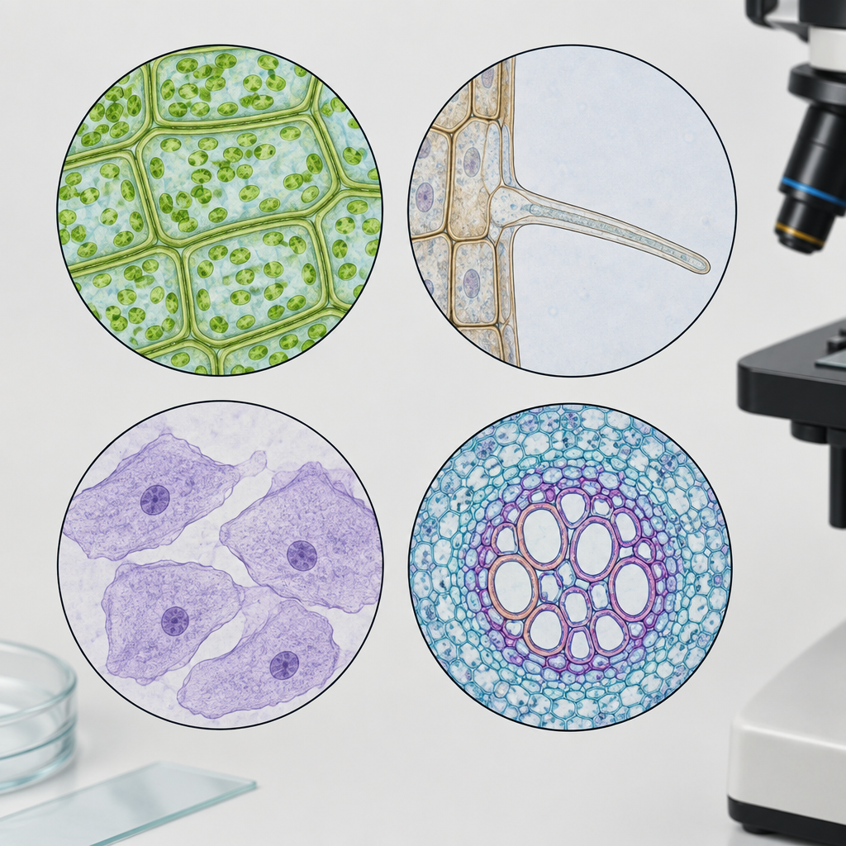

Hints
- Start with structure: only plant cells have a rigid cell wall, and only animal cells have a flexible, irregular outline (Outcome).
- Not all plant cells look alike. Chloroplasts only appear in cells that carry out photosynthesis, so a cell type such as onion skin (an underground storage structure) will not show them, while a leaf cell will (Outcome).
- A root hair cell has one clear, purpose-built feature for pulling in water from soil. Think about which structure would let a cell increase its surface area for water absorption, and match that to the sample described with a hair-like extension (Outcome).

Answer key
- Sample W = Onion skin cell
- Sample X = Cheek cell
- Sample Y = Elodea leaf cell
- Sample Z = Root hair cell
Reasoning: Cheek cells are animal cells, so they have no cell wall and an irregular shape, which matches Sample X (Outcome). The remaining three samples all have cell walls, so they are plant cells. Elodea leaf cells photosynthesize and therefore contain chloroplasts, matching Sample Y. Onion skin cells come from a bulb, a storage structure that does not photosynthesize, so it has a cell wall but no chloroplasts, matching Sample W. Root hair cells are specialized for water uptake through diffusion and osmosis and have a long thin extension to increase surface area for absorption, but like onion skin cells they do not photosynthesize, matching Sample Z (Outcome).

Note: 2 learning outcome blocks were left out to fit the 4000-token curriculum budget for this kind of material. Use "Split into parts" to generate one document per organizing idea.

AILI game · en · claude-sonnet-5 · 2026-09-17

