The Particle Model of Matter
Central concept: Particle Model of Matter

Connections
- Particle Model of Matter (includes) -> All Matter is Particles
- Particle Model of Matter (includes) -> Particles Always Moving
- Particle Model of Matter (includes) -> Spaces Between Particles
- Particle Model of Matter (explains) -> Solids
- Particle Model of Matter (explains) -> Liquids
- Particle Model of Matter (explains) -> Gases
- Particle Model of Matter (affects) -> Physical Properties
- Solids (has strongest) -> Attractive Forces
- Gases (has weakest) -> Attractive Forces
- Physical Properties (includes) -> Mass and Volume
- Physical Properties (includes) -> Density
- Physical Properties (includes) -> Compressibility
- Mass and Volume (determines) -> Density

Notes
- Particle Model of Matter: Explains behaviour of particles in all matter Understanding, PDF p.1
- All Matter is Particles: Matter is made up of small particles Knowledge, PDF p.1
- Particles Always Moving: Particles of matter are constantly in motion Knowledge, PDF p.1
- Spaces Between Particles: Particles have gaps between them Knowledge, PDF p.1
- Solids: Particles close together, vibrate in place Knowledge, Resource
- Liquids: Particles separated by spaces, slide past each other Knowledge, Resource
- Gases: Particles in large spaces, move in all directions Knowledge, Resource
- Attractive Forces: Strongest in solids, weakest in gases Knowledge
- Physical Properties: State, mass, volume, density, compressibility Knowledge
- Mass and Volume: Measured in grams, kilograms, millilitres, litres Knowledge
- Density: Comparison of mass to volume; denser or less dense Knowledge
- Compressibility: Ability to reduce volume under pressure Knowledge
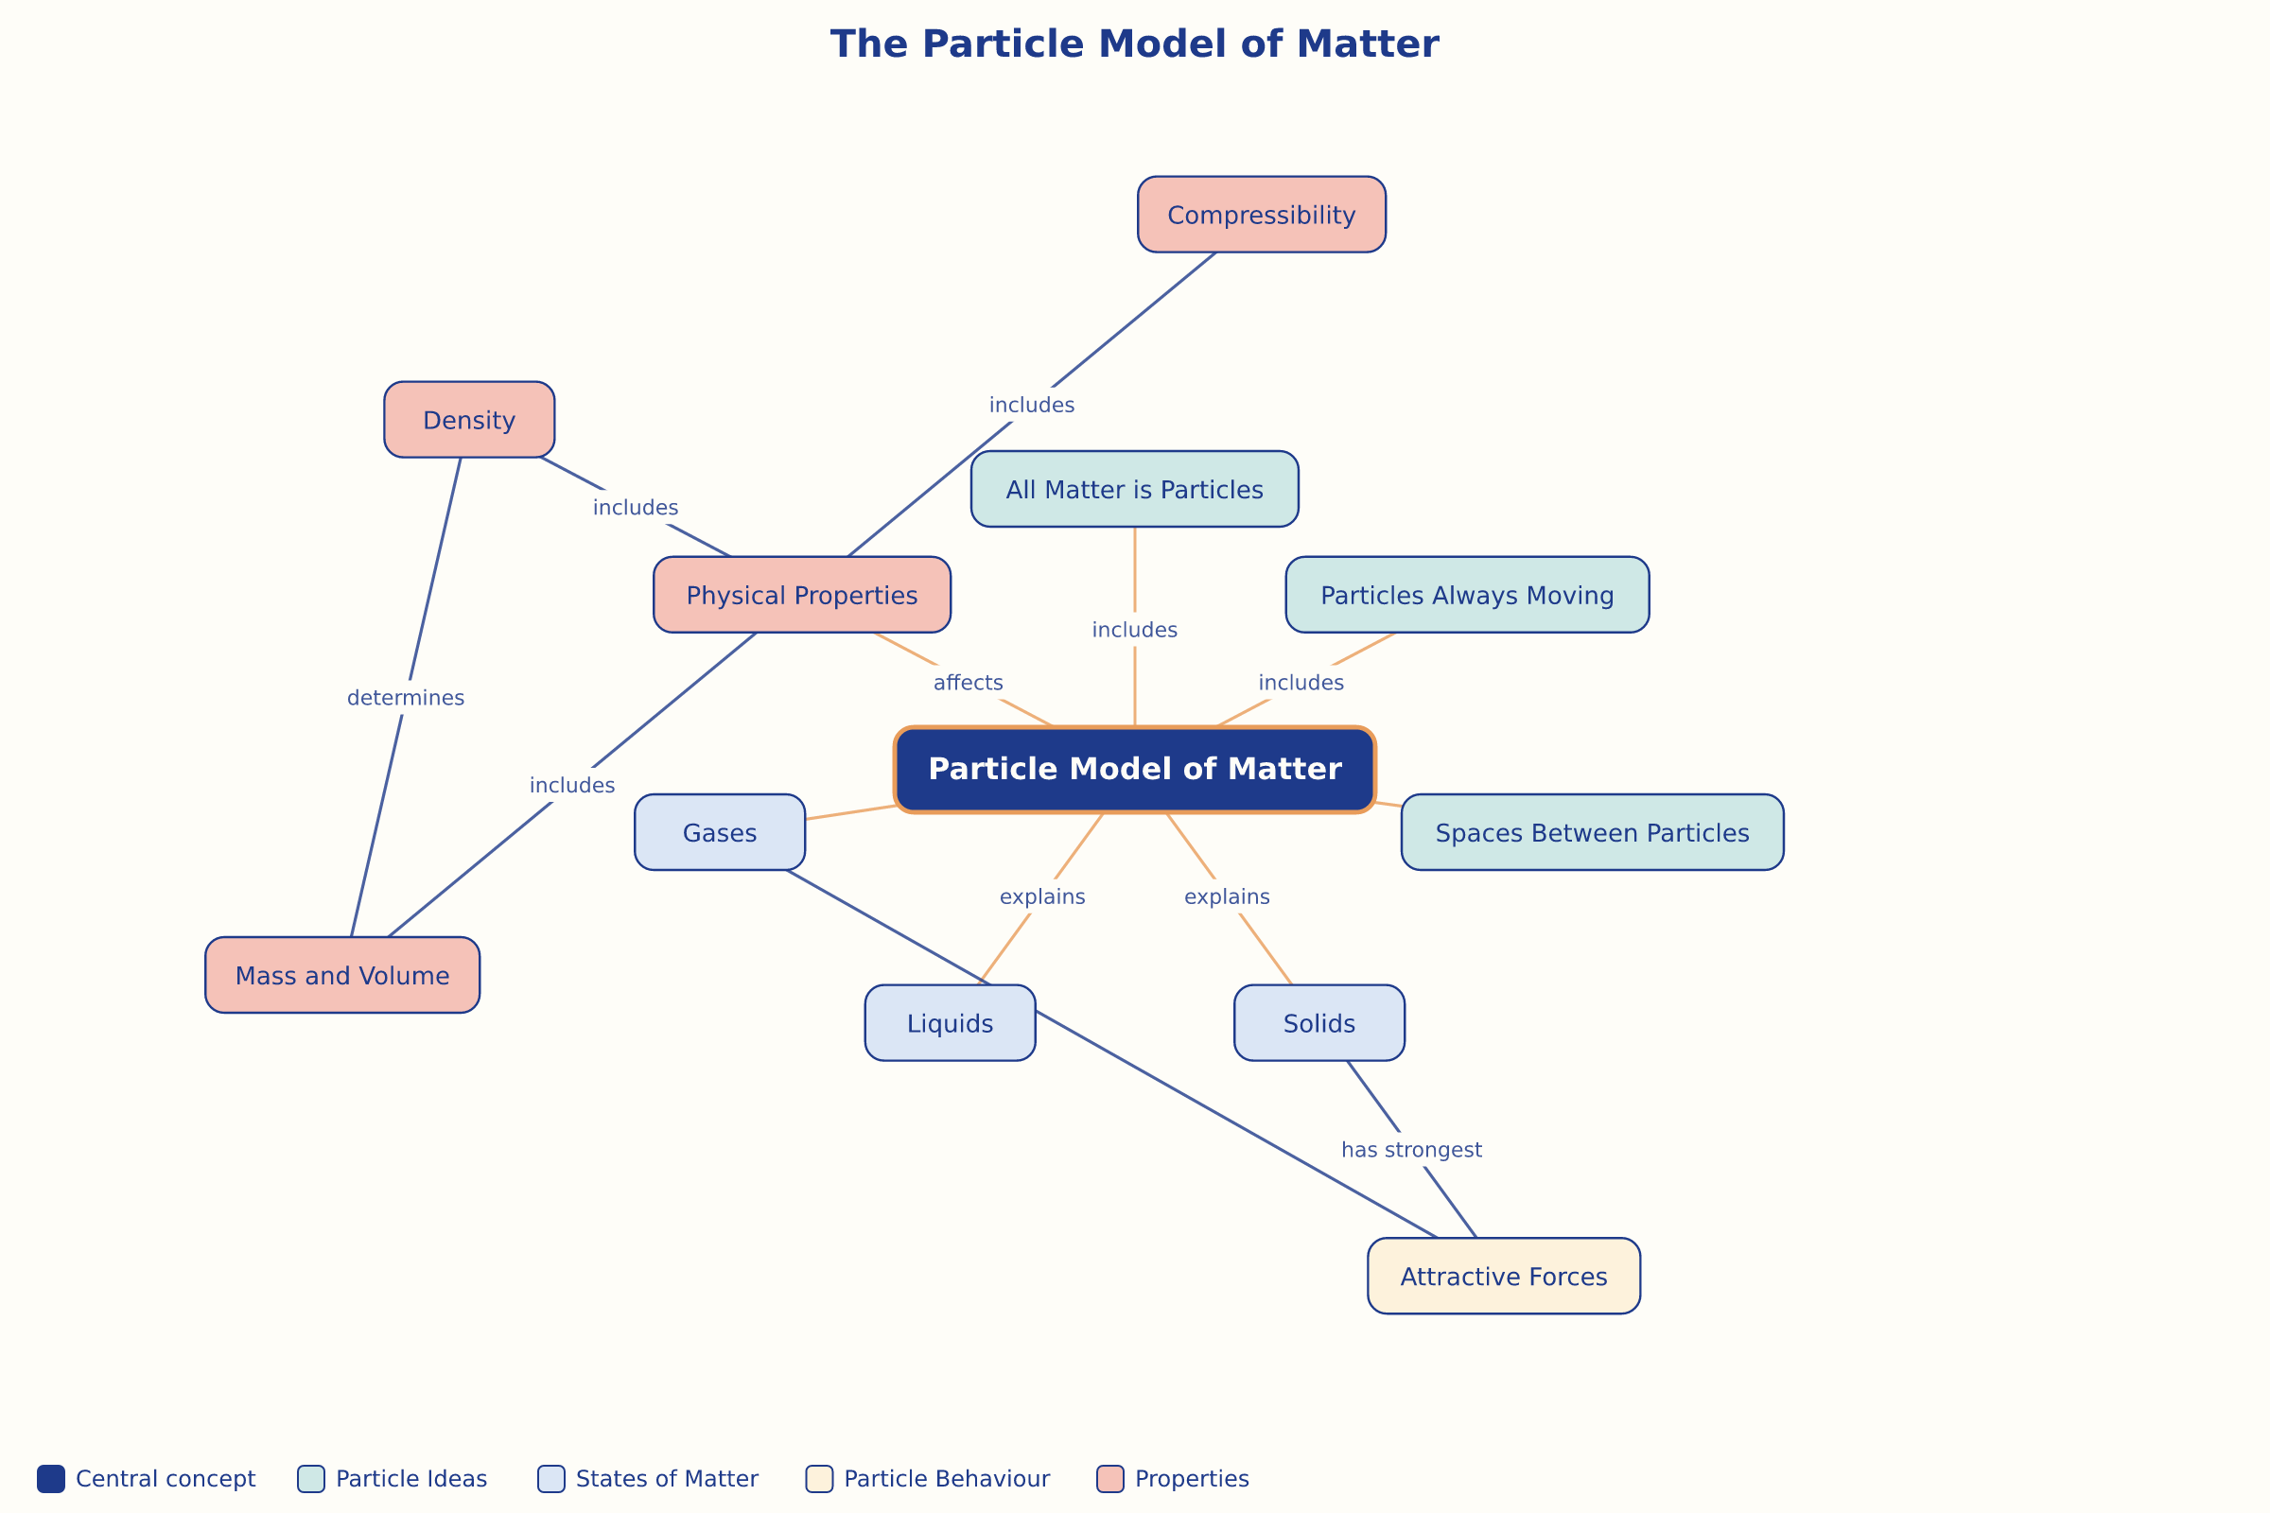

AILI word map · en · claude-haiku-4-5-20251001 · 2026-09-17

